2019
Community Health Needs Assessment
Marquette, Delta and Houghton Counties, Michigan
UP Health System - Marquette

Paper copies of this document may be obtained at: UP Health System - Marquette
850 W Baraga Avenue, Marquette, MI 49855or by phone 906-449-3000 or via the hospital website https://www.mgh.org

Table of Contents
Perspective/Overview 3
Community – Input and Collaboration 4
Data Collection and Timeline 4
Information Gaps 5
Participation by Those Representing the Broad Interests of the Community 5
Input of the Medically Underserved, Low-Income, and Minority Populations 6
Input of those with Expertise in Public Health 6
Community Selected for Assessment 6
Key Findings 7
Process and Methods 7
Description of the Communities Served 8
Demographics of the Community 2019-2024 8
Business Profile 16
Tapestry Segmentation 17
Community Input: Focus Group, Survey Results 17
Focus Group Results 17
Marquette, Delta, and Houghton County Community Surveys 23
Hospital Employee and Community Physicians Survey 25
Health Status Data 28
Results of the CHNA: Community Health Summit Prioritized Health Needs, Brainstormed Goals and Actions 44
Prioritization Criteria 44
Most Significant Community Health Needs 45
Impact of 2016 CHNA and Implementation Plan 50
Appendix 55

Perspective/Overview
Creating a culture of health in the community

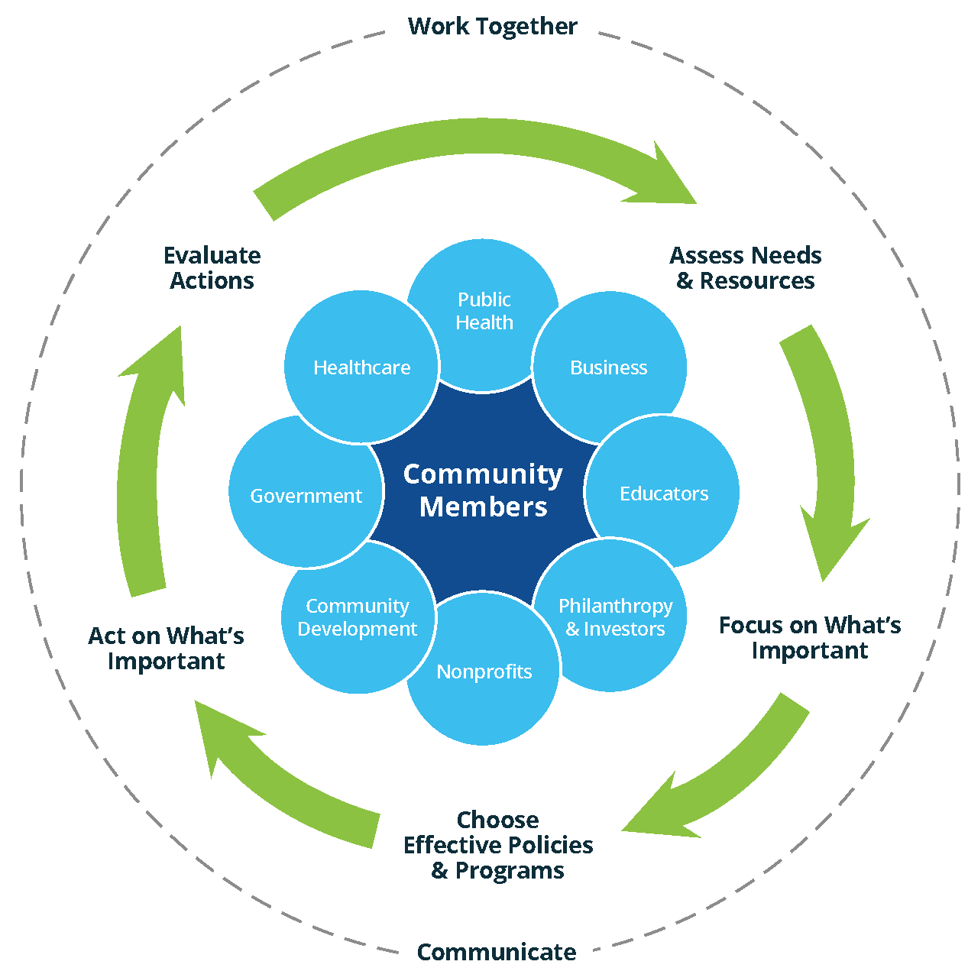

Action Cycle Source: the Robert Wood Johnson Foundation’s County Health Rankings website: http://www.Countyhealthrankings.org/roadmaps/action-center
The Action Cycle shows how to create healthy communities. The rankings later in the document assist in understanding what makes a healthy community.
The Community Health Needs Assessment (CHNA) uses systematic, comprehensive data collection and analysis to define priorities for health improvement, creates a collaborative community environment to engage stakeholders, and an open and transparent process to listen and truly understand the health needs of Marquette, Delta and Houghton Counties, Michigan.
This document is a hospital facility-specific Community Health Needs Assessment (CHNA) for UP Health System - Marquette.

UP Health System - Marquette as the sponsors of the assessment, engaged national leaders in community health needs assessments to assist in the project. Stratasan, a healthcare analytics and facilitation company based out of Nashville, Tennessee, provided the analysis of community health data and surveys, facilitated the focus group, and facilitated a community health summit to receive community input into the priorities and brainstorm goals and actions the community could take to improve health.
- Starting on January 28, 2020, this report is made widely available to the community via UP Health System - Marquette’s website https://www.mgh.org and paper copies are available free of charge at UP Health System - Marquette, 850 W Baraga Avenue, Marquette, MI 49855 or by phone 906-449-3000.
- UP Health System - Marquette’s board of directors approved this assessment and the hospital’s implementation plan on December 26, 2019.
Project Goals
To continue a formal and comprehensive community health assessment process which allows for the identification and prioritization of significant health needs of the community to assist with resource allocation, informed decision-making and collective action that will improve health.
To continue a collaborative partnership between all stakeholders in the community by seeking input from persons who represent the broad interests of the community.
To support the existing infrastructure and utilize resources available in the community to instigate health improvement in the community.
“We initiated the Community Health Needs Assessment with the goal to assess the health and needs of the community. This process is an affirmation of what we’ve been doing to improve health and has jumpstarted our next implementation plan,” said Jerry Dooley, Interim CEO UP Health System - Marquette
“The information gathered both from public health data and from community stakeholders provided the insight the community needed to set priorities for significant health issues and will be used by the community to inform and support our implementation plans,” added Emily Wright, Marketing Specialist, UP Health System – Marquette.

Community – Input and Collaboration

Data Collection and Timeline
In March 2019, UP Health System - Marquette began a Community Health Needs Assessment for Marquette, Delta and Houghton Counties. They sought input from persons who represent the broad interests of the community using several methods:
Information gathering, using secondary public health sources, occurred in August 2019.
The Western Upper Peninsula Health Department conducted a 12-page health survey in August to September of 2017 which was referenced in this assessment. 1,008 people responded from four counties (Houghton and Keweenaw counties were combined), Marquette and Delta Counties were the other two counties.
An online survey of UP Health System - Marquette employees and community physicians was conducted August 5 through September 5, 2019. 473 employees and 43 providers participated in the survey.
19 community members, not-for-profit organizations representing medically underserved, low-income, minority populations, and the elderly participated in a focus group on August 7, 2019.
A Community Health Summit was conducted on September 17, 2019 with 20 community stakeholders. The audience consisted of healthcare providers, business leaders, government representatives, schools, not-for-profit organizations, employers and other community members.

Information Gaps
While this assessment was quite comprehensive, it cannot measure all possible aspects of health in the community, nor can it adequately represent all possible populations of interest. It must be recognized that these information gaps might in some ways limit the ability to assess all the community’s health needs.

Participation by Those Representing the Broad Interests of the Community
1,568 individuals collaborated to implement a comprehensive CHNA process focused on identifying and defining significant health needs, issues, and concerns of Marquette, Delta and Houghton Counties. The three-month process centered on gathering and analyzing data as well as receiving input from persons who represented the broad interests of the community to provide direction for the community and hospital to create a plan to improve the health of the communities.
Participation in the focus group and at the Community Health Summit creating the Marquette, Delta and Houghton Counties Community Health Needs Assessment and Improvement Plan included:
Organization | Population Represented (kids, low income, minorities, those w/o access) | How Participated
City of Marquette | City | Focus Group
Great Lakes Recovery Center | Behavioral Health | Focus Group, Summit
Invest UP | Economic Development | Focus Group
LSCP |  | Focus Group
Marquette County | County | Focus Group
Marquette County Health Department | Marquette County | Focus Group, Summit
Marquette County Sheriff | Marquette County | Focus Group
Marquette-Alger RESA | Career Education -12 | Summit
MCSO |  | Focus Group
NICE Schools | Western Marquette County | Focus Group
Northern Michigan University | Students, Health Careers, faculty, staff | Focus Group, Summit
Retired, UPHS Board Member | Delta County - all | Summit
Senator Ed McBroom's office | Marquette, Delta, Houghton Counties; most of UP | Focus Group, Summit
Superior Health Foundation | Upper Peninsula | Focus Group, Summit
Superior Rehab/Active PT | All | Summit
UP Health System - Behavioral Health System | All | Focus Group, Summit
UP Health System - Bell | Everyone | Focus Group, Summit
UP Health System - Marquette | Everyone | Focus Group, Summit
UP Home Health and Hospice | UP Regional Home Health Alliance | Summit
UP Rehab Services | Pediatrics to geriatrics | Summit
Upper Peninsula Health Plan | Medicaid/Medicare population | Focus Group, Summit
West End Health Foundation | Marquette County West End | Summit
In many cases, several representatives from each organization participated.

Input of the Medically Underserved, Low-Income, and Minority Populations
Input of medically underserved, low-income and minority populations was received during the focus groups, surveys, and the Community Health Summit. Agencies representing these population groups were intentionally invited to the focus groups and Summit. Additionally, the community survey was distributed through the health departments and other agencies serving the low-income, medically underserved and minority populations. The community survey was representative of the whole community – by age, income, and education.

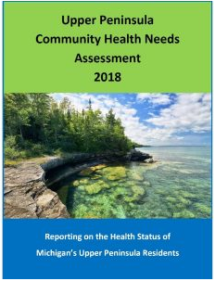
Input of those with Expertise in Public Health
A representative from the Marquette County Health Department participated in the focus group and presented at the summit.
UP Health System - Marquette partnered with 32 agencies and organizations to contribute to the 2018 Upper Peninsula Community Health Needs Assessment in 2018. This assessment references the behavioral risk factor survey of the Upper Peninsula conducted by the Western Upper Peninsula Health Department in August and September 2017.
Community Engagement and Transparency
Many members of the community participated in the focus groups, employee and physician surveys, and the summit. We are pleased to share the results of the Community Health Needs Assessment with the rest of the community in hopes of attracting more advocates and volunteers to improve the health of Marquette, Delta and Houghton Counties. The following pages highlight key findings of the assessment. We hope you will take the time to review the health needs of our community as the findings impact each and every citizen in one way or another; and join in the improvement efforts.

Community Selected for Assessment
Marquette, Delta and Houghton Counties were the primary focus of the CHNA due to the service area of UP Health System - Marquette. Used as the study area, Marquette County provided 50%, Delta County provided 15%, and Houghton County provided 6% of inpatient discharges. The community includes medically underserved, low-income and minority populations who live in the geographic areas from which UP Health System - Marquette draws its patients. All patients were used to determine the service area without regard to insurance coverage or eligibility for financial assistance under UP Health System - Marquette’s Financial Assistance Policy.
UP Health System - Marquette Study Area
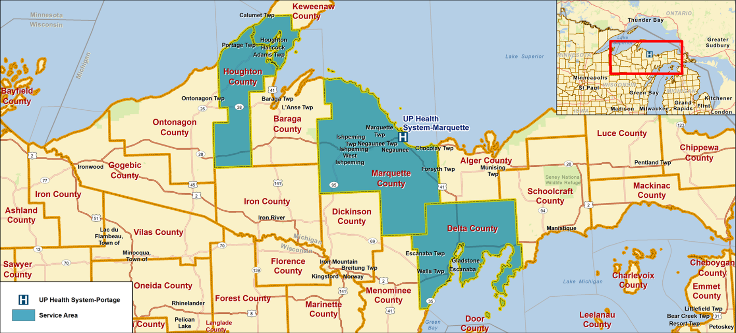

Key Findings
Based on the primary and secondary data, focus group and surveys the following needs were prioritized by attendees at the Community Health Summit. The remainder of the document outlines the process and data.
1.Substance Use
2.Mental Health
3 tie. Healthy eating/active living - obesity
3 tie. Youth issues/Adverse Childhood Experiences (ACEs)
5. Access to care
6. Seniors

Process and Methods
Both primary and secondary data sources were used in the CHNA.
Primary methods included:
Community focus group
Paper surveys of community members
Online survey of hospital employees and community physicians
Community Health Summit
Secondary methods included:
Public health data – death statistics, County Health Rankings, cancer incidence
Demographics and socioeconomics – population, poverty, uninsured, unemployment
Psychographics – behavior measured by spending and media preferences

Description of the Communities Served

Demographics of the Community 2019-2024
The table below shows the demographic summary of Marquette, Delta and Houghton Counties compared to Michigan and the U.S.
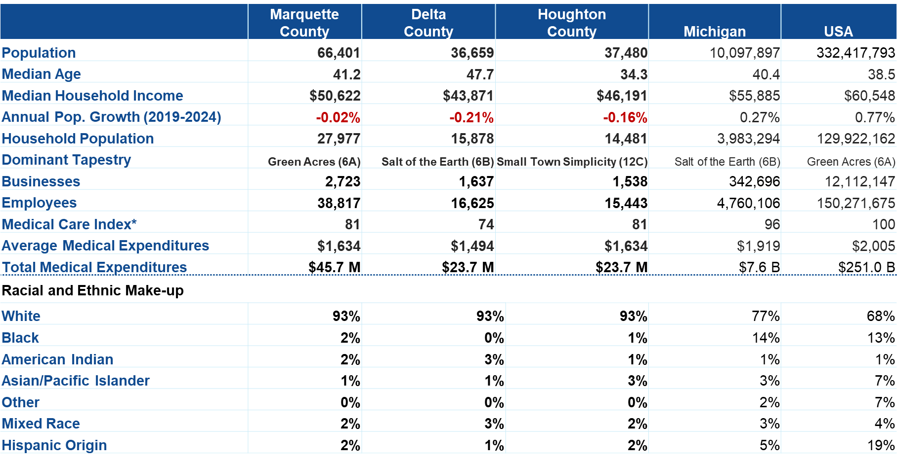
Source: ESRI
*The Medical Care Index is household-based, and represents the amount spent out of pocket for medical services relative to a national index of 100.
The median is the value at the midpoint of a frequency. There is an equal probability of falling above or below the median.

Marquette County
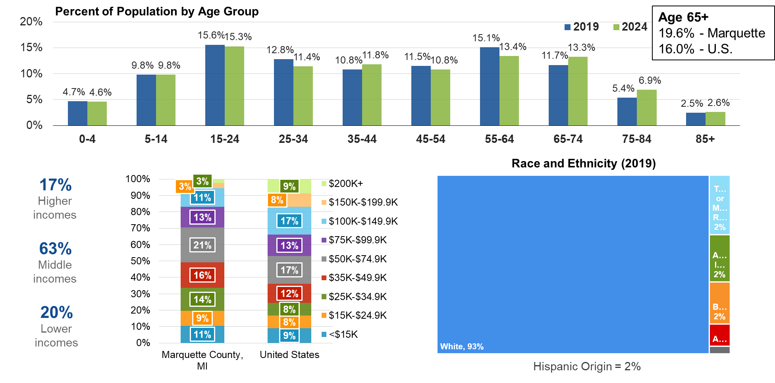
Source: ESRI
- The population of Marquette County is projected to decrease slightly from 2019 to 2024 (0.02% per year). Michigan is projected to increase 0.27% per year. The U.S. is projected to increase 0.77% per year.
- Marquette County had a higher median age (41.2 median age) than MI 40.4 and the U.S. 38.5. Marquette County percentage of the population 65 and over was 19.6%, higher than the U.S. population 65 and over at 16%.
- Marquette County had lower median household income at $50,622 than MI ($55,883) and the U.S. ($60,548). The rate of poverty in Marquette County was 16.7% which was higher than MI (7.7%) and the U.S. (13.4%).
- The household income distribution of Marquette County was 17% higher income (over $100,000), 63% middle income and 20% lower income (under $24,999).
- The medical care index measures how much the populations spent out-of-pocket on medical care services. The U.S. index was 100. Marquette County was 81, indicating 19% less spent out of pocket than the average U.S. household on medical care (doctor’s office visits, prescriptions, hospital visits). Additionally, each household spent an estimated $4,791 on the combination of medical care and health insurance per year.
- The racial and ethnic make-up of Marquette County was 93% White, 2% Black, 5% Hispanic Origin, 2% mixed race, 2% American Indian, and 1% Asian/Pacific Islander. (These percentages total to over 100% because Hispanic is an ethnicity, not a race.)

Delta County
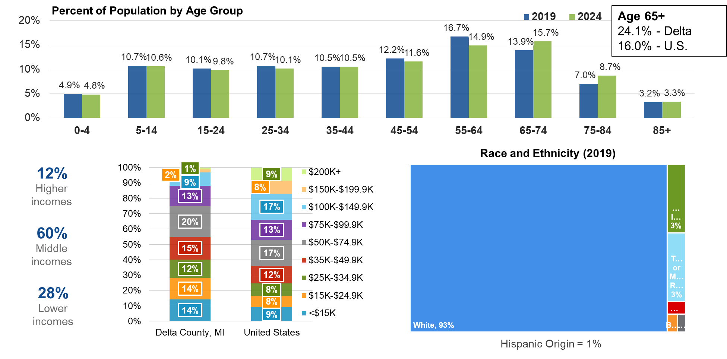
Source: ESRI
- The population of Delta County is projected to decrease from 2019 to 2024 (0.21% per year). Michigan is projected to increase 0.27% per year, and the U.S. 0.77% per year.
- Delta County had a higher median age (47.7 median age) than MI (40.4 median age) and the U.S. (38.5 median age). Delta County percentage of the population 65 and over was 24.1%, higher than the U.S. population 65 and over at 16%.
- Delta County had lower median household income at $43,871 than MI at ($55,885) and the U.S. ($60,548). The rate of poverty in Delta County was 12.6% which was higher than MI (7.7%), but lower than the U.S. (13.4%).
- The household income distribution of Delta County was 12% higher income (over $100,000), 60% middle income and 28% lower income (under $24,999).
- The medical care index measures how much the populations spent out-of-pocket on medical care services. The U.S. index was 100. Delta County was 74, indicating 26% less spent out of pocket than the average U.S. household on medical care (doctor’s office visits, prescriptions, hospital visits). Additionally, each household spent an estimated $4,363 on the combination of medical care and health insurance per year.
- The racial and ethnic make-up of Delta County was 93% White, 1% Hispanic Origin, 3% mixed race, 3% American Indian, and 1% Asian/Pacific Islander. (These percentages total to over 100% because Hispanic is an ethnicity, not a race.)

Houghton County
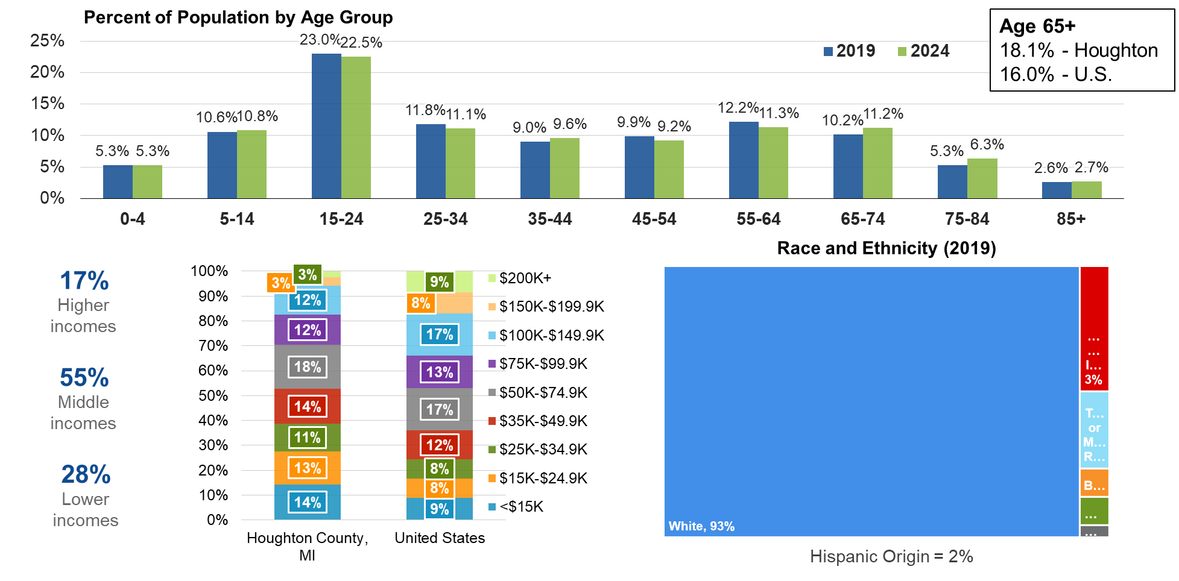
Source: ESRI
- The population of Houghton County is projected to decrease from 2019 to 2024 (0.16% per year). Michigan is projected to increase 0.27% per year, and the U.S. 0.77% per year.
- Houghton County had a lower median age (34.3 median age) than MI (40.4 median age) and the U.S. (38.5 median age). Houghton County percentage of the population 65 and over was 18.1%, higher than the U.S. population 65 and over at 16%.
- Houghton County had lower median household income at $46,191 than MI at ($55,885) and the U.S. ($60,548). The rate of poverty in Houghton County was 14.9% which was higher than MI (7.7%) and the U.S. (13.4%).
- The household income distribution of Houghton County was 17% higher income (over $100,000), 55% middle income and 28% lower income (under $24,999).
- The medical care index measures how much the populations spent out-of-pocket on medical care services. The U.S. index was 100. Houghton County was 81, indicating 19% less spent out of pocket than the average U.S. household on medical care (doctor’s office visits, prescriptions, hospital visits). Additionally, each household spent an estimated $4,763 on the combination of medical care and health insurance per year.
- The racial and ethnic make-up of Houghton County was 93% White, 2% Hispanic Origin, 2% mixed race, 1% Black, 1% American Indian, and 3% Asian/Pacific Islander. (These percentages total to over 100% because Hispanic is an ethnicity, not a race.)

2018 Population by Census Tract and Change (2018-2023)
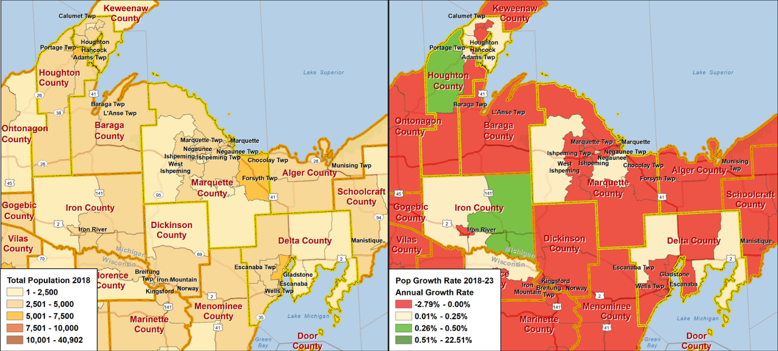
Source: ESRI
Red is population decline
Yellow is positive up to the MI growth rate
Green is greater than the MI growth rate
Dark Green is twice the MI growth rate

Census tracts generally have a population size between 1,200 and 8,000 people, with an optimum size of 4,000 people.

The census tracts with the highest population were Houghton in Houghton County, Forsyth in eastern Marquette, and Escanaba in Delta County.

The three counties’ population was projected to decrease from 2018 to 2023. However, there are a few census tracts where the population was projected to increase. The highest growing census tract was in south western Houghton County, projected to grow greater than the MI growth rate. Others that are projected to grow up to the MI growth rate were one tract in western and another in central Marquette County. As well as, two tracts in Delta county one in the northwest corner and the other on the eastern side.

2018 Median Age and Income
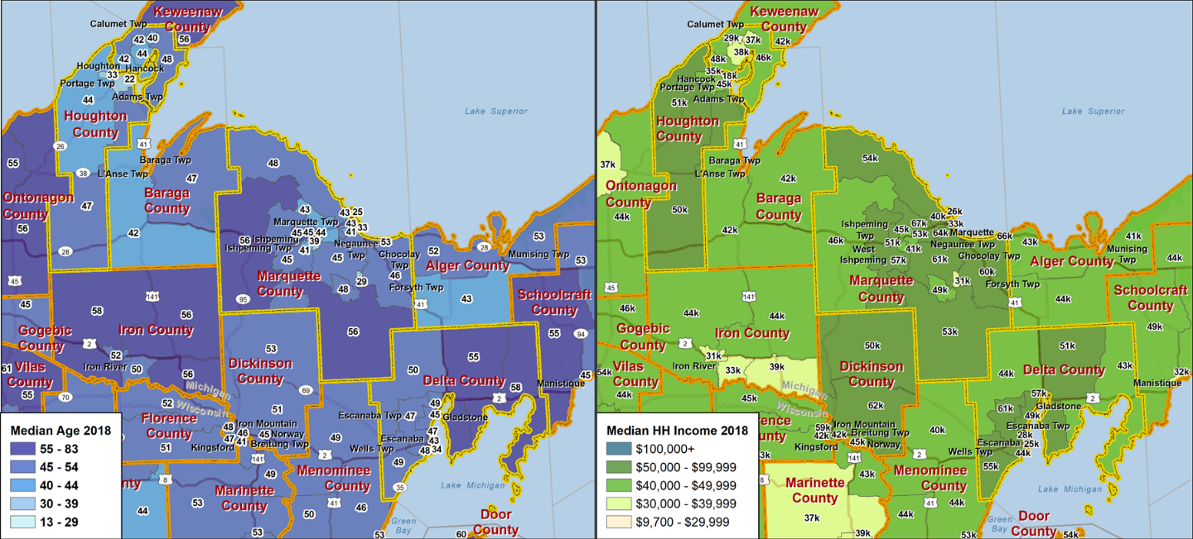
Households making less than $15,000 per year
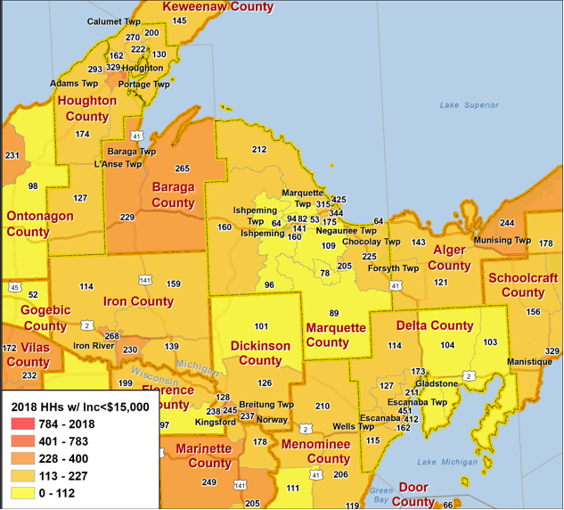
These maps depict median age and median income by census tract. Looking at age and income by census tract is helpful to demonstrate all areas of a county are not the same. The health needs may be very different in Houghton in Houghton County with a median age of 22 and the census tract in the south of Marquette county with a median age of 56.
Looking at median household income by census tract also gives insight into health status. The lower income areas may have lower health outcomes than the higher income tracts. Lower income areas were in the northern section of Houghton County near Calumet Township with $37K and $38K, near Hancock with $35K and $18K near the university, and one small tract in western Marquette County with median household income of $31K and two tracts in Marquette with $26K and $36K. In Delta county, the lowest income area is near Escanaba with $28K and $25K median household income.
The lower map is the number of households making less than $15,000 per year. Again, further attempting to identify those areas within the county that may have lower health status. Houghton had 329 households making less than $15,000. Escanaba in Delta County had two census tracts one with 451 households making less than $15,000 per year and the other at 412. Marquette (city) had three census tracts with high number of households making less than $15K, 425, 344 and 315.
Additionally, Marquette County’s May 2019 preliminary unemployment was 4.8%, Delta’s was 4.9%, and Houghton was 5.1% compared to 4.2% for Michigan and 3.6% for the U.S., which is a large decline in unemployment since 2014. These figures do not include those who have ceased looking for work and dropped out of the workforce. However, indications are these people have begun to reenter the workforce.

Business Profile
Sixty-two percent of employees in Marquette County were employed in:
- Health care and social assistance (17.0%)
- Mining (13.5%)
- Wholesale trade (11.9%)
- Retail trade (11.7%)
- Accommodation & food services (7.3%)
Retail jobs, accommodation and food services offers health insurance at a lower rate than mining, healthcare, manufacturing, public administration and educational services. Marquette County gains 204 net commuters per day commuting into the county for work, with 1,512 commuting into the county and 1,308 commuting out of the county.
Fifty-seven percent of employees in Delta County were employed in:
- Health care and social assistance (17.6%)
- Retail trade (14.9%)
- Manufacturing (8.5%)
- Accommodation and food services (8.5%)
- Educational services (7.3%)
Delta County loses 481 net commuters per day commuting out of the county for work, with 1,426 commuting into the county and 1,907 commuting out of the county.
Sixty-six percent of employees in Houghton County were employed in:
- Retail trade (16.1%)
- Health care and social assistance (15.5%)
- Educational services (15.3%)
- Accommodation and food services (12.1%)
- Public administration (7.1%)
Houghton County loses 153 net commuters per day commuting outside the county for work, with 1,082 commuting into the county and 1,235 commuting out of the county.
It is beneficial to contact people in groups to improve health. There are three primary places people gather during the week, work, church and school. These are three excellent places to reach people to create a culture of health.

Tapestry Segmentation
Demographics are population, age, sex, race. Psychographics are adding behavior data in the form of spending habits and survey data on top of demographics. 34% of Marquette, Delta and Houghton Counties are included in three Tapestry Segments. The map below is census tracts color coded by LifeMode, which are groupings of Tapestry Segments that behave similarly.
The dominant Tapestry Segments in the counties were Heartland Communities (13%), Rural Resort Dwellers (11%), and Midlife Constants (10%). The map below shows the number and letter representing the dominant Tapestry Segment by census tract.
There is a very brief description of the segments on the right of the map. There is much more information on Tapestry Segments, at http://doc.arcgis.com/en/esri-demographics/data/tapestry-segmentation.htm. Studying the Tapestry Segments in the study area helps determine health habits and communication preferences of residents enabling more effective communication and implementation of solutions to improve health.
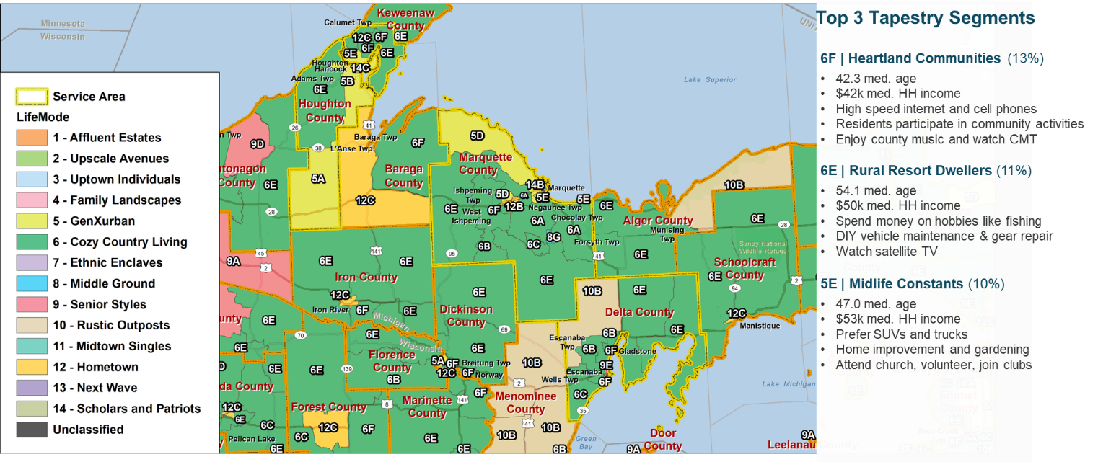Source: ESRI

Community Input: Focus Group, Survey Results

Focus Group Results
Nineteen community stakeholders representing the broad interests of the community as well as representing low income, medically underserved and minority populations participated in a focus group and one individual interview on August 7, 2019 for their input into the community’s health. Community participation in the focus groups and interviews represented a broad range of interests and backgrounds. Below is a summary of the 90-minute focus group discussions and the individual interview.
1. How do you define health?
- Feeling good every day
- State of well-being
- Wholistic- mental, physical, spiritual, financial
- Part of the community
- Equitable
- Absence of disease
- Living to their capabilities and capacity, physically and mentally

2. Generally, how would you describe the community’s health?
- Good, relatively
- Varies – depends on what part of the counties you’re in. The cities are good, but maybe in the rural areas worse.
- Access to care is variable
- Poor and indigent relationship to health – those that have access and those that don’t. Medicaid expansion helped, but there are working poor, mental health issues, chronic issues.
- There are also those that are insured but have limited out of their insurance
- Disparities – lower income and education less healthy.
- Some affluent people have issues also – nutrition, playing games all the time
- Disparity in wholistic health in economic indicators
- Mental health transcends the economic condition
- Generally, younger 20s to 50s are very healthy, active.
- Large percentage of people who aren’t healthy due to drugs. Kids suffering the effects of addicted parents. Babies born addicted. Kids having mental illness.
- Older population may be addicted to their narcotics

3. What are the most important health issues facing Marquette, Delta and Houghton Counties?
- Mental health-
  - Suicide has grown, suicide rate troubling
  - Homeless population – related to mental health
  - Depression and anxiety in children
  - School’s mental health capacity is limited, not trained to be social workers and mental health providers.
  - Challenges around mental health access. Shortage of psychiatrists. People are waiting weeks for mental health beds. Putting people in jail in surrounding counties as main care. ED had 8 patients waiting for psych beds. Just not enough providers.
  - Shortage of mental health providers, need more in the community
  - Many people could be managed by primary care for mental health
- Addiction and addiction services
- Hepatitis C – related to drug use
- Drug addicted babies, highest in the UP- we’ll see the results of this until they’re teenagers. Some entering the school system with chemically altered brains.
- Hearing from employers that people can’t pass a drug test to get a job and they fail random drug tests and lose their jobs.
- Chronic addiction worse as he’s seen it in 10 years. Lack of resources and everyone in the community is impacted.
- Meth epidemic and jail is healthcare with really sick people throughout the UP
- Losing the battle against vaping
- Kids raised in households where parents are using drugs.
  - Adverse Childhood Experiences (ACEs) may not be chemically altered brains but trauma from ACEs. Dealing with ACEs since birth would be traumatic.
- Access to care
  - Transportation – pocket communities with low income and have no or limited transportation. Elderly don’t have access to transportation.
  - Insurance with high deductibles – employers changing health plans and people cannot afford to use their insurance
  - Care for veterans in the UP, access an issue
- Healthy eating/active living
  - Access to healthy foods – grocery store and quality foods reasonably priced. Healthy foods are more expensive than processed foods. People don’t cook anymore and don’t know how to cook healthy foods. You have to acquire a taste for healthy food and if they just try it once and don’t like it, won’t eat it again.
  - Schools are trying to find a way to serve fresh food to introduce kids, but it’s been a challenge
  - Sedentary lifestyle – with long winters, chronic disease contributors
- Demographics not working for the community – lowest birth rates in the UP and a higher aging population, lower income population. The University is down to 9,000 students from 15,000.
  - People are not having multiple children, goes back to affordability, both parents are working
- Socioeconomic Issues/Social determinants
  - Jobs – need opportunities to keep graduates in the area.
  - Affordable housing, no place for people to live if there were jobs. Affordable housing, intermediate housing
  - Poverty more here than people realize
  - Have to start with the social determinants of health to improve health.
  - The issues for the Medicaid population are:
  - Food
    - Transportation
    - Housing
    - Employment
    - Commodities – clothes, baby supplies
- Senior Issues
  - Dementia and Alzheimer’s in the elderly are organic diseases not mental health per se. Biggest issue with Alzheimer’s patients who are violent and have nowhere to go.
  - Seniors are dealing with poverty and isolation
- Chronic diseases
  - Obesity leads to chronic diseases
  - Respiratory issues – COPD, asthma, smoking
  - Diabetes
  - Heart disease
- Others
  - People are attracted to the area because of the services; homeless attracted because of the resources.
  - Crisis around the provision of EMS services. Paid and volunteer EMS have regulatory burdens, cost burdens. Domestic violence also more than people realize
  - Many kids have attachment disorders parents who left them alone in cribs and growing up
  - Kids at schools who need someone to talk to and they don’t have social workers and teachers are so overwhelmed to form connections. The rural school districts have no help.
  - False information about what is best for health, anti-vaccinators

4. The community performed a CHNA in 2016 and identified the following priorities for health improvement,

Substance abuse
Obesity
Mental Health
Access to care, providers
Socioeconomic Issues
Senior Care
Tobacco

What has the community improved the most related to health status in 3 years?
- Same, agree
- Priority has changed. Mental health needs to be at the top. Tobacco is the least of my worries compared people to getting people off drugs.
- There is decreasing tobacco use, but vaping is increasing, and you can’t smell it
- Substance abuse hasn’t changed but has gotten more attention. Highest neonatal abstinence syndrome rate in the state.
- Marijuana use – edibles and smoking. What will be the impact of marijuana use?
- Alcohol is legal and more issues from alcohol.
- Seniors are dealing with dementia and can’t get a place for them. It is multiple weeks in ED waiting for placement. Seniors who have dementia and are violent are removed from nursing homes with no place to go. The new homeless. Need people to go into homes to care for people.
- What chronic issues are related to these? Addressed childhood obesity 3 years ago and the big overriding factor was the cost of healthy food. The kids were getting great messages in school, but Mom and Dad going through McDonalds. Culture and lifestyle overrode the interventions.

5. What behaviors have the most negative impact on health?
- Smoking
- Vaping
- Sedentary lifestyle
- Social media – on it all the time, pressure on the kids, taking a toll mentally resulting in depression and anxiety and associated with rates of ADHD and autism. They’re connected to something so colorful and active, they’re not connected to real life. Bullying of adults and kids on social media.
- Medication compliance – cost of prescription drugs and routines

6. Were there any barriers to improving health in the last 3 years, what will be the barriers going forward?
- Lack of broadband in many areas of the counties
- Some pockets of the communities don’t know the concept of being clean, bathing and washing clothes.
- Availability of all providers, including mental health
- Regulations for hiring providers. Marquette is now a health professional shortage area for psychiatrists.
- Need creative selling of the community. Find something attractive for both partners/spouses.
- It is hard for new people to fit into the community because everyone knows everyone and may be related.

7.What community assets support health and wellbeing?
- North Michigan University Behavioral Education and Resource Center providing free care for youth, working with the schools, graduating providers, but barely scratches the surface of needs. BCBA program.
- Students don’t stay in the UP because wages are low, so they leave
- NICE Community Schools have full-time social worker and share around with surrounding communities.
- Trail networks – multiuse paths, walking, hiking, hoses
- Farmer’s Markets
- YMCAs
- Art and culture
- Gyms
- UP Health System – Marquette – regional referral center, provider and employer
- Spirit of cooperation, people want to work together
- All organizations in this room
- There’s not adversity related to politics
- Public libraries – nice to go into and read a newspaper, free
- Youth programs to a dizzying point. Little League, Hockey, youth theater, adventure club, running club
- Hospital in Bell
- Health Department always collaborating with other organizations
- Community events
- People help each other all over the UP
- Education Access Network – Broadband operated by Northern MI University.
- University nursing program
- Universities: Northern MI, Michigan Tech, Finlandia. They have nursing schools and graduate health providers.
- Economic incubator in Central UP bringing jobs and economic viability
- LifePoint employed 400 people per day every day to build the new hospital
- Great Lakes Recovery Center – residential and outpatient mental health treatment
- Religious communities
- Senior Centers – great programs
- Little Brothers of the Poor in Houghton

8. Where do members of the community turn for basic healthcare needs?
- Within the County
- No problem accessing primary care
- Mental health and specialty care difficult especially pediatric specialties

9. If you had a magic wand, what priority health improvement action should the Counties focus on?
- Become a trauma informed community where all understand the adverse childhood experiences (ACEs) and their impact on people. Need to focus on resilience. In areas with trauma informed care, healthcare and law enforcement costs go down. There are common sense interventions to be used. The ACEs impacts suicide, health and substance use.
- All happy families
- Home family structures – all goes back to the family structure that can support the things we’ve talked about.
- We’re firefighters – look at where it starts, birth, families, before birth. Focus on prevention
- All mothers receive good prenatal care and no drugs are needed
- Public education and investing in children. State lagging so far behind. Figure it out; enable school systems to have what they need, social work resources.
- Kids in critical need affecting the kids not in critical need
- Avoid adverse childhood experiences (ACEs).
- Fix the bureaucracy around healthcare, behavioral health. Can’t be creative and forced to deliver care the way they do. There’s a better way.
- Provide more mental heath
- Urgent care for mental health, would keep people out of the ER
- Fix geriatric dementia placement issues also VA placement issues
- Get the mentally ill out of the jail
- Anecdotal successes around the country led by leaders in the private sector. Leave politics out of the solutions. Need wholistic involvement from private sector, politics will follow. Incent organizations to come together to deal with these hard, complicated issues.
- There is a need for more medically assisted treatment. MAT is better done in an OP setting. Finding more providers who will provide the treatment. Very difficult population to deal with.
- Transportation lacking – transportation across the UP. There are pregnant moms that can’t get to the clinic.
- Money – lots of programs that help people are grant funded. Great Lakes is equipped to implement big grants, not many organizations are able to take on these big projects.
- Good, sustainable programs that support a wide variety of issues
- Would like to see more activities for kids that are developmentally healthy. Lots of mental health issues start so early.

Marquette, Delta, and Houghton County Community Surveys
Survey Process
The Western Upper Peninsula Health Department conducted a behavioral risk factor survey to provide county-level data on physical and mental health status; access to primary care, dental care, mental health counseling and substance abuse treatment services; use of screening and preventive health care services; prevalence of chronic diseases and disabilities; and certain behaviors linked to health status, morbidity, and mortality, including diet, exercise, and use of alcohol, tobacco and other drugs. The survey was inspired by and modeled on the Centers for Disease Control and Prevention’s Behavioral Risk Factor Surveys, BRFS. The survey was a random sample of sample of adults conducted by mail.
The sample sizes were, Marquette County – 325, Delta County- 324, Houghton and Keweenaw Counties were combined and 359 surveys were completed. The surveys were weighted to the population and analyzed by Kelly Kamm, PHD from the Department of Kinesiology and Integrative Physiology, Michigan Technological University in Houghton. The survey was conducted August to September 2017. (Upper Peninsula Community Health Needs Assessment 2018, Western U.P. Health Department, p.195) The red on the map indicates where responses were worse than the State and green represents where responses were better than the State. Stratasan added the coloring to the tables.
Survey Results
Health Indicator | Houghton | Delta | Marquette | State
General Health Status Only Fair or Poor | 23.3% | 13.5% | 15.5% | 18.0%
Unable to Access Healthcare Due to Cost | 21.8% | 13.9% | 19.9% | 12.8%
No Routine Checkup in the Past 12 Months | 28.8% | 19.8% | 28.5% | 26.9%
No Dental Care Past 12 Months | 41.7% | 38.4% | 28.2% | 29.9%
Obese (BMI 30 or greater) | 40.3% | 41.7% | 32.6% | 32.5%
Current Cigarette Smoker | 19.0% | 10.0% | 19.7% | 20.4%
Former Smoker | 37.3% | 32.8% | 31.3% | 25.8%
5+ Servings of Fruits & Vegetables | 8.0% | 5.2% | 14.5% | 14.4%
Ever Diagnosed with Diabetes | 12.5% | 15.7% | 8.4% | 11.2%
Ever Diagnosed with Heart Disease | 14.4% | 12.4% | 7.3% | 5.1%
Ever Diagnosed with Cancer | 19.0% | 14.8% | 12.8% | 12.8%
Ever Diagnosed with Depressive Disorder | 20.7% | 24.6% | 27.2% | 22.0%
Took Medication for Mood Past 12 Months | 18.7% | 31.5% | 25.2% | NA
Heavy Alcohol Drinker | 19.2% | 10.4% | 14.5% | 6.9%
Binge Alcohol Drinker | 20.5% | 10.6% | 11.9% | 19.0%
Used Marijuana Past 30 days | 11.8% | 6.1% | 9.3% | NA
Ever Used Prescription Drugs to Get High | 6.1% | 0.5% | 5.8% | 4.7%
Had Flu Shot in Past 12 Months | 74.8% | 69.2% | 82.2% | 56.1%
Colorectal Cancer Screening, Age 50+ | 78.9% | 69.9% | 79.2% | 69.7%

Adult Health Disparities by Income
Health Indicator | UP Residents
 | < $25,000 | $50,000+
Health Fair or Poor | 29.9% | 5.1%
Uninsured (18-64) | 10.6% | 4.9%
Unable to Access Care Due to Cost | 19.2% | 11.3%
No Dental in Past Year | 55.1% | 18.1%
Current Smoker | 31.9% | 10.5%
No Physical Activity | 22.7% | 10.4%
Diabetes Diagnosis | 15.6% | 6.5%
Heart Disease | 12.0% | 6.4%
Chronic Lung Disease | 14.0% | 3.0%
Current Asthma | 14.1% | 10.5%
Limited By Arthritis | 44.4% | 21.4%
Depressive Disorder | 37.6% | 19.7%
Marijuana Past Month | 15.2% | 4.5%
Prescription Abuse | 4.4% | 2.3%
Drove after Drinking | 10.0% | 5.5%
The table above demonstrates the health disparities by income. In all of the categories, the lower income respondents had worse responses than the respondents making $50,000 and above.

Hospital Employee and Community Physicians Survey
Survey Process
UP Health System - Marquette conducted employee and physician surveys about the health of Marquette, Delta, and Houghton Counties. A total of 473 employees and 43 physicians completed the on-line surveys. The surveys were conducted between August 5 through September 5, 2019.
How would you describe the overall health status of the citizens of Marquette, Delta and Houghton Counties?
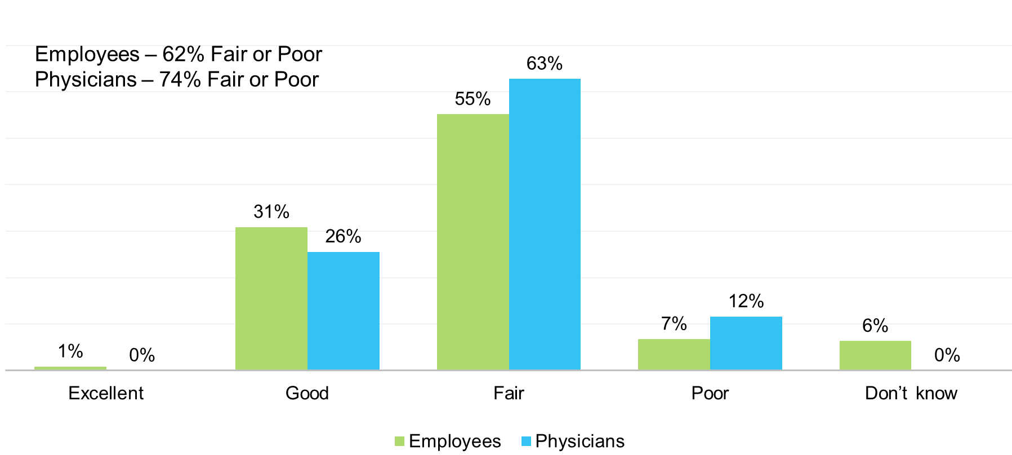
Healthcare providers see sick people most of their day, so their response skews higher in the fair and poor categories than in the Health Department survey or the BRFSS survey.
What are the most prevalent chronic diseases in your community?
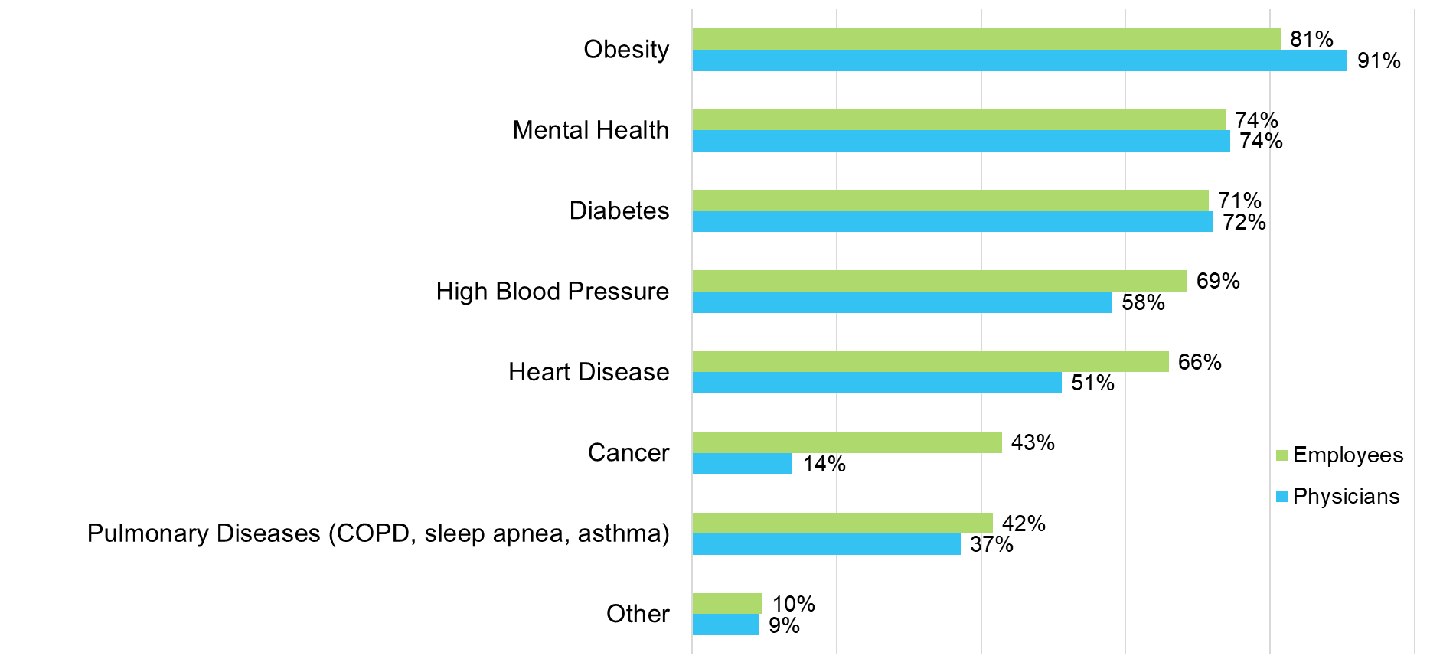
However, health care providers would have a good sense of chronic diseases in the communities. The employees and providers felt that obesity followed by mental health, diabetes, high blood pressure and heart disease were the most prevalent chronic diseases.
What are the top 3 issues that need to be addressed in your community that impact people's health?
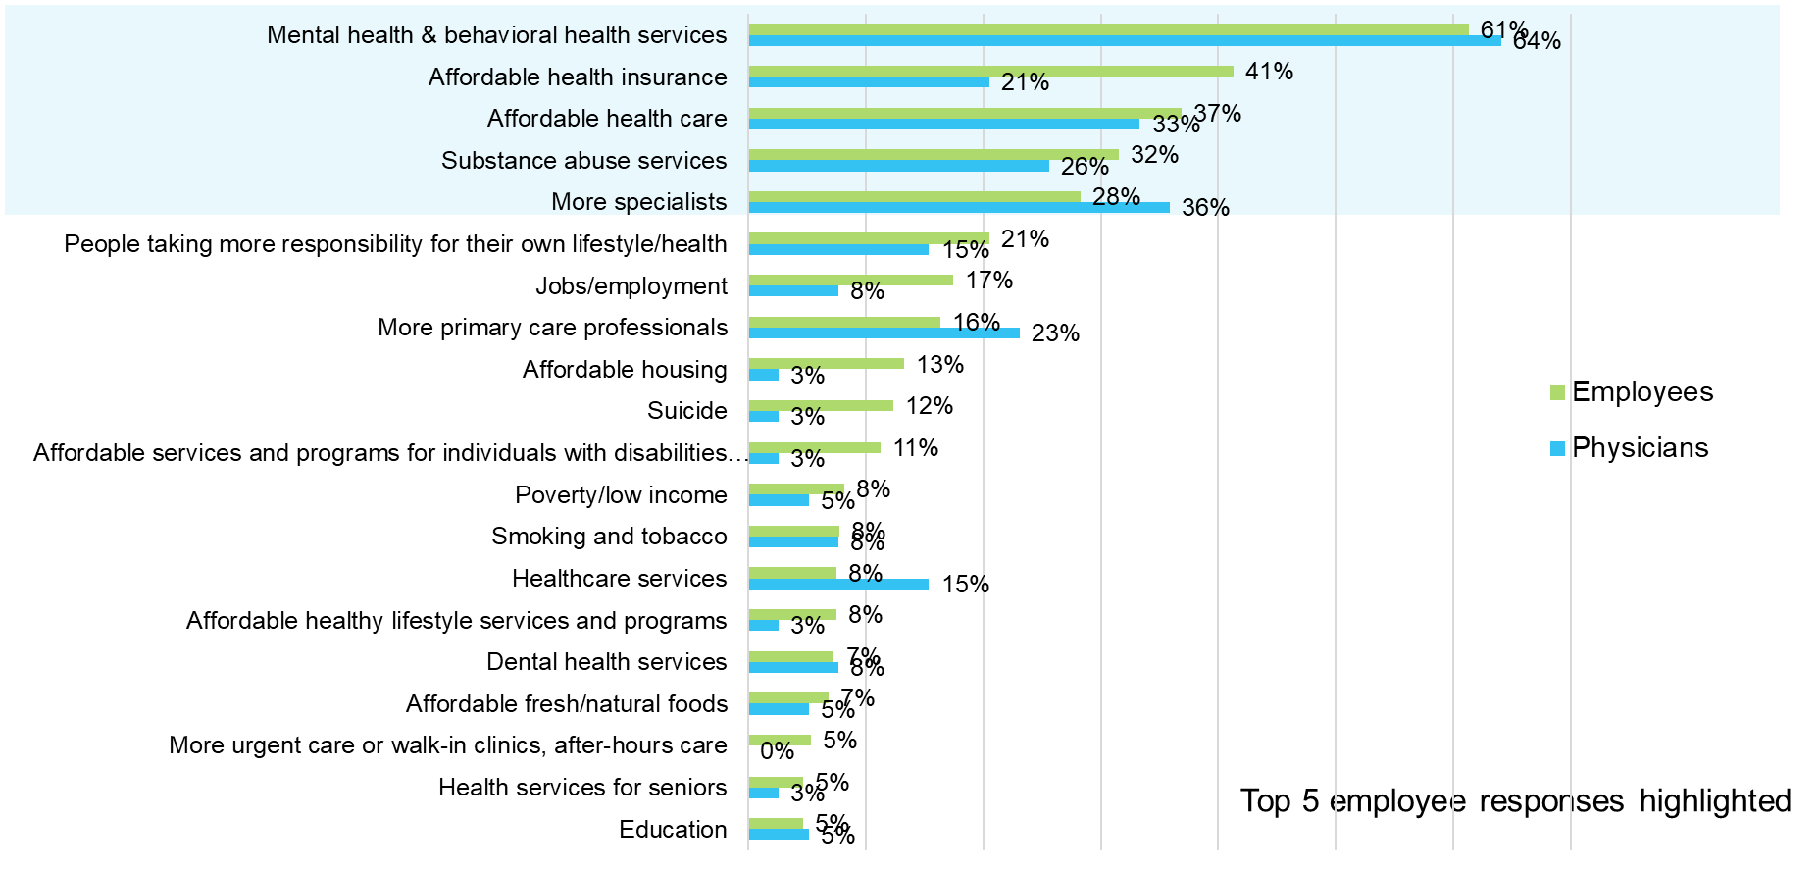
Employees thought mental and behavioral health, affordable health insurance, affordable health care, substance abuse services and more specialists were the top health needs that impact health. Providers thought mental health and behavioral health, more specialists, affordable health care, substance abuse services, and more primary care professionals were the top needs that impact health.
What are the top 3 health concerns for children in your community?
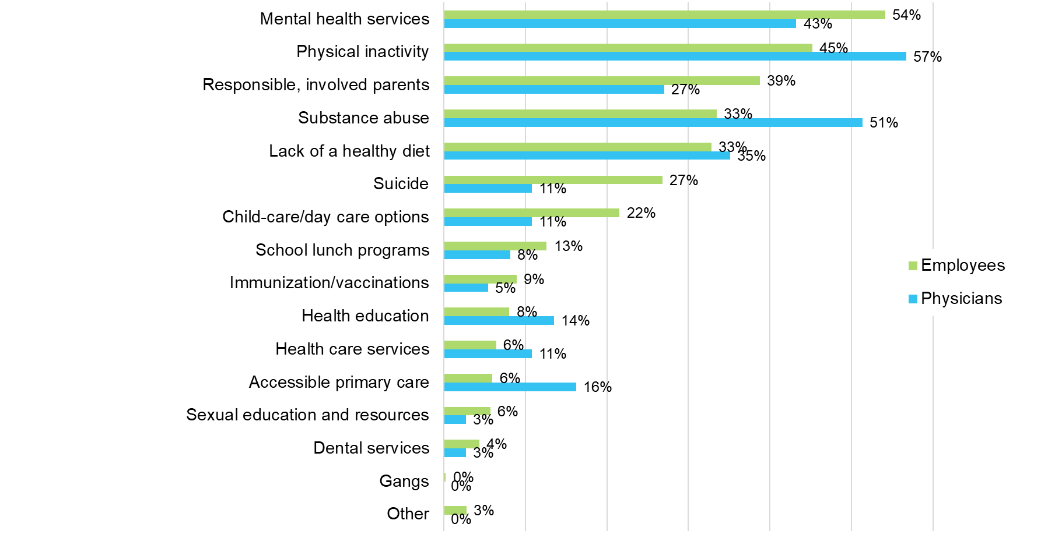
Employees thought the biggest health concerns for children were mental health, physical inactivity and responsible, involved parents followed by substance abuse and lack of a healthy diet. Providers thought physical inactivity, substance abuse, mental health, and lack of a healthy diet the top concerns.

What, if anything, do you think the people in the community need in order to manage their health more effectively?
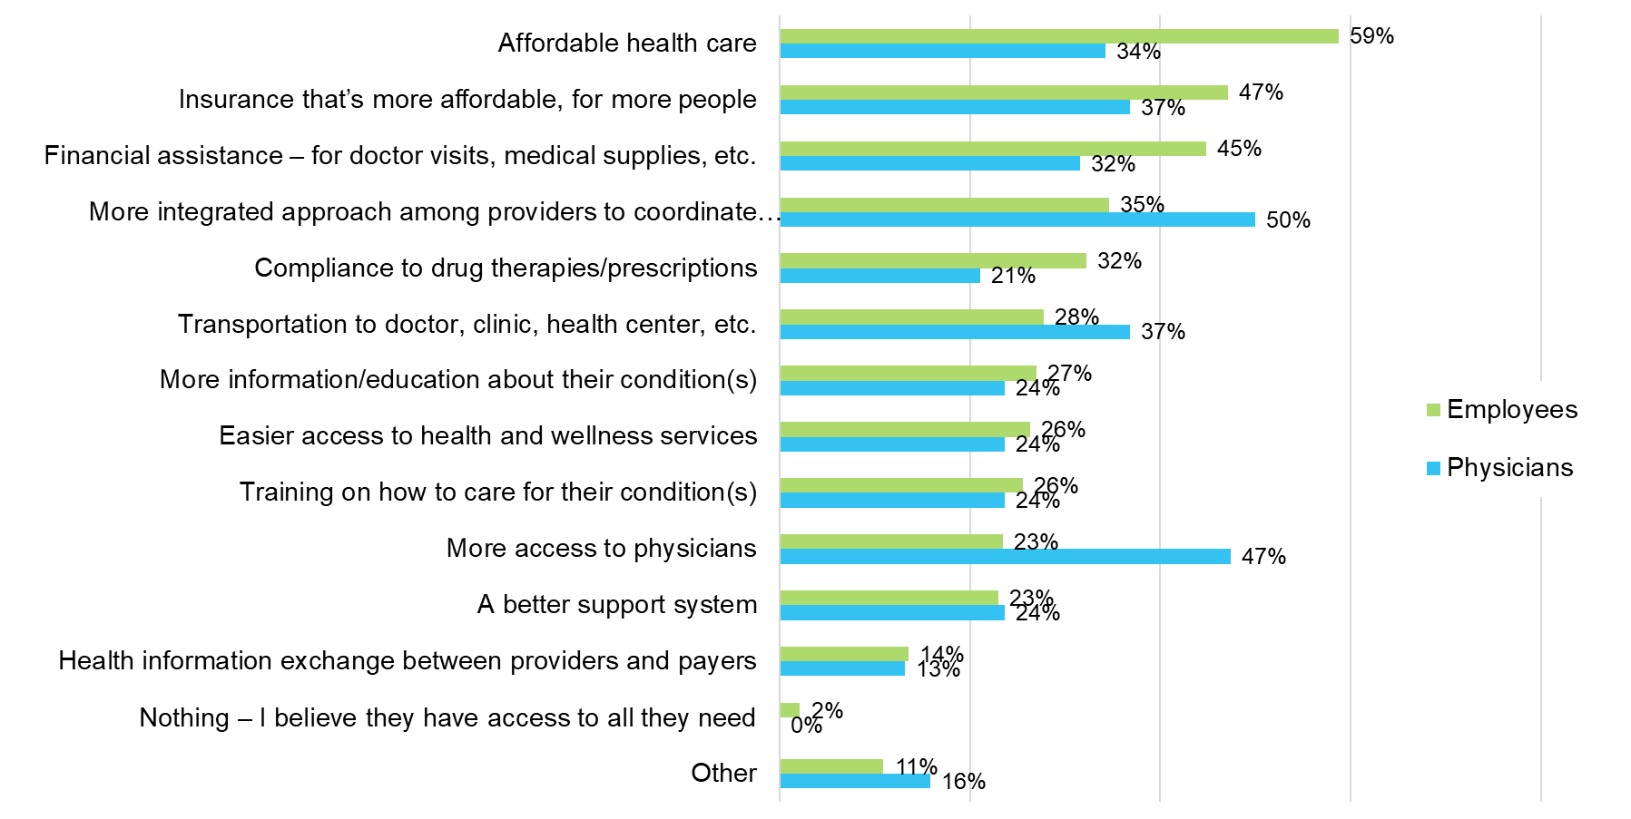
Affordable healthcare, affordable insurance, and financial assistance were top needs for employees. More integrated approach among providers, more access to physicians, transportation, and affordable insurance were top needs for physicians.

Health Status Data
Based on the 2018 County Health Rankings study performed by the Robert Wood Johnson Foundation and the University of Wisconsin², Marquette ranked 20th for health outcomes and 12th for health factors, (1= the healthiest; 83 = unhealthiest), Delta County ranked 26th for health outcomes and 22nd for health factors. Houghton County ranked 28th for health outcomes and 19th for health factors.
County Health Rankings suggest the areas to explore for improvement in Marquette County were higher adult smoking, higher adult obesity percentage, lower percentage of adults with some college and higher percentage of excessive drinking. The areas of strength were identified as lower percentage of physical inactivity, Lower alcohol-impaired driving deaths, lower teen births, lower uninsured, lower preventable hospital stays, lower unemployment, lower children in poverty, and lower income inequality.
County Health Rankings suggest the areas to explore for improvement in Delta County were higher adult smoking, higher adult obesity percentage, higher excessive drinking, higher population per primary care physician and higher air pollution. The areas of strength were identified as lower percentage of physical inactivity, lower teen births, lower uninsured, lower preventable hospital stays, higher mammography screening and higher flu vaccinations, higher percentage of adults with some college, lower unemployment, lower percentage of children in poverty, and lower income inequality
County Health Rankings suggest the areas to explore for improvement in Houghton County were higher adult smoking, higher adult obesity percentage, higher excessive drinking, higher population per primary care physician and higher air pollution. The areas of strength were identified as lower percentage of physical inactivity, lower teen births, lower uninsured, lower preventable hospital stays, higher mammography screening and higher flu vaccinations, higher percentage of adults with some college, lower unemployment, lower percentage of children in poverty, and lower income inequality
When analyzing the health status data, local results were compared to Michigan, the U.S. (where available), and the top 10% of counties in the U.S. (the 90th percentile). Where Marquette, Delta and Houghton Counties’ results were worse than MI and U.S., groups and individuals have an opportunity to act and improve these community measures. To become the healthiest community in Michigan and eventually the Nation, Marquette, Delta and Houghton Counties must close several lifestyle gaps. For additional perspective, Michigan was ranked the 34th healthiest state out of the 50 states. (Source: 2018 America’s Health Rankings) Michigan’s strengths were higher rate of primary care physicians, low incidence of Salmonella, and high meningococcal immunization coverage among adolescents. Michigan’s challenges were high prevalence of excessive drinking, high incidence of pertussis, low per capita public health funding.
Comparison of Health Status
Information from County Health Rankings and America’s Health Rankings was analyzed in the CHNA in addition to the previously reviewed information and other public health data. Other data analyzed is referenced in the bullets below, such as: causes of death, demographics, socioeconomics, consumer health spending, focus groups, and surveys. Data for Michigan, the U.S. or the top 10% of counties (90th percentile) were used as comparisons when available. If a measure was better than Michigan, it was identified as a strength, and where an indicator was worse than Michigan, it was indicated an opportunity for improvement. To prevent strengths from becoming opportunities for improvement, it’s important to continually focus on them. Opportunities were denoted with red symbols, and strengths were denoted with green stars for easy interpretation. The years displayed on the County Health Rankings graphs show the year the data was released. The actual years of the data are contained in the source notes below the graphs.
Health Outcomes (Length of Life and Quality of Life)
Health outcomes are a combination of length of life and quality of life measures. Marquette County ranked 20th, Delta County ranked 26th, and Houghton County ranked 28th in health outcomes out of 83 Michigan counties.
Length of life was measured by years of potential life lost per 100,000 population prior to age 75, lower is better. For example, if a 25-year-old is killed in an accident, that is 50 years of potential life lost prior to age 75. Marquette County ranked 33rd, Delta County ranked 17th, and Houghton County ranked 29th in length of life in MI. Marquette County lost 6,850, Delta lost 6,219, and Houghton lost 6,685 years of potential life per 100,000 population which was lower than MI and the U.S.
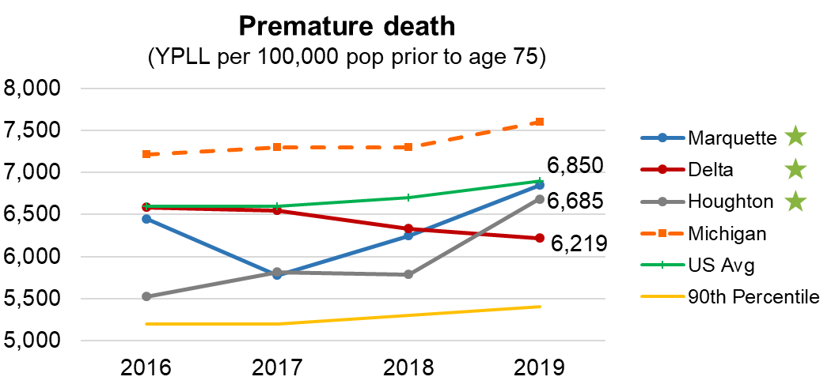
Source: County Health Rankings; National Center for Health Statistics – Mortality File 2015-2017

Leading Causes of Death: Age-Adjusted Death Rates per 100,000
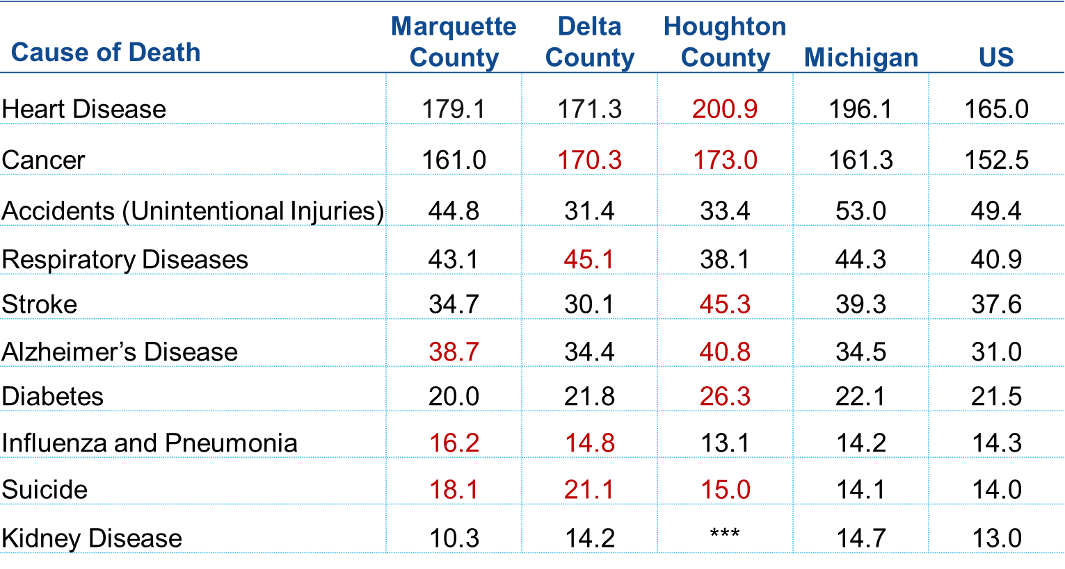
Source(s): Wonder CDC.gov (2017) Age-adjusted rates per 100,000 population. Multiple years were combined for each county to calculate reliable use rates. Marquette, Delta and Houghton County data from 2014-2017. MI and US data from 2017. Rates that appear in red for a county denote a higher value compared to state data. Age Adjustment Uses 2000 Standard Population.
Intentional Self-Harm (Suicide) Deaths per 100,000 Population
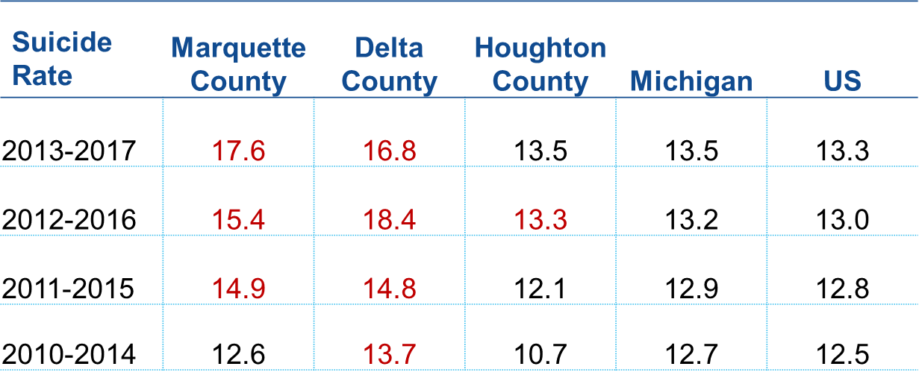
Red areas had death rates higher than MI. The leading causes of death in Marquette, Delta and Houghton Counties were heart disease followed by cancer, like MI and the U.S. Suicide deaths in in all three counties were higher than MI and the U.S.
In most of the following graphs, Marquette County will be blue, Delta County will be red, Houghton will be gray, Michigan (MI) will be orange, U.S. green and the 90th percentile of counties in the U.S. gold. *indicates a change in the Behavior Risk Factor Surveillance System (BRFSS) Survey calculations of results. 2016 forward cannot be compared to prior year results.

Quality of Life
Quality of life was measured by: % reporting fair or poor health, the average number of poor physical health days and poor mental health days in the past 30 days, and % of live births with birthweight less than 2500 grams, or 5.5 lbs. Marquette County ranked 18th, Delta ranked 55th, and Houghton ranked 36th in Michigan for quality of life.
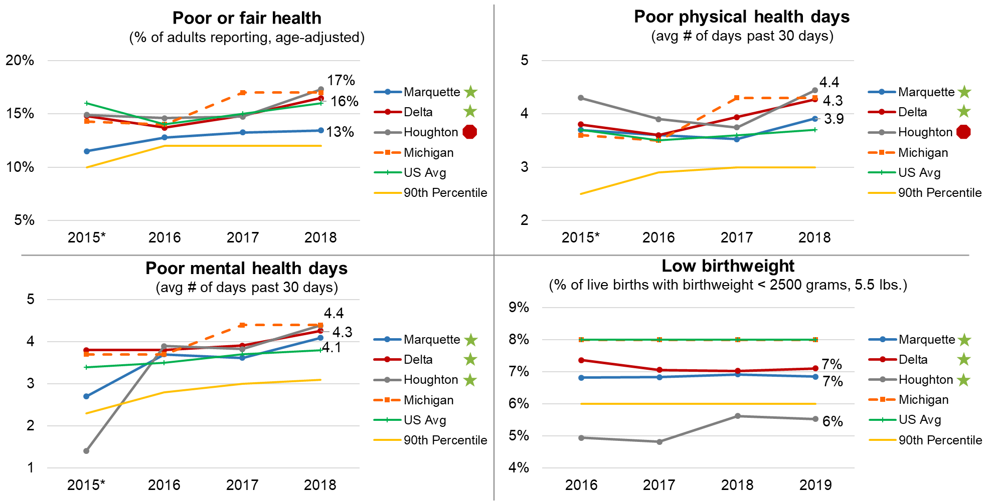
Source: County Health Rankings; Behavioral Risk Factor Surveillance System (BRFSS) 2016 Source: County Health Rankings: National Center for Health Statistics – Natality files (2011-2017)
Quality of Life STRENGTHS
- Years of potential life lost per 100,000 population prior to age 75 in all three counties were lower than MI and the U.S.
- Marquette County had a lower death rate for heart disease, cancer, accidents, respiratory diseases stroke diabetes and kidney disease than MI. Delta County had lower death rates for heart disease, accidents, stroke, Alzheimer’s Disease, diabetes and kidney disease. Houghton County had lower percentages of death rates for accidents, respiratory diseases, and influenza and pneumonia. All three counties had lower death rates for accidents.
- Marquette and Delta Counties had a lower percentage of adults reporting poor or fair health, at 16% and 13% respectively than MI.
- Marquette County had lower average number of poor physical health days in the past 30 days than MI at 3.9. Delta County was the same as the U.S. at 4.3 days.
- Marquette and Delta Counties also had a lower number of poor mental health days in the past 30 days than MI at 4.1 and 4.3. These are lower than MI, but higher than the U.S. Houghton was equal to MI at 4.4.
- All three counties had lower percentages of low birthweight babies than MI and the U.S.
Quality of life OPPORTUNITIES
- Marquette County had higher death rates than MI for Alzheimer’s Disease, influenza and pneumonia and suicide. Delta County had higher death rates for cancer, respiratory diseases, influenza and pneumonia and suicide. Houghton County had higher death rates than MI for heart disease, cancer, stroke, Alzheimer’s Disease, diabetes and suicide. All three counties had higher death rates for suicide than MI and the U.S.
- Houghton County had a higher percentage of adults reporting poor or fair health than MI (and the U.S.) at 17%.
- Houghton County had higher average number of poor physical health days than MI and the U.S. at 4.4.

Health Factors or Determinants
Health factors or determinants rankings are comprised of measures related to health behaviors (30%), clinical care (20%), social & economic factors (40%), and physical environment (10%). Marquette County ranked 12th, Delta County ranked 22nd, and Houghton County ranked 19th out of 83 counties in Michigan.
Health Behaviors
Health behaviors are made up of nine measures and account for 30% of the county rankings. Marquette County ranked 33rd, Delta County ranked 37th, and Houghton County ranked 35th out of 83 counties in Michigan.
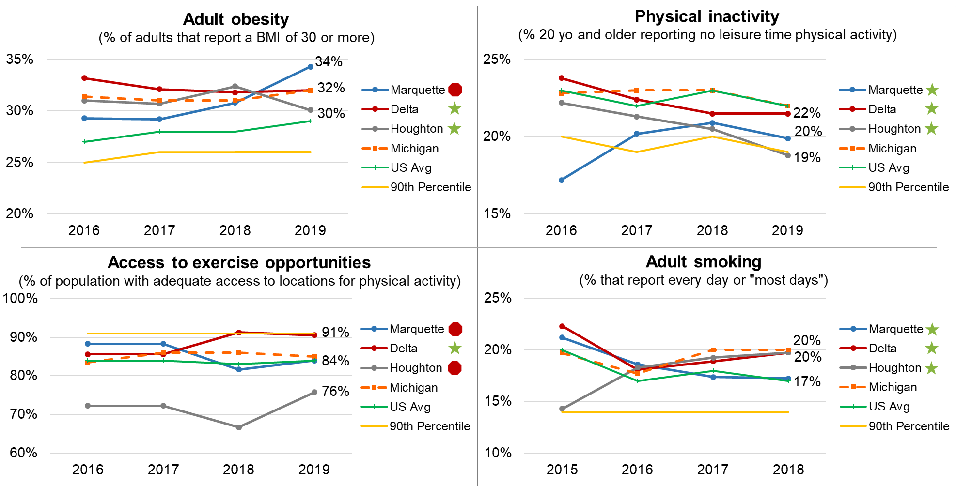
Source: Obesity, physical inactivity - County Health Rankings; CDC Diabetes Interactive Atlas based on responses to BRFSS and Census Bureau’s population estimates program, 2015 Source: Access to exercise opportunities - County Health Rankings; ArcGIS Business Analyst, Delorme map data, Esri and U.S. Census Tigerline Files, 2010 and 2018. Measures the percentage of individuals in a County who live reasonably close to a location for physical activity, defined as parks or recreational facilities (local, state national parks, gyms, community centers, YMCAs, dance studios and pools based on SIC codes) Source: Smoking - County Health Rankings; Behavioral Risk Factor Surveillance System (BRFSS), 2016
Reason for Smoking Ranking
Each year approximately 480,000 premature deaths can be attributed to smoking.[1] Cigarette smoking is identified as a cause of various cancers, cardiovascular disease, and respiratory conditions, as well as low birthweight and other adverse health outcomes. Measuring the prevalence of tobacco use in the population can alert communities to potential adverse health outcomes and can be valuable for assessing the need for cessation programs or the effectiveness of existing programs.
[1] U.S. Department of Health and Human Services. The Health Consequences of Smoking—50 Years of Progress: A Report of the Surgeon General. Atlanta: U.S. Department of Health and Human Services, Centers for Disease Control and Prevention, National Center for Chronic Disease Prevention and Health Promotion, Office on Smoking and Health, 2014[accessed 2018 Feb 22].[2] Nelson DE, Holtzman D, Bolen J, Stanwyck CA, Mack KA. Reliability and validity of measures from the Behavioral Risk Factor Surveillance System (BRFSS). Soz Praventivmed. 2001;46:S3-S42.
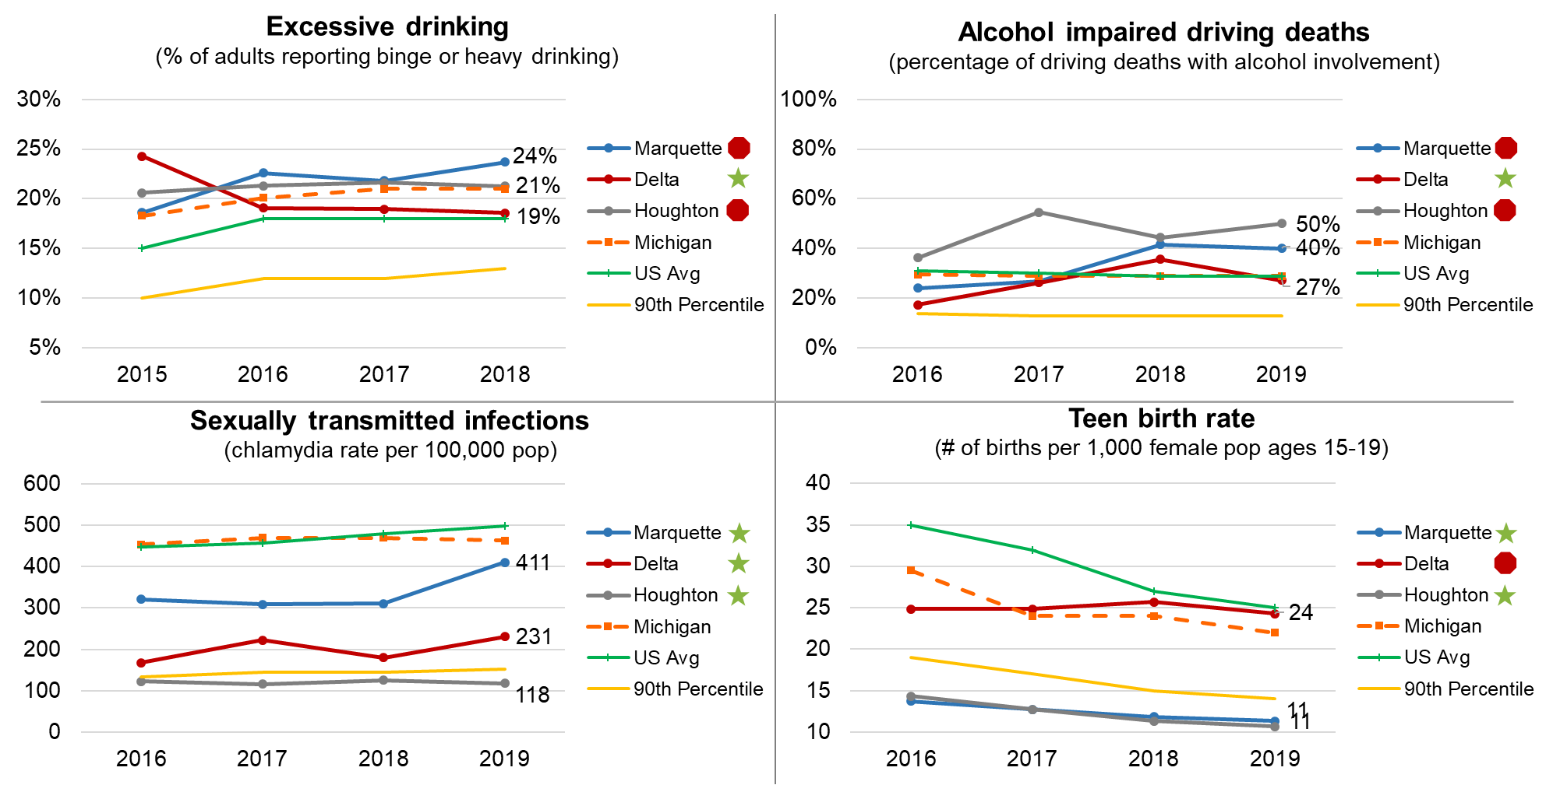
Source: Excessive drinking - County Health Rankings; Behavioral Risk Factor Surveillance System (BRFSS), 2016 Source: Alcohol-impaired driving deaths - County Health Rankings; Fatality Analysis Reporting System, 2013-2017 Source: STIs - County Health Rankings; National Center for HIV/AIDS, Viral Hepatitis, STD, and TB Prevention, 2016 Source: Teen birth rate – County Health Rankings; National Center for Health Statistics – Natality files, 2011-2017
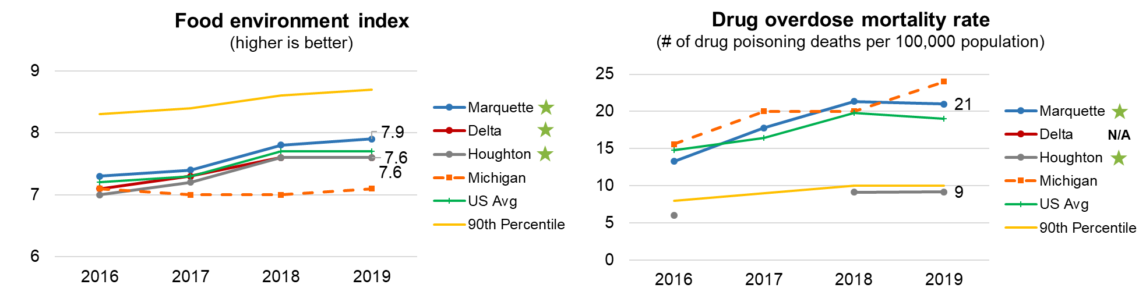
Source: County Health Rankings; USDA Food Environment Atlas, Map the Meal Gap from Feeding America, 2015 & 2016; CDC WONDER mortality data, 2015-2017
The food environment index is a comprised of % of the population with limited access to healthy foods and % of the population with food insecurity. Limited access to foods estimates the % of the population who are low income and do not live close to a grocery store. Food insecurity is the % of the population who did not have access to a reliable source of food during the past year.
Source: US Census County Business Patterns, 2016
Following excerpt taken from American Lung Association website, www.lung.org, “The Impact of E-Cigarettes on the Lung”
“In January 2018, the National Academies of Science, Engineering and Medicine¹ released a consensus study report that reviewed over 800 different studies.
That report made clear: using e-cigarettes causes health risks. It concluded that e-cigarettes both contain and emit a number of potentially toxic substances. The Academies' report also states there is moderate evidence that youth who use e-cigarettes are at increased risk for cough and wheezing and an increase in asthma exacerbations.
A study from the University of North Carolina found that the two primary ingredients found in e-cigarettes—propylene glycol and vegetable glycerin—are toxic to cells and that the more ingredients in an e-liquid, the greater the toxicity.²
E-cigarettes produce a number of dangerous chemicals including acetaldehyde, acrolein, and formaldehyde. These aldehydes can cause lung disease, as well as cardiovascular (heart) disease.³
E-cigarettes also contain acrolein, a herbicide primarily used to kill weeds. It can cause acute lung injury and COPD and may cause asthma and lung cancer.⁴”
1. NAM Report - https://www.nap.edu/resource/24952/012318ecigaretteConclusionsbyEvidence.pdf
2. Sassano MF, Davis ES, Keating JE, Zorn BT, Kochar TK, Wolfgang MC, et al. (2018) Evaluation of e-liquid toxicity using an open-source high-throughput screening assay. PLoS Biol 16(3): e2003904. https://doi.org/10.1371/journal.pbio.2003904
3.Ogunwale, Mumiye A et al. (2017) Aldehyde Detection in Electronic Cigarette Aerosols. ACS omega 2(3): 1207-1214. doi: 10.1021/acsomega.6b00489].
4. Bein K, Leikauf GD. (2011) Acrolein - a pulmonary hazard. Mol Nutr Food Res 55(9):1342-60. doi: 10.1002/mnfr.201100279.

Neonatal Abstinence Syndrome Rates by County per 1,000 Hospital Births
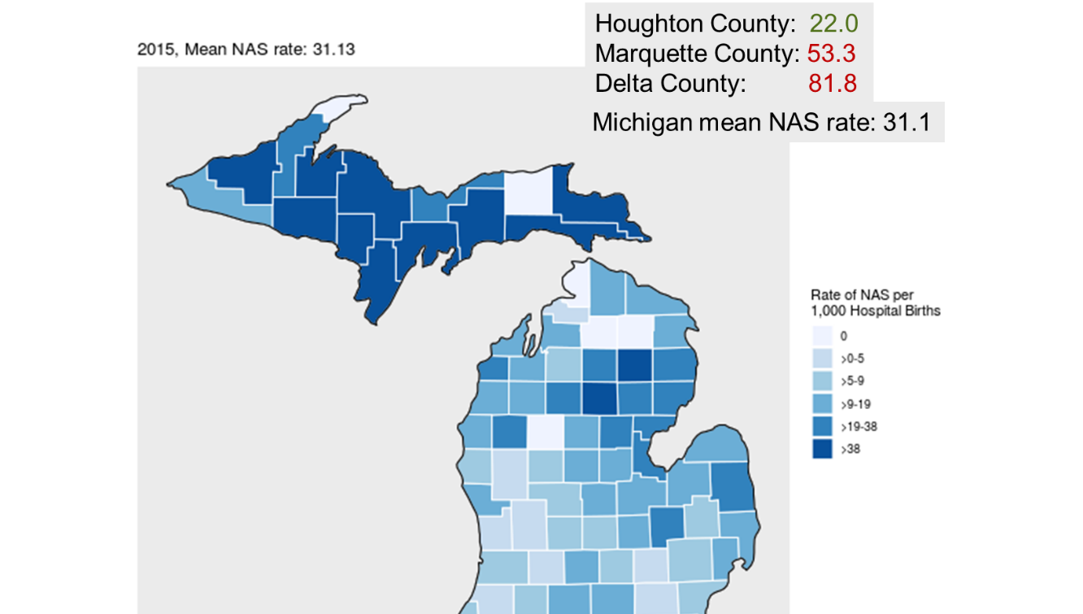
Marquette and Delta counties’ neonatal abstinence syndrome rate were in the sixth sextile (worst) in Michigan. Houghton County was in the fifth sextile.
Birth Rates
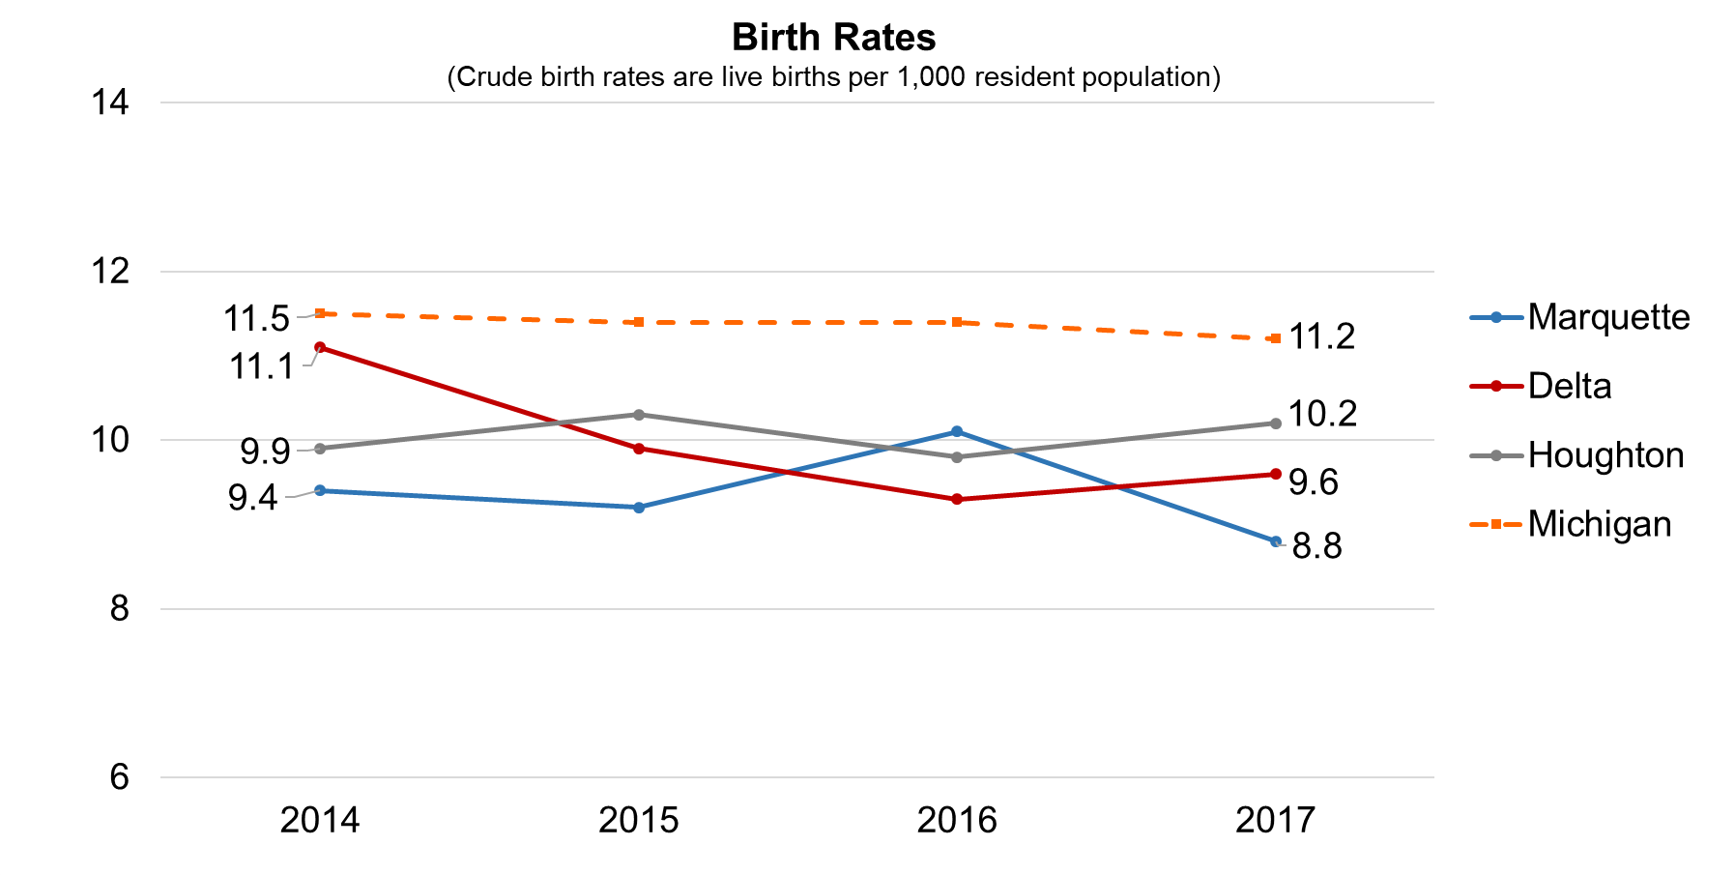
The birth rates in Marquette and Delta Counties and MI declined from 2014 to 2017. Houghton County’s birth rates increased from 9.9 in 2014 to 10.2 births per 1,000 population in 2017.

Health Behaviors STRENGTHS
- Adult obesity in Delta County was equal to MI at 32% but is higher than the U.S. at 29%. Houghton County was lower than MI at 30% but higher than the U.S.
- Physical inactivity in all three counties was lower than MI and the U.S. both at 22%.
- Access to exercise opportunities was 91% in Delta County, higher than MI and in the U.S. in the top 10% of all counties.
- Adult smoking was lower in Marquette, Delta and Houghton Counties (17%, 19.8%, 19.8% respectively) than MI at 20% but higher than the U.S. at 17%. However, given the dangers of any smoking the percentage should be lower.
- Excessive drinking and alcohol impaired driving deaths were lower in Delta County than MI at 19% and 27%.
- Sexually transmitted infections measured by chlamydia rate per 100,000 population were lower in Marquette County (411), Delta County (231), and Houghton County (118) than MI (463) and the U.S. (497).
- The teen birth rates in Marquette and Houghton Counties were lower than MI in the top 10% of all counties at 11 births per 1,000 female population ages 15-19 with MI at 22 births and the U.S. at 25 births and has decreased since 2016.
- The drug overdose mortality rates in Marquette and Houghton Counties were lower than MI. Houghton was in the top 10% of all counties and Marquette was higher than the U.S. at 19 deaths per 100,000 population.
- Neonatal abstinence syndrome was lower in Houghton County 22 per 1,000 hospital births than MI at 31.1.
- The food environment index was higher (better) in all three counties than MI. The index has increased/improved for all counties since 2016. Delta and Houghton Counties were slightly lower than the U.S.
Health Behaviors OPPORTUNITIES
- Adult obesity in Marquette County was 34% and higher than MI at 32%, and the U.S. at 29%. The obesity trend has been increasing in Marquette. Obesity in Michigan and the U.S. continue to rise, putting people at increased risk of chronic diseases including diabetes, kidney disease, joint problems, hypertension and heart disease. Obesity can cause complications in surgery and with anesthesia. It has been implicated in Alzheimer’s Disease and often leads to metabolic syndrome and type 2 diabetes.
- Access to exercise opportunities in Marquette County was 84% and Houghton County was 76% both lower than MI at 85%.
- 24% of Marquette County and 21% of Houghton County reported binge or heavy drinking higher than MI, and higher than the U.S. at 18%.
- Alcohol impaired driving deaths were higher in Marquette and Houghton Counties (40% and 50% respectively) than in MI and the U.S.
- The teen birth rate in Delta County was higher than MI, but lower than the U.S.
- Neonatal abstinence syndrome rates were higher in Marquette and Delta Counties (53.3 and 81.8 per 1,000 hospital births) than MI at 31.1.
Clinical Care
Clinical care ranking is made up of seven indicators, and account for 20% of the county rankings. Marquette County ranked 2nd, Delta County ranked 11th, and Houghton County ranked 36th out of 83 Michigan counties in clinical care.
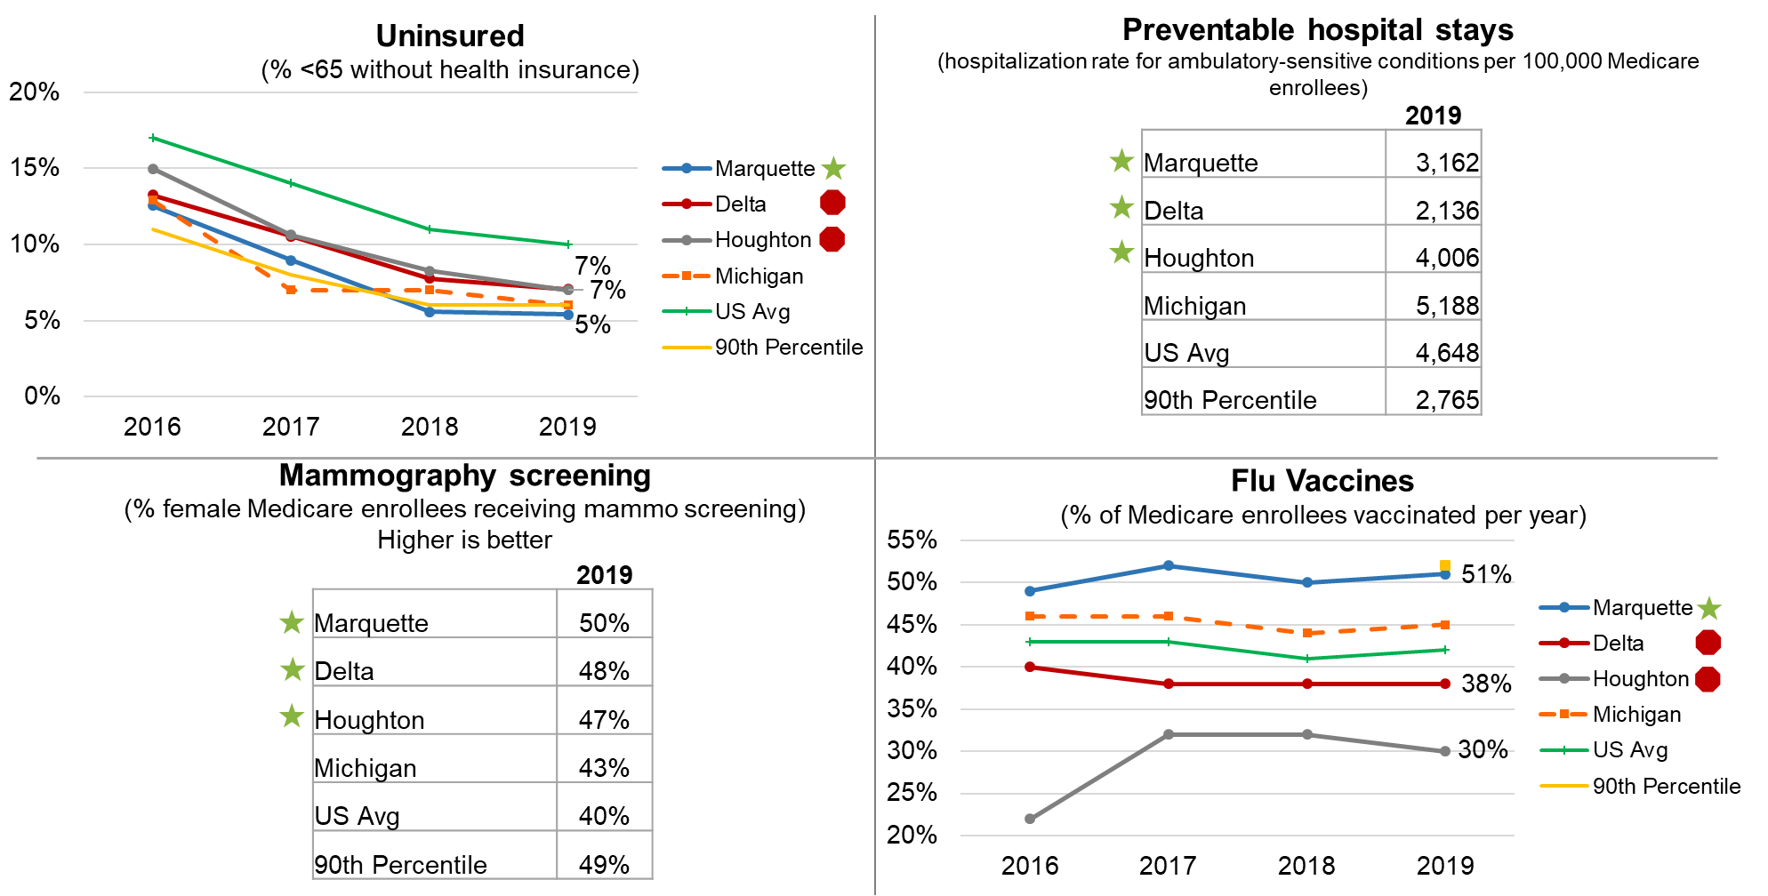
Source: Uninsured - County Health Rankings; Small Area Health Insurance Estimates, 2016
Source: Preventable hospital stays, mammography screening – County Health Rankings, CMS Mapping Medicare Disparities Tool, 2016
Source: Flu Vaccines - County Health Rankings; The Centers for Medicare & Medicaid Services Office of Minority Health's Mapping Medicare Disparities (MMD) Tool, 2016
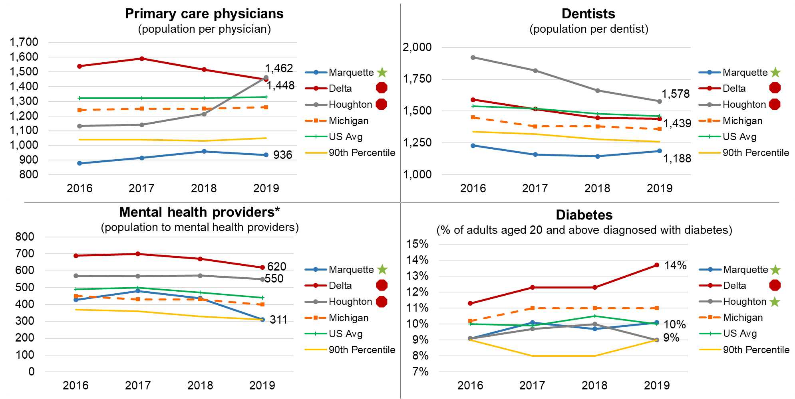
Source: Pop to PCP - County Health Rankings; Area Health Resource File/American Medical Association, 2016
Source: Pop to Dentists - County Health Rankings; Area Health Resource File/National Provider Identification file, 2017
Source: Pop to mental health provider (psychiatrists, psychologists, licensed clinical social workers, counselors, marriage and family therapists and advanced practice nurses specializing in mental health) County Health Rankings; CMS, National Provider Identification, 2018
Source: Diabetes -

Cancer Incidence Rates – MI Counties

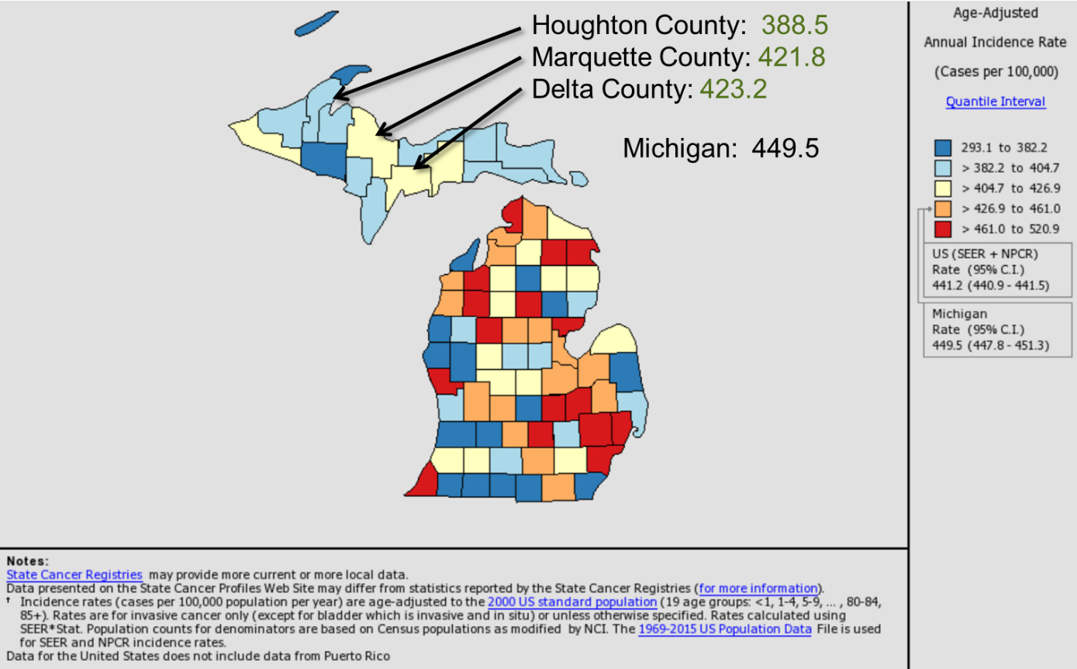

Clinical Care STRENGTHS
- The percent of population under sixty-five without health insurance was 5% in Marquette County, which was lower than MI, the U.S. at 10% and in the top 10% of all counties in the U.S. The uninsured trend has been declining since 2016.
- Preventable hospital stays in Marquette, Delta and Houghton Counties were 3,163, 2,136 and 4,006 per 100,000 Medicare enrollees which was lower than MI (5,188) and the U.S. (4,648).
- Mammography screening was higher in all three counties than MI at 43% and the U.S. at 40%.
- The percent of Medicare enrollees with flu vaccines per year was higher in Marquette County at 51% than MI and the U.S.
- The population per primary care physicians, dentists and mental health providers was lower in Marquette County in the top 10% of all counties.
- The percentage of adults aged 20 and above diagnosed with diabetes was lower in Marquette and Houghton Counties at 10% and 9% respectively, than MI. Houghton County was in the lowest 10% of all counties.
- The cancer cases per 100,000 population were lower in all three counties than MI (449.5).
Clinical Care OPPORTUNITIES
- The uninsured percentages were higher in Delta and Houghton Counties, both at 7%, than MI, but lower than the U.S. at 10%.
- The percent of Medicare enrollees with flu vaccines per year was lower in Delta and Houghton Counties at 38% and 30% respectively than MI and the U.S.
- The population per primary care physician, dentist and mental health providers was higher in Delta and Houghton Counties than MI and the U.S.
- The percentage of adults with diabetes in Delta County at 14% was higher than MI and the U.S. and is increasing.

Social and Economic Factors
Social and economic factors account for 40% of the county rankings. There are eight measures in the social and economic factors category. Marquette County ranked 21st, Delta County ranked 33rd, and Houghton County ranked 19th out of 83 Michigan counties.
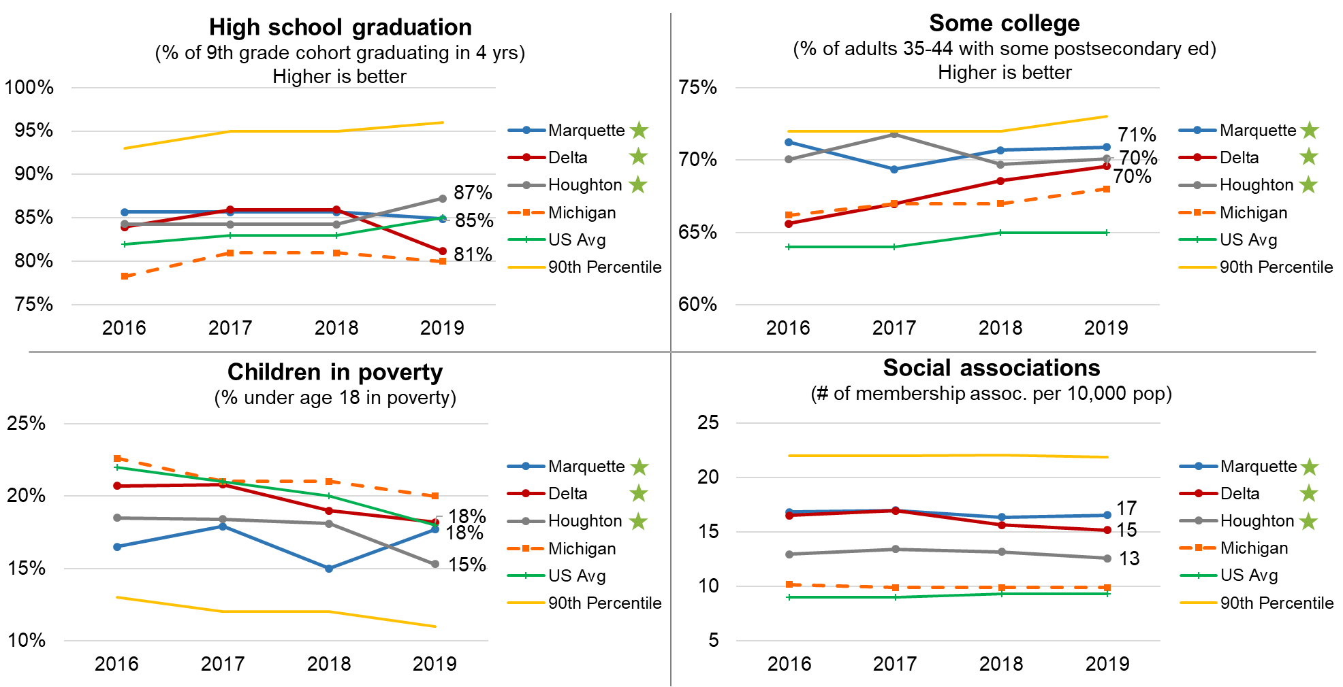
Source: High School graduation – County Health Rankings; MI Dept of Public Instruction, 2016-2017 Source: Some college - County Health Rankings; American Community Survey, 5-year estimates, 2013-2017. Source: Children in poverty - County Health Rankings; U.S. Census, Small Area Income and Poverty Estimates, 2017 Source: Social associations - County Health Rankings; County Business Patterns, 2016
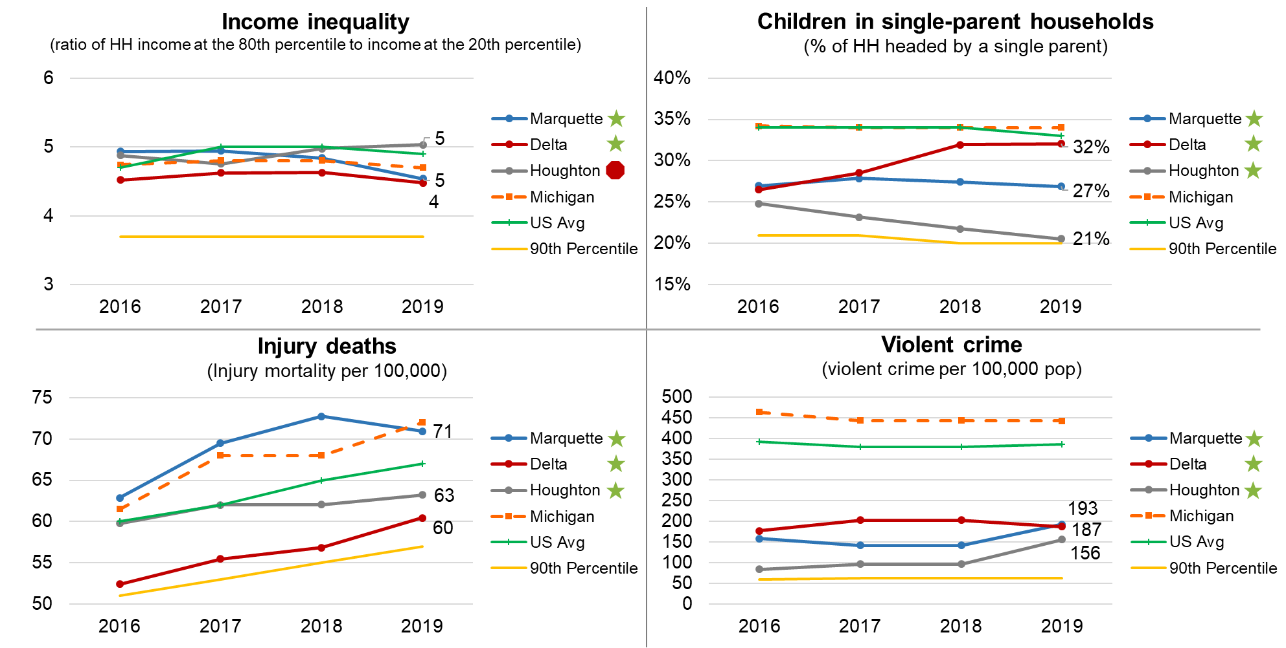
Source: Income inequality and children in single-parent households - County Health Rankings; American Community Survey, 5-year estimates 2013-2017. Source: Injury deaths – County Health Rankings; CDC WONDER mortality data, 2013-2017. Source: Violent crime - County Health Rankings; Uniform Crime Reporting – FBI, 2014 & 2016
Social and Economic Factors STRENGTHS
- High school graduation was higher in all three counties than MI at 89% and the U.S. at 85%. However, the trend is down in Delta County approaching the low MI level.
- The three counties had higher percentages of adults with some postsecondary education than MI and the U.S.
- The children in poverty rate was lower in all three counties than MI (20%) and the U.S. (18%). All three counties experienced a significant decrease since 2016 except Marquette which ticked up in the 2019 report.
- Social associations were higher in all three counties at 17, 15 and 13 memberships per 10,000 population than MI at 11 and the U.S. at 9 memberships. Associations include membership organizations such as civic organizations, bowling centers, golf clubs, fitness centers, sports organizations, religious organizations, political organizations, labor organizations, business organizations, and professional organizations.
- Income inequality represents the ratio of household income at the 80th percentile compared to income at the 20th percentile. Income inequality was lower in Marquette, and Delta Counties at 4.5 than in MI (5) and the U.S. (5).
- Injury deaths were lower in all three counties at 71, 63 and 60 deaths per 100,000 population than MI (72).
- The percentages of children in single-parent households were 27% in Marquette County, 32% in Delta County, and 21% in Houghton Counties which was lower than MI at 34% and the U.S. at 33%.
- The violent crime rate measured as violent crimes per 100,000 population were lower in all three counties than in MI at 443 and the U.S. at 386.
Social and Economic Factors OPPORTUNITIES
- Income inequality was higher in Houghton County than MI and the U.S. at 5 (ratio of household income at the 80th percentile to income at the 20th percentile).
- The median household incomes in all three counties were lower than MI $55,885 and the U.S. at $60,548.
- The poverty estimates for 2017 were higher in all three counties than MI, and Marquette and Houghton Counties poverty rates were higher than the U.S.

Physical Environment
Physical environment contains four measures in the category and accounts for 10% of the County rankings. Marquette County ranked 11th, Delta County ranked 23rd, and Houghton ranked 4th out of 83 Michigan counties in physical environment.
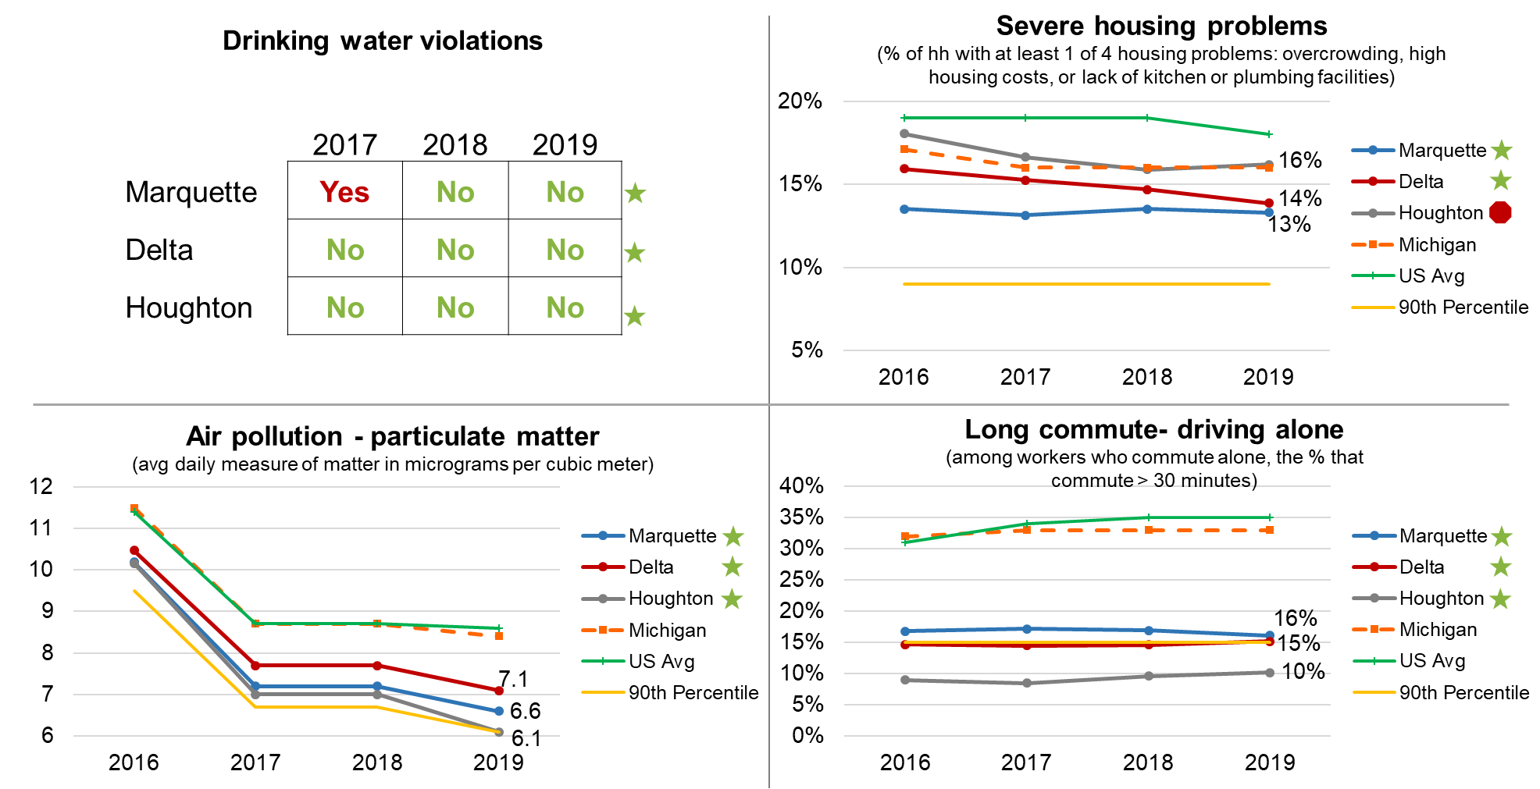
Source: Drinking water violations – County Health Rankings; EPA, Safe Drinking Water Information System, 2017. Source: Severe housing problems – County Health Rankings; HUD Comprehensive Housing Affordability Strategy data, 2011-2015. Source: Driving alone to work and long commute – County Health Rankings: American Community Survey, 5-year estimates, 2013-2017. Source: Air pollution – County Health Rankings: CDC National Environmental Health Tracking Network, 2014
Physical Environment STRENGTHS
- All three counties had no drinking water violations in the most recent year.
- Marquette and Delta Counties had a lower percentage of severe housing problems than MI and the U.S. at 13% and 14% respectively.
- Air pollution measured as the average daily measure of matter in micrograms per cubic meter was lower in all three counties than MI and the U.S.
- All three counties had low percentages of workers commuting alone and driving over 30 minutes.
Physical Environment OPPORTUNITIES
- Houghton County had slightly higher percentage of severe housing problems at 16% than MI, but lower than the U.S.
Four Broad Themes that Emerged in the Process:
- Marquette, Delta and Houghton Counties need to create a “Culture of Health” which permeates throughout the towns, employers, churches, and community organizations to engender commitment to health improvement.

- There is a direct relationship between health outcomes and affluence (income and education). Those with the lowest income and education generally have the poorest health outcomes.

- While any given measure may show an overall good picture of community health, subgroups such as the lower income census tracts may experience lower health status measures.

- It will take a partnership with a wide range of organizations and citizens pooling resources to meaningfully impact the health of the community. However, the counties have many assets to improve health.

Results of the CHNA: Community Health Summit Prioritized Health Needs, Brainstormed Goals and Actions

Prioritization Criteria
At the Community Health Summit, the attendees reviewed the community health information and used the criteria below to prioritize the health needs in the community.
Magnitude / scale of the problem | How big is the problem? How many people does the problem affect, either actually or potentially? In terms of human impact, how does it compare to other health issues?
Seriousness of Consequences | What degree of disability or premature death occurs because of this problem? What would happen if the issue were not made a priority? What is the level of burden on the community (economic, social or other)?
Feasibility | Is the problem preventable? How much change can be made? What is the community’s capacity to address it? Are there available resources to address it sustainably? What’s already being done, and is it working? What are the community’s intrinsic barriers and how big are they to overcome?

Most Significant Community Health Needs
The following needs were prioritized by attendees at the Community Health Summit. Using a nominal group technique, each attendee received three sticky notes and selected their top three health needs and posted their ideas on paper at the front of the room. The results of the activity are below with higher numbers indicating the number of “votes” or priority by topic. The bullets below the health need are many of the comments received on the sticky notes.
1.Substance Use
2.Mental Health
3 tie. Healthy eating/active living - obesity
3 tie. Access to care
5. Youth issues/Adverse Childhood Experiences (ACEs)
6. Seniors
1. Substance Use (17 sticky notes)
Substance use/abuse (10)
Substance abuse care/treatment
Drugs/vaping
More free education about drugs and alcohol for the community
Vaping and vaping in youth (2)
Smoking
Drug addiction – 1 in 3 babies born at OSF St. Francis Hospital has a drug problem
2. Mental Health (14 sticky notes)
Mental health (care) (8)
Mental health services-Psychiatric, psychological, Therapy, diagnostic specialties (2)
Behavioral health
More free education events that talk about mental health
Child mental health- psychiatrist here
Access to long-term mental health beds
3 tie. Healthy eating/active living - Obesity (7 sticky notes)
Obesity (3)
Free screening health fair days to offset the high cost for people
Unhealthy choices (e.g. inactivity, diet, substance abuse)
Inactivity, social media overload
Lack of physical activity and healthy eating
3 tie. Access to care (7 sticky notes)
Access to care – specialty services
Access to mid-level mental health
Affordable insurance
Affordability of care
Uninsured or underinsured health insurance
Collaboration and communication between providers
Transportation to providers/programs
5. Youth Issues/Adverse Childhood Experiences (5 sticky notes)
Adverse childhood experiences (2)
Social media and teens
Young children intervention to mental health
Trauma identification and programs for children
6. Senior Issues (3 sticky notes)
Alzheimer’s Disease
Dementia Care – senior care
Senior care
7. Other
Cost of housing
Community Health Summit Brainstorming
The most significant health needs coalesced into six categories. Table groups then brainstormed goals and actions for each goal along with resources and collaborators needed. The brainstorm results are below. UPHS Marquette and other community organizations can use the brainstorming when creating their plans to improve the health of the community.
Significant Health Need 1 - Substance Use
Goal 1 – Reduce prevalence of youth smoking/vaping by 25%
Action 1: Educate from elementary through college on the negative effects of smoking and vaping. Attempt to obtain lungs (or photo) from a person who had died from vaping. De-glamorize vaping.
Action 2: Community campaign to expose the public on the hazards of smoking/vaping
Resources/Collaborators Needed: School district, Health Department, Universities, Hospitals, Grants from big tobacco, health and human services
Goal 2 – Increase access to treatment for pregnant women with substance use disorders by 25% by the next community health assessment (2022)
Action 1: Incentivize PCPs to become certified as substance abuse addictionologists
Action 2: Educate on access for available PCPs and where to find them
Resources/Collaborators Needed: Hospital, grants, health department
Goal 3 – Decrease alcohol-related injuries by 25% by next community health assessment (2022)
Action 1: Partner with insurance companies to provide free rides, rate reductions
Action 2: Promote Breathalyzers available at alcohol providing establishments
Resources/Collaborators Needed: Legislative, insurance companies
Goal 4 – Increase providers who provide medically assisted treatment and carry a patient load to achieve good processes with care managers and counselors.

Significant Health Need 2 - Mental Health
Goal 1 – Recruit two child psychiatric providers to reduce impact of ACEs
Action 1: Develop a recruitment strategy and incentives
Action 2: Identify funding sources
Resources/Collaborators Needed: Foundations, UPHS Marquette and Portage
Goal 2 – Develop specific education track for mental health support staff
Action 1: Assessment of gaps in psychiatric nurses, counsellors, social workers, and other mental health support providers.
Action 2: Work with University to be part of the rural health track provision of care
Resources/Collaborators Needed: Universities and community colleges, UPHS Marquette
Goal 3 – Provide behavioral geriatric support to assisted livings and nursing homes in the counties
Action 1: Survey facilities on their needs for keeping behavioral geriatric residents
Action 2: Utilize MSU tele geriatric program
Action 3: Examine nursing home policies on medical restraints. Sometimes it is appropriate.
Resources/Collaborators Needed: MSU, grants, private investors

Significant Health Need 3 tie - Healthy eating/Active living – Obesity

Goal 1 – Educate and coach people about healthy foods and healthy cooking for adults and youth
Action 1: Provide healthy cooking classes, and how to make healthy choices
Action 2: Provide education on how to cook on a budget – seasonally
Resources/Collaborators Needed: Senior center, schools, churches, Home Economics classes, Extension, Food Co-op, schools, Head Start, Tribal organizations, dieticians, school meals
Goal 2 – Increase access to healthy food in the communities
Action 1: Expand and develop programs to distribute healthy/low cost food
Action 2: Involve restaurants in a campaign for healthy options
Resources/Collaborators Needed: Partridge Creek Farm, MQT Food coop, Feeding America, local restaurants, MCHD, UPHS, grocery stores, Co-op Extension, Salvation Army, school Power Packs, prepared food boxes, Tribal orgs.
Goal 3 – Encourage 30 min/day activity
Action 1: Community-wide prizes for community exercise
Action 2: Create a Community Health Alliance – participate in health fairs, work with workplaces, assisted living centers, create a challenge with prizes, make part of the culture
Resources/Collaborators Needed: Exercise facilities, MCHD, workplace, churches, YMCA, Northern Michigan University, biking groups, senior centers, UPHS, UPHP, BCBS, apartments senior living, schools, tribes, churches, weight watchers, Tribal organizations

Significant Health Need 3 tie - Access to Care
Goal 1 – Work collaboratively with local transportation agencies and non-profits to provide travel to and from doctor appointments
Action 1: Determine which agencies are available and available volunteers
Action 2: Determine how to communicate resources
Resources/Collaborators Needed: Vehicles, drivers, community action agencies, non-profits
Goal 2 – Encourage medical provider collaboration with scheduling appointments from offices and ancillary services on same day or time frame so patients can receive services together and reduce travel
Action 1: Coordinate appointments with all other services via case management or scheduling coordinators
Resources/Collaborators Needed: Case management, central scheduling
Goal 3 – Improve IT infrastructure so systems can talk to each other and visit notes can be shared and providers can follow patients through their care journey. Creates comprehensive collaboration between specialists/primary care and hospitals/clinics to improve health access. Coordination and collaboration reduces travel to appointments and reduces delays in receiving answers. Improve telehealth usage.
Action 1: Perform an IT needs assessment to determine changes needed
Action 2: Perform an IT telehealth assessment to determine which services are most needed, most utilized and in which areas
Action 3: Determine reimbursement for telehealth and work to improve
Resources/Collaborators Needed: Local IT companies, hospitals/clinical IT departments

Significant Health Need 5 - Youth Issues/Adverse Childhood Experiences
Goal 1 – Increase screening for Adverse Childhood Experiences (ACEs)
Action 1: Create an awareness campaign targeted for the three counties to increase awareness of ACEs. Media linkage, PSAs, medical community support for screenings.
Action 2: Create a centralized place to refer families and identified children with ACEs for referral and tracking
Action 3: Create a directory of linkages from screenings to interventions. Formulate an ACEs 211 guide for practical health and assistance.
Goal 2 – Develop coordinated interventions for ACEs
Action 1: Reinforce family values and character development
Action 2: Find funding sources for the development of interventions for ACEs
Resources/Collaborators Needed: schools, churches resources, curriculum, parenting classes, outreach support, BCBS, foundations – what programs will be supported to be an interventions? State, family
Goal 3 – Support ACEs in schools
Action 1: Develop high school curriculum reaching kids “7 good seconds” approach to connecting with kids
Action 2: Connect ACEs to behavioral acting out – stop the triggers to vaping, bullying, social media

Significant Health Need 6 - Senior Issues
Goal 1 – Establish a specialized facility to care for senior patients with mental health/dementia disease by 2024
Action 1: Increase number of training events for community members and health care workers
Action 2: Recruit trained individuals to work in the facility
Goals 2 – Establish reliable, consistent transportation system for seniors by 2021 (Increase access to services)
Action 1: Grow network of volunteers to provide transportation especially in winter
Action 2: Enhance bus service (i.e. Room at the Inn) to/from senior events
Action 3: Recruit from the college population to assist with transportation
Goal 3 – Provide extensive community education about senior needs and resources for care by 2021
Action 1: Public forums at churches, senior centers, radio, public TV to educate
Action 2: Recruit qualified experts to educate the community (families, patients, providers)
Action 3: Develop a workforce that wants to provide assistance to seniors
Resources/Collaborators Needed: CMH, SNFs, UPCAP, UPHP, hospitals

Impact of 2016 CHNA and Implementation Plan

In 2016, the Marquette, Delta and Houghton Counties, Michigan communities prioritized the following health needs:
- Obesity/Nutrition and Activity
- Substance Abuse
- Mental/Behavioral Health
- Children and Family Issues
- Access
- Socioeconomics/poverty
- Miscellaneous

Based on the results of the previous CHNA conducted in 2016, UP Health System Marquette (UPHS Marquette) selected two (2) of the identified significant health needs to address for the 3-year period beginning in 2016. The initiatives are listed below, along with a summary of the actions taken and the most current status.
1. Behavioral Health
2. Access to Care

Behavioral Health: Mental Health and Substance Use Actions to meet the needs
1. Initiate an intensive recruitment campaign for psychiatrists
UPHS Marquette provider recruitment services have identified 4 psychiatrist candidates since 2016. In the interview and site visit processes, it became clear that providers in such high demand are not willing to provide inpatient services or be on call, which would be a significant requirement for our behavioral health providers. For this reason, UPHS Marquette has not yet been successful in recruiting additional psychiatrists to meet the community's needs.
In response to the above, UPHS Marquette has initiated a new psychiatric residency program in collaboration with Michigan State University’s College of Human Medicine – rural campus program, which will begin in summer of 2020 with 1 resident physician starting in July, followed by another 2 resident physicians starting in September. Terms of the residency require these providers to work and serve in a designated rural community for at least 2 years after graduating.
2. Collaborate with local and regional agencies to improve community awareness of behavioral health resources through marketing initiatives (UPHSM website can list resources)
UPHS Marquette has partnered with the National Alliance for Mental Illness - Alger/Marquette as a major sponsor for their NAMI Walks in 2018 and 2019. These events have raised over $40,000 to increase awareness for mental illness and support the community resources available for those with mental illnesses.
3. Participate in community collaboratives such as the suicide prevention committee, the mental health advisory committee Status
UPHS Marquette partnered with Henry Ford Health System's "Zero Suicide" initiative in May 2019 to bring guest speaker Dr. Brian Ahmedani to Marquette. Dr. Ahmedani delivered lectures to both UPHS medical providers, targeting primary care and pediatricians, as well as the community on how to identify the signs that someone is considering suicide and how to successfully intervene. Since implementing their Zero Suicide initiative amongst all their providers, Henry Ford Health System has seen a drastic decline in suicide deaths among their existing patient population.
Marquette's local mental health advisory committee, a group made up of law enforcement, corrections, health departments, citizens, community mental health agencies, community resource agencies, and healthcare workers meet quarterly to discuss initiatives and are hosted by UPHS Marquette.
4. Increase the number of Substance Use group therapy opportunities in the Outpatient clinic
Currently, the number of substance use group therapy sessions in an outpatient setting has not increased, as we have seen the departure of several social workers qualified to conduct these meetings. UPHS Marquette is actively recruiting to replace these social workers and expand the number of group therapy sessions available in the outpatient setting.
To offset the patient load in psychiatry and addiction medicine, family medicine physicians in the Marquette clinic; Katrina Brang, MD, Ryan Brang, MD, and Lisa Long, MD have obtained waivers to prescribe and administer suboxone to any patient in their existing panel who has been diagnosed with opioid use disorder.
UPHS Marquette hosts monthly Narcotics Anonymous meetings at their facility.
5. Collaborate with local and regional primary care offices to integrate behavioral health services in the primary care setting
Michigan State University has received a grant to expand their MC3 program in Marquette, which provides a pediatric counselor from Pathways, our CMH agency, who will be available to see whichever patients our pediatricians deems necessary of an assessment and/or counseling services.
Michigan State University also received a grant to improve the treatment of opioid use disorders in Marquette. Provisions include a counselor embedded 2 days a week in Marquette’s family medicine residency office. Primary care providers from Marquette can refer directly to the counselor, who would then refer to the CMH agency, Pathways, if necessary. Both of these programs will begin in January 2020.
6. Utilize telehealth when possible to reduce the transportation burden of patients
UPHS Marquette has been utilizing tele-psych services for many years and continues to offer provider-patient visits via telehealth to patients across the Upper Peninsula whenever necessary and possible.
7. Complete a long-range strategy to address access to inpatient and outpatient specialty care
A contract is in place with Michigan State University to supply UPHS Marquette with more behavioral health providers available for tele-psych visits with UP patients as soon as they have the resources available.
8. Teaching rotation for nursing, social work and medical students to educate on the care of those with mental illness
UPHS Marquette has in place rotations for nursing students, social workers and medical students to round with appropriate professionals in the behavioral health settings. This rotation is offered to students from all UP colleges, except for Lake Superior State University.

Access to Care
UP Health System Marquette met the significant health need by:
1. The actions the hospital facility intended to take to address the significant health need
a. UPHS – Marquette has identified recruiting and retention of medical staff as our top priority. We are currently recruiting the following specialties: Cardiology, Endocrinology, Family Medicine, Gastroenterology, General Surgery, Infectious Disease, Internal Medicine, Neonatology, Nephrology, Neurology, Neurosurgery, Hematology/Oncology, Orthopaedics, Plastic Surgery, Pediatrics, Physical Medicine & Rehab, Psychiatry, Psychology, Pulmonary Medicine, Critical Care Medicine, Rheumatology and Urology.
An additional 28 providers have been recruited and retained to increase the number of providers available in areas including; anesthesia, bariatric surgery, radiation oncology, CVT surgery, cardiology, pediatric cardiology, emergency medicine, family medicine, pediatrics, interventional radiology, orthopedic surgery, podiatry and wound care.
A full-time sourcing position was added to UP Health System’s provider recruitment team in 2017, effectively doubling Marquette’s manpower for the recruitment of new providers.
A separate recruitment web page was added, WorkAtUPHS.com, which is dedicated to targeting and attracting talent interested in health care positions within our system.
A state-of-the-art new UPHS Marquette facility was completed in 2019, which is a tremendous asset to our community and a significant recruitment tool.
b. UP Health System has partnered with LifePoint Health to create a Clinically Integrated Network (CIN) in the Upper Peninsula. In its simplest implementation, a CIN is a collection of healthcare providers, such as physicians, hospitals, and post-acute care treatment providers, that come together to improve patient care and reduce overall healthcare costs. CINs rely on evidence-based care guidelines to provide high-quality care across participating providers including:
i. Prevention Strategies
ii. Acute Treatment
iii. Ongoing condition maintenance
AdvantagePoint Health Alliance, Great Lakes chapter was created by LifePoint to coordinate a local Clinically Integrated Network (AC0). A dedicated full-time position was created to coordinate and recruit practices for the CIN. Currently, the Great Lakes chapter includes more than 35 practices across the UP, representing over 35 unique specialties and subspecialties.

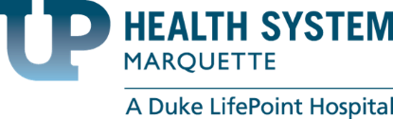
Completed by UP Health System Marquette in partnership with:
Stratasan
Community Health Needs Assessment
for Marquette, Delta and Houghton Counties

Appendix

Community Assets and Inventories
Marquette County
Delta County
Houghton County

Marquette County, MI
2019 Community Asset Inventory
Community Health Needs Assessment
UP Health System - Marquette

Geography
Cities
Cities
Ishpeming
Marquette (county seat)
Negaunee

Census-designated places
Big Bay
Gwinn
Harvey (originally named Harvey Gardens)
KI Sawyer AFB
Michigamme
Palmer
Republic
Trowbridge Park
West Ishpeming

Unincorporated communities
Alder
Antlers
Arnold
Beaver Grove
Birch
Brookton Corners
Carlshend
Clarksburg
Dukes (originally named Lehtola)
Eagle Mills
Empire Iron Mine
Gordon
Green Garden
Greenwood (originally named Greenwood Furnace)
Homeier
Huron Mountain
Lakewood
Lawson
Little Lake (originally named Cheshire Junction then Forsyth (1877-1966)
Maple Grove
McFarland
Midway Location
National Mine
North Lake
Northland
Sand River
Selma
Snowville
South Greenwood
South Republic
Suomi Location
Vick
Witch Lake

Townships
Champion Township
Chocolay Charter Township
Ely Township
Ewing Township
Forsyth Township
Humboldt Township
Ishpeming Township
Marquette Township
Michigamme Township
Negaunee Township
Powell Township
Republic Township
Richmond Township
Sands Township
Skandia Township
Tilden Township
Turin Township
Wells Township
West Branch Township

Transportation
Sawyer International Airport
125 Ave G
Gwinn, MI 49841

Major Highways:
US 41
M-28
M-35
M-94
M-95
M-553

Media
AM Radio
WZAM | 970 AM | Ishpeming, MI
WIAN | 1240 AM | Ishpeming, MI

FM Radio
WUPZ | 94.9 FM | Chocolay Township, MI
WUPT | 100.3 FM | Gwinn, MI
WJPD | 92.3 FM | Ishpeming, MI
W248BU | 97.5 FM | Ishpeming, MI
WMQT | 107.7 FM | Ishpeming, MI
WNMU | 90.1 FM | Marquette, MI
WUPX | 91.5 FM | Marquette, MI
W227CJ | 93.3 FM | Marquette, MI
WUPK | 94.1 FM | Marquette, MI
WHWL | 95.7 FM | Marquette, MI
WFXD | 103.3 FM | Marquette, MI
WNOA | 103.9 FM | Marquette, MI
W286BC | 105.1 FM | Marquette, MI
W291CJ | 106.1 FM | Marquette, MI
WDMJ | 1320 AM | Marquette, MI
WSHN | 89.3 FM | Munising, MI
WKQS | 101.9 FM | Negaunee, MI
WRUP | 98.3 FM | Palmer, MI
WUPG | 96.7 FM | Republic, MI

Newspaper
The Mining Journal
249 W Washington St
Marquette, MI 49855

Government
County Department Phone Numbers
Administrator's Office | (906) 225-8151
Aging Services | (906) 315-2658
Airport - Sawyer | (906) 346-3308
Board of Commissioners | (906) 225-8151
Central Dispatch | (906) 475-9912
Circuit Court | (906) 225-8209
Judge - North Chamber | (906) 225-8205
Judge - South Chamber | (906) 225-8217
Probation/Parole | (906) 225-8224
County Clerk | (906) 225-8330
Department of Human Services | (906) 228-9691
District Court Marquette | (906) 225-8235
District Court Ishpeming | (906) 485-5579
District Court Bailiff/Scheduling Clerk | (906) 225-8234
District Court- Jury Duty | (906) 225-8233
Marquette - Probation | (906) 225-8250
Ishpeming - Probation | (906) 485-5594
Drain Commissioner | (906) 458-9118
Equalization-Tax Administration | (906) 225-8410
Finance | (906) 225-8175
Friend of the Court | (906) 225-8262
Health Department Administration | (906) 475-9977
Clinical Services | (906) 475-7844
Environmental Health | (906) 475-4195
Community Health Services | (906) 475-7848
Human Resources | (906) 225-8162
Humane Society | (906) 475-6661
Information Systems | (906) 225-8170
Juvenile Court Clerk | (906) 225-8300
KI Sawyer Development | (906) 346-3137
MSU Extension | (906) 475-5731
Marq-Tran | (906) 225-1112
Mine Inspector | (906) 485-1392
Perkins Park | (906) 345-9353
Probate Court Clerk | (906) 225-8300
Probate Court Jury Duty | (906) 225-8298
Prosecutor's Office | (906) 225-8310
Family Support | (906) 226-4990
Register of Deeds | (906) 225-8415
Resource Management | (906) 225-8180
Retired Senior Volunteer Program | (906) 315-2607
Road Commission - Main Office | (906) 486-4491
Sheriff's Office - Administration | (906) 225-8435
Sheriff's Office - Emergency Services | (906) 346-4045
Treasurer's Office | (906) 225-8425
Veterans Affairs | (906) 485-1996

County Board of Commissioners
District 1- John Depetro
District 2- Joseph Derocha (Vice-Chair)
District 3- Stephen Adamini
District 4- Gerald Corkin (Chair)
District 5- Bill Nordeen
District 6- Karen Alholm

Elected County Officials
County Clerk: Linda Talsma
County Treasurer: Anne Giroux
Drain Commissioner: P. Michael Farrell
Mine Inspector: John Carlson
Prosecutor: Matt J. Wiese
Register of Deeds: Carla L'Huillier
Sheriff: Gregory S. Zyburt

Major Employers
UP Health System – Marquette
Cliffs Natural Resources, Michigan Operations
Peninsula Medical Center
UP Health System – Bell
Wal*Mart
RTI Surgical
American Eagle Regional Aircraft Maintenance Facility
Eagle Mine
Westwood Mall Association
Eastwood Nursing Center
Alger-Marquette County Community Action Board
Norlite Nursing Center
Ojibwa Casino II
WE Energies
Superior Extrusion, Inc.
Potlatch
Pathways

Public Employers:
Northern Michigan University
Marquette Area Public Schools
Michigan Department of Corrections
County of Marquette
Negaunee Public Schools
D.J. Jacobetti Home for Veterans
City of Marquette
N.I.C.E Public Schools
Gwinn Area Community Schools
Ishpeming Public Schools
Northern Michigan University

Public Safety
Police
Forsyth Township Police Department
99 N Pine St
Gwinn, MI 49841

Chocolay Township Police Department
5010 US-41
Marquette, MI 49855

Marquette Police Department
300 W Baraga Ave
Marquette, MI 49855

NMU Police Department
HH8V+PF Marquette
Marquette Township, MI

Negaunee City Police Department
319 W Case St
Negaunee, MI 49866

Ishpeming Twp Police Department
1575 US-41
Ishpeming, MI 49849

Fire
Chocolay Township Fire Department
5010 US-41
Marquette, MI 49855

Marquette Fire Department
418 S 3rd St
Marquette, MI 49855

Marquette Fire Department
723 N Front St
Marquette, MI 49855

Fire Safety Office
1504 W Washington St # B
Marquette, MI 49855

Ishpeming Fire Department
100 E Division St
Ishpeming, MI 49849

Negaunee Fire Department
200 S Pioneer Ave
Negaunee, MI 49866

Richmond Twp Fire Department
510 Nicholas Ave
Negaunee, MI 49866

EMS Ambulance Services
Ishpeming Ambulance Services
100 E Division St
Ishpeming, MI 49849

Richmond Twp EMS
510 Nicholas Ave
Palmer, MI 49871

Marquette County Central Dispatch
180 US 41 East
Negaunee, MI 49866

Healthcare
Hospitals
UP Health System – Marquette
850 W Baraga Ave
Marquette, MI 49855

Bell Hospital
901 Lakeshore Dr.
Ishpeming, MI 49849

Upper Peninsula Medical Center
1414 W Fair Ave
Marquette, MI 49855

Health Department
Marquette County Health Department
184 US-41
Negaunee, MI 49866

Dentists
My Community Dental Centers- Marquette
989 W Washington St
Marquette, MI 49855

906 Family Dentistry
125 N Pansy St
Ishpeming, MI 49849

Richard A Peura, DDS
708 Chippewa Sq Ste 1
Marquette, MI 49855

James Vanlandschoot DDS
760 W Washington St
Marquette, MI 49855

Paul T Zhulkie DDS Inc
801 N 3rd St
Marquette, MI 49855

Donn G Kipka DDS
1010 N 3rd St
Marquette, MI 49855

Paul C Gerrish DDS PC
2336 US Highway 41 S
Marquette, MI 49855

Dental Center PLLC
1550 Commerce Dr
Marquette, MI 49855

Collins & Gould
100 Croix St
Negaunee, MI 49866

Micklow, Susan L DDS MS PC
101 S Front St Ste 505
Marquette, MI 49855

Michael Orhanen DDS
1029 Lincoln Ave Ste B
Marquette, MI 49855

Peter Lafrinere DR
200 Marquette St
Negaunee, MI 49866

James D Jackson DDS
101 S Front St Ste 201
Marquette, MI 49855

Carla Skaates DDS
1320 W Ridge St
Marquette, MI 49855

Stephen R Wissler DDS PC
1055 W Fair Ave
Marquette, MI 49855

Pinkard J Scott
1029 Lincoln Ave Ste 2
Marquette, MI 49855

Wright Street Dental
3135 Wright St
Marquette, MI 49855

Herbert C Remien DDS
1720 US Highway 41 W
Ishpeming, MI 49849

Northern Trails Dental Center
271 E State Highway M35
Gwinn, MI 49841

Peter G Kelly DDS PC
101 S Front St Ste 509
Marquette, MI 49855

PM Belpedio DDS
801 N 3rd St
Marquette, MI 49855

James L Savera DDS
101 S Front St Ste 401
Marquette, MI 49855

Bruce D Miller DDS
301 W Magnetic St
Marquette, MI 49855

Gary Asano DDS MS PC
1055 W Fair Ave
Marquette, MI 49855

Bruce J Pablov DDS
1101 Lincoln Ave
Marquette, MI 49855

Dental Implant Center
1029 Lincoln Ave Ste 2
Marquette, MI 49855

Clinics
Sage Premiere HealthCare
2250 US Highway 41 S
Marquette, MI 49855

Marquette Medical Clinic-Sawyer
301 Explorer St
Gwinn, MI 49841
(906) 346-3837

UP Health System - Lakewood Family Medicine
5089 US-41
Marquette, MI 49855

Marquette General Family Medicine
089 US-41
Marquette, MI 49855

Denali Healthcare
200 Van Epps St
Harvey, MI 49855

Singletrack Health
107 Main St Suite #2
Marquette, MI 49855

Dr. Gregory Sulik, MD
150 W Ridge St
Marquette, MI 49855

Superior Walk-In Center
1414 W Fair Ave #134
Marquette, MI 49855

UP Health System - Marquette Family Medicine
1414 W Fair Ave
Marquette, MI 49855

UP Health System - Marquette Behavioral Health
580 W College Ave
Marquette, MI 49855

UP Health System - Marquette Radiology
420 W Magnetic St
Marquette, MI 49855

Upper Great Lakes Sawyer Family Health Center
301 Explorer St
Gwinn, MI 49841

Twin Cities Medical Clinic
100 Malton Rd #6
Negaunee, MI 49866

Bell Medical-Ishpeming Medical
100 Malton Rd # 1
Negaunee, MI 49866

Stevens Hardie Family Practice
107 Main St
Marquette, MI 49855

Long-term Care and Assisted Living
Marquette County Medical Care Facility
200 Saginaw St
Ishpeming, MI 49849

Teal Lake Senior Living Community
290 W Water St
Negaunee, MI 49866

Eastwood Nursing Center Inc
900 Maas St
Negaunee, MI 49866

Pam's Adult Foster Care Home
1111 W Little Shag Lake Rd
Gwinn, MI 49841

Jensen Case Management, LLC
769 Lakewood Ln
Marquette, MI 49855

Brookridge Heights
1901 Division St
Marquette, MI 49855

Adult Learning Systems
607 W Spring St
Marquette, MI 49855

Sundara Non-Profit Housing
401 Lincoln Ave
Marquette, MI 49855

Mill Creek Assisted Living
1600 Mill Creek
Marquette, MI 49855

Home Health and Hospice
UP Home Health & Hospice- Marquette
1125 W Ridge St
Marquette, MI 49855

UP Home Health & Hospice- Ishpeming
510 Mather Ave
Ishpeming, MI 49849

Trillium Hospice House - Central UP Hospice Care
1144 Northland Dr
Marquette, MI 49855

Lake Superior Life Care & Hospice
914 W Baraga Ave
Marquette, MI 49855

Peace of Mind Home Care
29905 Co Rd 581
Ishpeming, MI 49849

Acti-Kare Responsive In-Home Care of Upper Michigan
US-41
Marquette, MI 49855

Upper Peninsula Home Health
1125 W Ridge St
Marquette, MI 49855

UPCAP Services
1025 Commerce Dr b
Marquette, MI 49855

Arcadia Home Care & Staffing
2292 US 41 West #6
Marquette, MI 49855

Parallel Home Care Services
1600 Mill Creek
Marquette, MI 49855

Apria Healthcare
989 W Washington St Ste 105
Marquette, MI 49855

Behavioral and Addiction Services
UP Health System - Marquette Behavioral Health
580 W College Ave
Marquette, MI 49855

Great Lakes Recovery Center- Ishpeming Outpatient Services
97 S 4th St
Ishpeming, MI 49849
Great Lakes Recovery Centers - Marquette Outpatient Services
1009 W Ridge St
Marquette, MI 49855

Great Lakes Recovery Centers - Adult Residential Services
241 Wright St
Marquette, MI 49855

Great Lakes Recovery Centers - Adolescent Services Center
104 Malton Rd
Negaunee, MI 49866

Marquette Electrolysis
325 Erickson St
Marquette, MI 49855

Pathways Community Mental Health
200 W Spring St
Marquette, MI 49855

Marriage & Family Counselors
30 County Rd 510
Negaunee, MI 49866

Joni Peffers Counseling Office
301 Explorer St
Gwinn, MI 49841

Fran S. Waters Counseling & Training
706 Chippewa Sq Ste 205-A
Marquette, MI 49855

Durable Medical Equipment
Agiliti
912 Co Rd 480
Marquette, MI 49855

Great Lakes Home Medical Inc
256 US-41
Negaunee, MI 49866

National Seating & Mobility
2612 US-41
Marquette, MI 49855

Beltone Skoric Hearing Aid Center LLC
925 W Washington St
Marquette, MI 49855

RTI Surgical
375 River Park Cir
Marquette, MI 49855

Baxter Healthcare
175 Hawley St
Marquette, MI 49855

Other
UP Rehab Services UP Health System- Marquette
America Mall Building, 555 County Rd Hq #200
Marquette, MI 49855

UP Diabetes Outreach Network
1025 Commerce Dr Suite B
Marquette, MI 49855

UP Health System - Marquette Radiology
420 W Magnetic St
Marquette, MI 49855

The Lighthouse at Ishpeming
435 Rd PI
Ishpeming, MI 49849

MGHS Imaging Center
1414 W Fair Ave #232
Marquette, MI 49855

UPHS - Marquette Heart and Vascular
850 W Baraga Ave
Marquette, MI 49855

Marquette Orthopedic & Sports Therapy
841 W Washington St
Marquette, MI 49855

Hotlines
Local Hotlines
Bell Behavioral Services
(906) 249-9002
Catholic Social Services
(906) 227-9119
Great Lakes Recovery Centers
Marquette - (906) 228-6545
Sawyer - (906) 346-7410
Pathways to Healthy Living
(906) 228-2572
Harbor House Domestic Violence Shelter
(906) 226-6611 or 1-800-455-6611
Women's Center
(906) 225-1346
Michigan Protection & Advocacy
(906) 228-5910
National Hotlines
Emergency
911
National Suicide Prevention Lifeline
800-273-TALK or 800-237-8255
National Runaway Safe line
1-800-RUNAWAY
National Centers for Disease Control
1-800-232-4636
Gay, Lesbian, Bisexual and Transgender National Hotline
1-888-843-4564
HIPS Hotline
1-800-676-HIPS
National Sexually Transmitted Disease Hotline
1-800-227-8922
Women Alive
1-800-554-4876
AIDS Info
1-800-HIV-0440
Project Inform
1-800-822-7422
DMRS Investigations
1-888-633-1313
Mobile Crisis
1-800-681-7444
Domestic Violence
1-800-356-6767
Spanish Domestic Violence Hotline Number
1-800-942-6908
Poison Control Center
1-800-222-1222
Veterans Crisis Line
800-273-8255 Press 1
National Youth Crisis Hotline
800-442-HOPE (4673)
National Missing Children Hotline
1-800-235-3535
National Sexual Assault Hotline
1-800-656-4673
Alcohol Hotline
1-800-331-2900
Alcohol Treatment Referral Hotline
1-800-252-6465
National Drug Abuse Hotline
1-800-662-4357
Poison Control
1-800-942-5969
National Homeless Hotline
1-800-231-6946
National Elder Abuse Hotline
1-800-252-8966

Community, Civic, Non-Profit Organizations
Basic Needs Assistance
Paw Packs
PO Box 655
Gwinn, MI 49841

Room at the Inn
347 Rock St
Marquette, MI 49855

The New Free Store
1420 M-28 East
Marquette, MI 49855

Slow Food USA
PO Box 1004
Marquette, MI 49855

Housing
Habitat for Humanity International Inc
PO Box 213
Marquette, MI 49855

Women’s Services
Care Clinic
1213 N 3rd St
Marquette, MI 49855

Pregnancy Services of Marquette Inc
1213 N 3rd St
Marquette, MI 49855

Sawyer Care Clinic
330 Fortress St
Gwinn, MI 49841

Children and Youth Organizations
YMCA of Marquette County
1420 Pine St
Marquette, MI 49855

Association for Little Friends Inc
1025 Maas St
Negaunee, MI 49866

Community Coordinated Child Care Association of the Upper Peninsula
104 Coles Dr Ste F
Marquette, MI 49855

Lake Superior Village Youth and Family Center
712 Chippewa Sq Ste 200
Marquette, MI 49855

Upper Peninsula Children’s Museum Inc
123 W Baraga Ave
Marquette, MI 49855

906 Adventure Team
148 W Hewitt Ave
Marquette, MI 49855

Articatz Volleyball Club
1680 County Road 492
Marquette, MI 49855

Great Lakes Rodeo of Michigan
341 Mottes Ln
Gwinn, MI 49841

Revolutions
PO Box 1002
Marquette, MI 49855

Star Children’s Bereavement Services Inc
3007 State Highway M28 E
Marquette, MI 49855

Start the Cycle
PO Box 815
Marquette, MI 49855

Chief Lake Wilderness Youth Camp Inc
1067 Blackbird Ln
Republic, MI 49879

Grow & Lead - Community and Youth Development
712 Chippewa Squaresuite 200
Marquette, MI 49855

Lake Superior Village Youth and Family Center
712 Chippewa Sq Ste 200
Marquette, MI 49855

Republic Community Services and Youth Organizations
PO Box 265
Republic, MI 49879

Superior Arts Youth Theater
PO Box 741
Marquette, MI 49855

Community Service Organizations
American Association of University Women
617 W Hampton St
Marquette, MI 49855

American-Italian Societies
605 Lakeshore Dr Apt 4
Ishpeming, MI 49849

Big Bay Sportsman’s Club Inc
PO Box 185
Big Bay, MI 49808

Buzz the Gut Inc
2344 County Road 496
Ishpeming, MI 49849

Chocolay Woods Condominium Association
121 Wintergreen Trl
Marquette, MI 49855

Circle K International Inc
PO Box 63
Marquette, MI 49855

Citizens United for Better Schools - Marquette
200 Birchridge Dr
Marquette, MI 49855

Disabled American Veterans
1787 County Road 492
Marquette, MI 49855

Disabled American Veterans Auxiliary Inc
811 W Magnetic St
Marquette, MI 49855

Grand Marais Commercial Fishermen’s Memorial
124 Wintergreen Trl
Marquette, MI 49855

Hiawatha Trails Inc
121 Deerview Rd
Marquette, MI 49855

International Association of Lions Clubs
29 Stonegate Hts
Marquette, MI 49855

International Association of Lions Clubs
435 Blemhuber Ave
Marquette, MI 49855

International Association of Lions Clubs
469 Liberator St
Gwinn, MI 49841

International Association of Lions Clubs
637 N 5Th St
Ishpeming, MI 49849

International Association of Lions Clubs
PO Box 307
Ishpeming, MI 49849

Irontown USA Negaunee MI USA
PO Box 128
Negaunee, MI 49866

Ishpeming Independence Day Inc
PO Box 173
Ishpeming, MI 49849

Ishpeming Rock & Mineral Club Inc
PO Box 102
Ishpeming, MI 49849

Ishpeming Ski Club Inc
PO Box 127
Ishpeming, MI 49849

Key Club International
319 E Division St
Ishpeming, MI 49849

Ki Sawyer Lions Club
Box 308
Gwinn, MI 49841

Kiwanis International
P.O. Box 563
Marquette, MI 49855

Lake Arfelin Landowners Association
1885 Cindy St
Ishpeming, MI 49849

Lake Michigamme Property Owners Inc
PO Box 137
Michigamme, MI 49861

Lambda Uplison Zeta Housing Corp Lambda Chi Alpha House
PO Box 811
Marquette, MI 49855

Lions International Marquette Lions Club
360 W Crescent St
Marquette, MI 49855

Marine Corps League
9687 Us Highway 41
Champion, MI 49814

Marquette Alano Club Inc
1202 S Front St
Marquette, MI 49855

Marquette Country Recreational Trails Inc
311 W Main St
Marquette, MI 49855

Michigamme Museum 1900 Steamer Fund
262 Orange Rd
Michigamme, MI 49861

Michigan Council of Resource Conservation and Development Areas
129 W Baraga Ave Ste F
Marquette, MI 49855

Michigan North Woods Club
64500 County Road 581
Ishpeming, MI 49849

Middle Island Point Campers Association
57 Middle Island Point Rd
Marquette, MI 49855

Moose Country Sno-Mobile Club
PO Box 453
Republic, MI 49879

National Exchange Club
221 Timber Ln
Marquette, MI 49855

Operation Action-Up
501 S Front St
Marquette, MI 49855

Range Mountain Bike Association
1000 Country Ln Ste 100
Ishpeming, MI 49849

Republic Sportsperson Club Inc
6958 County Road 601
Republic, MI 49879

Rotary Club of Ishpeming
PO Box 217
Ishpeming, MI 49849

Rotary International
PO Box 383
Marquette, MI 49855

Shiras Institute
C/O Kendricks Bordeau 128 W Spring
Marquette, MI 49855

Upper Peninsula Coalition for Women’s Rights
PO Box 7005
Marquette, MI 49855

Upper Peninsula Health Plan Inc
228 W Washington St
Marquette, MI 49855

Upper Peninsula North Country All- Terrain Vehicle Riders Association
2116 Washington Ave
Ishpeming, MI 49849

Upper Peninsula Road Runners Club
PO Box 1023
Marquette, MI 49855

UPSDA Inc
PO Box 15
Marquette, MI 49855

West Branch Sportsmen’s Club
1888 Engman Lake Road
Skandia, MI 49885

Wood View Estates Condominium Association
PO Box 81
Gwinn, MI 49841

Zonta International
PO Box 1052
Marquette, MI 49855

Cultural, Ethnic Awareness
American Indian Coordinating Council Inc
333 Old Little Lake Road
Marquette, MI 49855

Ishpeming Italian Heritage Society
102 W Euclid St
Ishpeming, MI 49849

Economic Development Organizations
Accelerate Up
153 W Washington St Ste A
Marquette, MI 49855

Invest Up
857 W Washington St Ste 301
Marquette, MI 49855

Upper Peninsula Certified Development Company
1401 Presque Isle Ave Ste 202 Nmu J
Marquette, MI 49855

Economic Club of Marquette County
412 W Washington St
Marquette, MI 49855

Foundations
Ancient American Artifact Preservation Foundation
Co Rd 553
Gwinn, MI 49841

Anna Sun Foundation
PO Box 131
Negaunee, MI 49866

Artists of Aquarius Foundation
315 S First Street Num 252
Ishpeming, MI 49849

Bash Family Foundation Inc
1507 Lynn Ave
Marquette, MI 49855

Grant Henriksen Memorial Foundation
117 Dandelion Ln
Marquette, MI 49855

International Foundation for the Tutoring Profession
13 Specker Cir
Marquette, MI 49855

Iron Mountain Public School Scholarship Foundation
1502 W Washington St
Marquette, MI 49855

Lake Superior Community Partnership Foundation
501 S Front St
Marquette, MI 49855

Lg Kaufman Endowment Foundation
First Bank 1502 W Washington
Marquette, MI 49855

Marquette Area Public Schools Educational Foundation
1201 W Fair Ave
Marquette, MI 49855

Marquette Community Foundation
250 N McClellan Avenue Suite B
Marquette, MI 49855

Marquette West Rotary Foundation
PO Box 383
Marquette, MI 49855

Michigan Parkinson Foundation
410 Jackson St
Negaunee, MI 49866

Nelson D Rupp Foundation
PO Box 771
Marquette, MI 49855

New Attitudes Foundation
305 E Arch St
Marquette, MI 49855

Phyllis and Max Reynolds Foundation Inc
Range Bank 100 N Front Street
Marquette, MI 49855

Ray & Peg Hirvonen Charitable Foundation
451 Lakewood Ln
Marquette, MI 49855

Ronalds Hope-The Ronald Grant Pierce Foundation
421 N Main St
Ishpeming, MI 49849

Smith Mountain Foundation Inc
8030 Bayview Ln
Republic, MI 49879

Springs of Hope Foundation Inc
3916 Squaw Beach Rd
Big Bay, MI 49808

Superior Health Foundation
121 N Front St
Marquette, MI 49855

Superior Medical Research Foundation
2645 W Grove St
Marquette, MI 49855

Sylarn Foundation
128 W Spring St
Marquette, MI 49855

The Northern Michigan University Foundation
1401 Presque Isle Ave
Marquette, MI 49855

Tourville Foundation
380 Meeske Ave
Marquette, MI 49855

Upper Peninsula Catholic Foundation Inc
1004 Harbor Hills Dr
Marquette, MI 49855

Upper Peninsula Health Foundation Inc
853 W Washington St
Marquette, MI 49855

Wesearch Foundation
1805 Harbour View Dr
Marquette, MI 49855

Western Marquette County Health Foundation
910 Us 41 West
Ishpeming, MI 49849

Windfall Foundation
128 W Spring St
Marquette, MI 49855

Life Skills/Job Training
Michigan Works
1498 O’Dovero Drive
Marquette, MI 49855

Non- Emergency Transport Services
UPHP Transportation Department
1-800-835-2556

Outreach Ministries
Life Outreach Center
PO Box 563
Hancock, MI 49930

Silver Creek
219 Silver Creek Road
Marquette, MI 49855

St.Paul's Episcopal Church
201 E Ridge St
Marquette, MI 49855

Parks and Outdoor Activities
Marquette North and South Trails
Presque Isle Park
Iron Ore Heritage Trails
Harlow Lake Trails
South Beach Park
Giants Foot Park
Picnic Rocks Park
Ellwood A Mattson Lower Harbor Park
Noquemanon South trails Head
Little Presque Isle Day Use Area

Carp River Forge Bi-Centennial Park Association Inc
73 Forge Rd
Negaunee, MI 49866

Friends of Van Riper and Craig Lake State Parks
851 County Road Ake
Champion, MI 49814

Marquette Range Iron Mining Heritage Theme Park Inc
PO Box 555
Ishpeming, MI 49849

Senior Services
Ishpeming Senior Citizens Center
320 S Pine St
Ishpeming, MI 49849

Marquette County Aging Services
234 W Baraga Ave
Marquette, MI 49855

Marquette Senior Center
W Spring St
Marquette, MI 49855

TWIC Enrollment Center
128 W Washington St
Marquette, MI 49855

Violence Assistance
Rainbow House
1530 Main St.
Marinette, WI 54143

Harbor House
245 W. Baraga Street
Marquette, MI 49855

Women's Center
1310 S. Front Street
Marquette, MI 49855

Attractions, Festivals, and Events
Attractions
U.S. National Ski and Snowboard Hall of Fame
Beaumier U.P. Heritage Center
Marquette Regional History Center
K.I Sawyer Heritage Air Museum
Marquette Arts and Culture Center
Ishpeming Area Historical Society and Museum
Marquette Symphony Orchestra
Marquette Maritime Museum
Negaunee Historical Museum
The Studio Gallery
Upper Peninsula Children’s Museum
Vista Theatre
Zero Degrees Artist Gallery

Festivals and Events
Fresh Coast Film Festival
Upper Peninsula Shakespeare Festival
Farmers Market
Blues Fest
Fall Fishing tournament
Rock’n Marquette Trail Talk
Namiwalks Northern Michigan
Lake Superior Shore Run
UP Pride Fest
Iron Ore and The Civil War
Run 4 Lakeview 5K and 1 Mile Youth Run
Fresh Coast Film Festival
Fall Fun Oktoberfest
Marquette Beer Choir

Education Resources
Libraries
Forsyth Township Public Library
184 W Flint St
Gwinn, MI 49841

Carnegie Public Library
317 N Main St
Ishpeming, MI 49849

UPRLC Inc Automated Library
1615 Presque Isle Ave
Marquette, MI 49855

Negaunee Public Library
319 W Case St
Negaunee, MI 49866

Richmond Township Library
304 Synder St
Palmer, MI 49871

Ishpeming Carnegie Public Library
317 North Main Street
Ishpeming, MI 49849

Peter White Public Library
217 North Front St
Marquette, MI 49855

Republic-Michigamme Public Library
227 Maple Street
Republic, MI 49879

Public Schools
Aspen Ridge School
350 Aspen Ridge School Rd
Ishpeming, MI 49849

Birchview Elementary School
663 Poplar St
Ishpeming, MI 49849

Bothwell Middle School
1200 Tierney St
Marquette, MI 49855

Central Elementary School
324 E Pearl St
Ishpeming, MI 49849

Cherry Creek Elementary School
1111 Ortman Rd
Marquette, MI 49855

Clarence L Phelps Middle School
700 E North St
Ishpeming, MI 49849

Community Schools
101 S Pioneer Ave
Negaunee, MI 49866

Diocese of Marquette
347 Rock St
Marquette, MI 49855

Gilbert Elementary School
250 W Iron St
Gwinn, MI 49841

Graveraet Middle School
611 N Front St
Marquette, MI 49855

Gwinn Middle School
50 W State Highway M35
Gwinn, MI 49841

Ki Sawyer Elem School
411 Scorpion Rd
Gwinn, MI 49841

Lakeview Elementary School
200 Croix St
Negaunee, MI 49866

Negaunee Middle School
102 W Case St
Negaunee, MI 49866

North Lake Elementary School
905 School St
Ishpeming, MI 49849

Pineview Elementary School
Smith St
Palmer, MI 49871

Republic-Michigamme School District
227 Maple St
Republic, MI 49879

Sandy Knoll Elementary School
401 N 6th St
Marquette, MI 49855

Silver Creek Elementary School
219 Silver Creek Rd
Marquette, MI 49855

Wells Twp School District 18
426 County Rd
Arnold, MI 49819

Marquette Senior High
1175 Erie Ave
Marquette, MI 49855

Gwinn High School
50 W M35
Gwinn, MI 49841

Negaunee High School
500 W Arch St
Negaunee, MI 49866

Westwood High School
300 S Westwood Dr
Ishpeming, MI 49849

Ishpeming High School
319 E Division St
Ishpeming, MI 49849

Private Schools
Father Marquette Elementary School
500 S 4th St
Marquette, MI 49855

Father Marquette Middle School
414 W College Ave
Marquette, MI 49855

Crossroads Christian Academy
219 Silver Creek Rd
Marquette, MI 49855

Child Care Centers
Stepping Stones Daycare
79 Co Hwy EXC
Gwinn, MI 49841

Kids -R- Us Child Development Center, Inc.
120 Voodoo Ave
Gwinn, MI 49841

Grove-R Daycare and Pre School
6448 US-41 S
Marquette, MI 49855

Chocolay Children’s Center
197 W Terrace St
Marquette, MI 49855

Ms. Emma's Christian Daycare
605 Brule Rd
Marquette, MI 49855

Christine Olson Childcare
311 Fisher St
Marquette, MI 49855

Superior Sprouts
420 S 7th St
Marquette, MI 49855

Discovery Central
131 W Washington St
Marquette, MI 49855

Child Central Station
515 W Bluff St
Marquette, MI 49855

Busy Bees Day Care
101 E W Hewitt Ave
Marquette, MI 49855

Great Start To Quality UP Resource Center
104 Coles Dr F
Marquette, MI 49855

Mister McGregor's Garden
510 N McClellan Ave
Marquette, MI 49855

Crayon Club
1910 Werner St
Marquette, MI 49855

Miss Lissa's Daycare
1613 West Ave
Marquette, MI 49855

Beehive Daycare
1801 Wright St
Marquette, MI 49855

Little Friends Children’s Center
1025 Maas St
Negaunee, MI 49866

Lily Pad Learning Center
201 Iron St
Negaunee, MI 49866

Post-Secondary Education
Northern Michigan University
1401 Presque Isle Ave
Marquette, MI 49855

Museums
Upper Peninsula Children’s Museum
K.I. Sawyer Heritage Air Museum, Inc
Michigan Iron Industry Museum
Michigamme Historical Museum
Marquette Maritime Museum
Cliffs Shaft Mine Museum
Ishpeming Area Historical Society Museum
Negaunee Historical Museum
Devos Art Museum

Churches
Presbyterian Church of Big Bay | Big Bay
Saint Mary's Catholic Church | Big Bay
Emmanuel Church | Carlshend
Evangelical Covenant Church | Carlshend
Heritage Baptist Church | Carlshend
Our Redeemer Lutheran Church | Champion
Sacred Heart Catholic Church | Champion
Saint Agnes Catholic Church | Champion
First Baptist Church | Gwinn
Grace Lutheran Church | Gwinn
Heritage Baptist Church | Gwinn
Living Faith Fellowship | Gwinn
Saint Anthony's Catholic Church | Gwinn
Sawyer Free Will Baptist Church | Gwinn
United Methodist Church | Gwinn
Upper Room Church of God | Gwinn
Church of Jesus Christ | Harvey
Harvey Baptist Church | Harvey
Prince of Peace Lutheran Church | Harvey
Saint James the Less Episcopal Church | Harvey
Saint Louis Catholic Church | Harvey
Saint Pauls Church | Harvey
Silver Creek Church | Harvey
Apostolic Lutheran Church | Ishpeming
Bethel Lutheran Church | Ishpeming
Bible Baptist Church | Ishpeming
Christ the King Lutheran Church | Ishpeming
Faith Lutheran Church | Ishpeming
Good News Assembly of God Church | Ishpeming
Good Shepherd Fellowship | Ishpeming
Grace Episcopal Church | Ishpeming
Hope Free Evangelical Lutheran Church | Ishpeming
Jehovah's Witnesses | Ishpeming
Laestadian Church | Ishpeming
Old Fashion Baptist Church | Ishpeming
Saint John the Evangelist Church | Ishpeming
Salisbury United Methodist Church | Ishpeming
Trinity Lutheran Church | Ishpeming
United Evangelical Covenant Church | Ishpeming
United Presbyterian Church | Ishpeming
Holy Innocents Episcopal Church | Little Lake
Little Lake Gospel Chapel | Little Lake
Victory Lutheran Church | Little Lake
Bethel Baptist Church | Marquette
Calvary Lutheran Church | Marquette
Faith Evangelical Lutheran Church | Marquette
Faith in Christ Fellowship | Marquette
First Baptist Church | Marquette
First Presbyterian Church | Marquette
First United Methodist Church | Marquette
Grace Community Church of the Nazarene | Marquette
Grace United Methodist Church | Marquette
Greek Orthodox Church of the Assumption | Marquette
His House Christian Fellowship | Marquette
Marquette Bible Church | Marquette
Marquette Gospel Tabernacle Church | Marquette
Marquette Missionary Church | Marquette
Messiah Lutheran Church | Marquette
New Life Church | Marquette
Northshore Christian Church | Marquette
Redeemer Lutheran Church | Marquette
Saint Christopher Parish | Marquette
Saint Mark's Lutheran Church | Marquette
Saint Michael Catholic Church | Marquette
Saint Paul's Episcopal Church | Marquette
Saint Peters Cathedral | Marquette
Unity Church of Inner Peace | Marquette
Jehovah's Witnesses | Marquette
Highway Gospel Church | McFarland
Church in the Wildwood | Michigamme
Bethany Lutheran Church | Negaunee
Calvary Baptist Church | Negaunee
Calvary Church of Negaunee | Negaunee
Church of Our Saviour | Negaunee
Eastwood Apostolic Lutheran Church | Negaunee
Immanuel Lutheran Church | Negaunee
Mitchell United Methodist Church | Negaunee
Saint Paul Parish | Negaunee
Seventh Day Adventist Church | Negaunee
Bethany Lutheran Church | Negaunee SW
Saint Joseph Church | Negaunee SW
Temple Beth Sholom | Negaunee SW
Wesley United Methodist Church | Negaunee SW
Episcopal Church of Saint Johns | Palmer
Finnish Church | Palmer
Our Lady of Perpetual Help Catholic Church | Palmer
Palmer-Suomi Lutheran Parish | Palmer
Republic United Methodist Church | Republic
Saint Augustine Catholic Church | Republic
Bethany Lutheran Church | Republic SW
First Baptist Church | Republic SW
Grace Korean Church | Sands
Lake Superior Christian Church | Sands
Shiloh Baptist Church | Sands
Country Chapel | Skandia
Skandia United Methodist Church | Skandia

Sources
https://www.google.com/maps/
Geography
https://en.wikipedia.org/wiki/Marquette_County,_Michigan#Education
Media
https://radio-locator.com/cgi-bin/locate?select=city&city=Marquette&state=MI
Public Safety
https://www.marquettemi.gov/departments/fire/
https://www.marquettemi.gov/departments/police/
Government
https://www.co.marquette.mi.us/
Employers
https://marquette.org/principal-employers/
Healthcare
http://www.mgh.org/
https://www.bellhospital.org/find-a-doctor/?
Community, Civic, Non-Profit Organizations
http://www.eup-planning.org/PDF/ECON/UPWIBorderStudyFINAL.pdf
https://www.travelmarquettemichigan.com/events/
Education
http://www.everylibrary.com/county/Marquette-MI.html
https://www.publicschoolreview.com/michigan/marquette-county/private
Churches
https://michigan.hometownlocator.com/features/cultural,class,church,scfips,26103,startrow,76.cfm

To update or add information, complete the form below

Name of Organization:

Contact Name:

Phone #: Fax #:

Email:

Web page:

Mailing:

List services:

Please describe your organization’s purpose, services, etc.

Send updated information to: Name

Delta County, MI
2019 Community Asset Inventory
Community Health Needs Assessment
UP Health System – Marquette

Geography
Cities
Escanaba (county seat)
Gladstone

Village
Garden

Civil townships
Baldwin Township
Bark River Township
Bay de Noc Township
Brampton Township
Cornell Township
Ensign Township
Escanaba Township
Fairbanks Township
Ford River Township
Garden Township
Maple Ridge Township
Masonville Township
Nahma Township
Wells Township

Unincorporated communities
Bark River
Brampton
Chaison
Fairport
Fayette
Ford River
Garden Corners
Harris
Hyde
Isabella
Island View
Kipling
Lake Bluff
Maplewood
Nahma
Narenta
Perkins
Perronville
Rapid River
Riverland
Rock
Schaffer
Wells
West Gladstone

Transportation
US 2
US 41
M-35
M-69
M-183
Delta County Airport (KESC)
Bus Lines: Indian Trails, DATA (Delta Area Transit Authority)
Marine: 3 deep-water ports: Escanaba, Gladstone, & Wells

Media
AM Radio
WCHT 600 AM
WDBC 680 AM

FM Radio
WUPJ 90.9 FM
WNMU 96.5 FM
WGLQ 97.1 FM
WRPP 98.7 FM
WHWL 100.1 FM
WYKX 104.7 FM
WGKL 105.5 FM

Government
County Department Phone Numbers
Administration & Finance
(906) 789-5100

Board of Commissioners
(906) 789-5100

Building & Zoning
(906) 789-5100

Clerk’s Office
(906) 789-5100

Health Department
(906) 786-4111

Maintenance Department
(906) 789-5154

Parks Office
(906) 786-1020

Probate Court
(906) 789-5100

Prosecutor's Office
(906) 789-5100

Register of Deeds
(906) 789-5100

Road Commission Office
(906) 786-3200

Sheriff's Office
(906) 789-5100

Treasurer Office
(906) 789-5100

Veteran Services Office
(906) 786-7228

County Board of Commissioners
District #1 – Gerard Tatrow
District #2 – Patrick Johnson
District #3 – Theresa Nelson
District #4 – David Moyle
District #5 – David Rivard

Elected County Officials
47th Circuit Court
Judge John Economopoulos

94th District Court
Judge Steven C. Parks

Administration & Finance
Philip Strom

Airport
Jeffery Sierpien

Building & Zoning
Dan Menacher

Clerk
Nancy Przewrocki

Drain Commissioner
George Maciejewski

Emergency Management Coordinator
Robert Berbohm

Equalization
Juli Kolbe

Family Independence Agency
Russell Sexton

Health Department
Mike Snyder

Maintenance Department
Cory Schroeder

Medical Examiner
Steven Dosh, M.D.

Pathways
Mary Swift

Pinecrest Medical Care Facility
Darlene Smith

Probate Court
Judge Perry Lund

Prosecutor's Office
Brett Gardner

Register of Deeds
Nancy Kolich

Road Commission
Jody Norman

Sheriff's Office Sheriff
Edward Oswald

Surveyor
Mel Davis

Treasurer
Sherry Godfrey

Veteran Services Office
Dave Dziewior

Major Employers
Hannahville Indian Community & Enterprises
New Page (pulp and paper mill)
OSF St. Francis Medical Group and Hospital
Escanaba Schools
EMP (Engineered Machined Products)
Walmart
Bay College
Elmers
Bishop Noa
Gladstone Schools
Menard's
Christian Park

Public Safety
Police
Escanaba Public Safety Dept
1900 3rd Ave N
Escanaba, MI 49829
(906) 786-6810

Gladstone Police Dept
922 Lake Shore Dr
Gladstone, MI 49837
(906) 428-4412

Fire
Escanaba Fire Department
1900 3rd Ave N
Escanaba, MI 49829
(906) 786-6810

Escanaba Township Fire Department
8189 P5
Gladstone, MI 49837
(906) 420-8688

Ensign Township Hall
9498 24th Rd
Rapid River, MI 49878
(906) 474-9231

Bark River Fire Department
4309 D RD
Bark River, MI 49807
(906) 466-1912

Cornell Volunteer Fire Department
9802 River JJ LN
Cornell, MI 49818
(906) 384-6404

EMS Ambulance Services
Rampart EMS Inc
Escanaba, MI 49829
(906) 786-2334

Rampart Emergency Medical Services
828 Sheridan Rd
Escanaba, MI 49829
(906) 786-2051

Healthcare
Hospitals
UP Health System - Doctors Park
710 S Lincoln Rd
Escanaba, MI 49829
(906) 786-4628

OSF St. Francis Hospital & Medical Group
3401 Ludington St
Escanaba, MI 49829
(906) 786-5707

Marquette General Health System
2500 7th Ave S
Escanaba, MI 49829
(906) 786-2172

Health Department
MDHHS- Delta County
305 Ludington St
Escanaba, MI 49829
(906) 786-5394

Escanaba Health Department
2920 College Ave
Escanaba, MI 49829
(906) 786-4111

Dentists
Ballard Michael J DDS
716 Superior Ave
Gladstone, MI 49837
(906) 428-2321

Thorbahn Jenny
823 Delta Ave # 101
Gladstone, MI 49837
(906) 428-1325
Wilson Denise
1103 Delta Ave
Gladstone, MI 49837
(906) 428-1616

Kelly Dental
5 Lowrie Ave
Gladstone, MI 49837
(906) 428-1923

Aspen Dental
205 N Lincoln Rd
Escanaba, MI 49829
(906) 233-9477

Great Smile Dentistry
2201 Ludington St
Escanaba, MI 49829
(906) 786-4033

Perry C. Uhazie DDS
2500 7th Ave S Ste 204
Escanaba, MI 49829
(906) 786-3159

Kristopher J. Pfotenhauer DDS
2500 7th Ave S #214
Escanaba, MI 49829
(906) 789-4000

Knudsen Dentistry
1830 Ludington St
Escanaba, MI 49829
(906) 786-3936

Jacobs Smile Center
429 S Lincoln Rd
Escanaba, MI 49829
(906) 786-7878

Carlyon Dentistry
1106 1st Ave S
Escanaba, MI 49829
(906) 786-3891

Dubord Dental lab
407 S 7th St
Escanaba, MI 49829
(906) 789-9111

Eastin Annette E DDS
1100 1st Ave N
Escanaba, MI 49829
(906) 786-3814

Clinics
Bellin Health Escanaba
610 S Lincoln Rd
Escanaba, MI 49829
(906) 786-6488

Doctors Park Family Physicians
710 S Lincoln Rd
Escanaba, MI 49829
(906) 786-4628

Gauthier Kimber MD
2500 7th Ave S #201
Escanaba, MI 49829
(906) 786-6488

Dr. Steven R. Miljour, DO
1100 Ludington St # 401
Escanaba, MI 49829
(906) 789-1596

OSF St. Francis Walk-In Clinic
3409 Ludington St #100
Escanaba, MI 49829
(906) 789-4414

Dr. Jordan M. Povich
3409 Ludington St #104
Escanaba, MI 49829
(906) 786-8343

Goulet Karen L MD
3401 Ludington St
Escanaba, MI 49829
(906) 786-3311

Dupuis Tangerine R MD
3011 N Lincoln Rd
Escanaba, MI 49829
(906) 786-6488

Marquette Medical Clinic
2002 Minneapolis Ave
Gladstone, MI 49837
(906) 428-1796

Dr. Scott A. Randall
128 Michigan Ave
Gladstone, MI 49837
(906) 428-3273

Dr. Charles S. Olsen, DO
145 4th Ave
Gladstone, MI 49837
(906) 428-3273

Long-term Care and Assisted Living
Lakeview Assisted Living LLC
1100 N Lake Shore Dr
Gladstone, MI 49837
(906) 428-7000

Sunny Shores AFC Home
1615 Lake Shore Dr
Gladstone, MI 49837
(906) 428-2943

Soderman Residence
6207 Days River 24.5 Rd
Gladstone, MI 49837
(906) 428-2487

Whispering Pines
416 S 17th St
Gladstone, MI 49837
(906) 428-3012

Bridgewood Soo Hill
5004 18th Rd
Escanaba, MI 49829
(906) 553-7772

Bridgewood Central
800 26th St S
Escanaba, MI 49829
(906) 786-7930

Cedar Hill Assisted Living & Senior Housing
1059 Old U.S. 41
Bark River, MI 49807
(906) 466-9991

Emmons Adult Foster Care
2419 14th Rd
Bark River, MI 49807
(906) 466-2646

Bishop Noa Home
2900 3rd Ave S
Escanaba, MI 49829
(906) 786-5810

Christian Park Health Care Center
2415 5th Ave
Escanaba, MI 49829
(906) 786-6907

Assisted Living Concepts
501 S Lincoln Rd
Escanaba, MI 49829
(906) 789-2268

North Woods Place
501 S Lincoln Rd
Escanaba, MI 49829
(906) 553-4465

St Jude's Adult Foster Care
509 S 22nd St
Escanaba, MI 49829
(906) 786-3386

Home Health and Hospice
UP Health System Home Care and Hospice
2420 1st Ave S Ste 102
Escanaba, MI 49829
(906) 789-1305

UPCAO Services
2501 14th Ave S
Escanaba, MI 49829
(906) 786-4701

Great Northern Home Care Services
921 Delta Ave
Gladstone, MI 49837
(906) 428-9670

OSF Home Health & Hospice – Escanaba
901 N Lincoln Rd
Escanaba, MI 49829
(906) 786-4456

Behavioral and Addiction Services
Great Lakes Recovery Centers - Escanaba Outpatient Services
2500 7th Ave S #202
Escanaba, MI 49829
(906) 789-3528

Behavioral Health Services
1100 Ludington St # 401
Escanaba, MI 49829
(906) 789-1596

Touchstone Act
429 S 10th St
Escanaba, MI 49829
(906) 786-9543

The Counseling Center
701 S Lincoln Rd
Escanaba, MI 49829
(906) 789-3483

Pathways Community Mental Health
2500 7th Ave S
Escanaba, MI 49829
(906) 786-6441

Bellin Health Psychiatric Center – Escanaba
610 S Lincoln Rd
Escanaba, MI 49829
(920) 433-6073

Durable Medical Equipment
Beltone Skoric Hearing Aid Center LLC
2717 N Lincoln Rd
Escanaba, MI 49829
(906) 233-6288

Other Healthcare Providers
UP Rehab Services UP Health System ESCANABA
710 S Lincoln Rd #500
Escanaba, MI 49829
(906) 789-2639

Dr. James J. Boes DO
3409 Ludington St # 200
Escanaba, MI 49829
(906) 786-7600

Gladstone Eye Care
20 S 10th St
Gladstone, MI 49837
(906) 420-8322

Family Eye Care
814 Ludington St
Escanaba, MI 49829
(906) 786-6573

UP Otolaryngology: Carlson Thomas K MD
2525 5th Ave S
Escanaba, MI 49829
(906) 786-6047

Spine Pain Diagnostics Associates Escanaba
1323 Ludington St
Escanaba, MI 49829
(888) 724-6377

Hotlines
Emergency
911
National Suicide Prevention Lifeline
800-273-TALK or 800-237-8255
National Runaway Safe line
1-800-RUNAWAY
National Centers for Disease Control
1-800-232-4636
Gay, Lesbian, Bisexual and Transgender National Hotline
1-888-843-4564
HIPS Hotline
1-800-676-HIPS
National Sexually Transmitted Disease Hotline
1-800-227-8922
Women Alive
1-800-554-4876
AIDS Info
1-800-HIV-0440
Project Inform
1-800-822-7422
DMRS Investigations
1-888-633-1313
Mobile Crisis
1-800-681-7444
Domestic Violence
1-800-356-6767
Spanish Domestic Violence Hotline Number
1-800-942-6908
Position Control Center
1-800-222-1222
Veterans Crisis Line
800-273-8255 Press 1
National Youth Crisis Hotline
800-442-HOPE (4673)
National Missing Children Hotline
1-800-235-3535
National Sexual Assault Hotline
1-800-656-4673
Alcohol Hotline
1-800-331-2900
Alcohol Treatment Referral Hotline
1-800-252-6465
National Drug Abuse Hotline
1-800-662-4357
Poison Control
1-800-942-5969
National Homeless Hotline
1-800-231-6946
National Elder Abuse Hotline
1-800-252-8966

Community, Civic, Non-Profit Organizations
Basic Needs Assistance
Anishnabeg Mom-Weh Inc
220 N 30th St
Escanaba, MI 49829

Housing
Habitat for Humanity International Inc
1300 Ludington St
Escanaba, MI 49829

Women’s Services
Tri-County Safe Harbor
905 1st Ave S
Escanaba, MI 49829

OSF St. Francis Women's Center
3409 Ludington St Ste 204
Escanaba, MI 49829

Pregnancy Services of Delta County
1801 Ludington St
Escanaba, MI 49829

Children and Youth Organizations
Bay De Noc Children’s Museum Inc
80 Delta Ave
Gladstone, MI 49837

Forum for Youth Initiatives Inc
1219 N 16th St
Escanaba, MI 49829

Gladstone Youth Wrestling Club
PO Box 65
Gladstone, MI 49837

Great Lakes Youth Pool Tournament
8293 23rd Pt 3 Ln
Rapid River, MI 49878

Youth Assistance Program Inc
7292 Lake Bluff 19.4 Rd
Gladstone, MI 49837

Upper Peninsula Youth Football
5227 S Kurth 17.75 Dr
Escanaba, MI 49829

YMCA Delta Program Center
2001 North Lincoln Road
Escanaba, MI 49829

Community Service Organizations
1st Step Inc
2415 14th Ave S
Escanaba, MI 49829

ABATE of Michigan Inc
13282 Friday Q.1 Rd
Rapid River, MI 49878

Altrusa International Inc
PO Box 921
Escanaba, MI 49829

American Association of University Women
PO Box 40
Escanaba, MI 49829

American Legion Post 559 Rock
PO Box 204
Rock, MI 49880

Delta County Gun Owners Association
6332 Poplar L Point 6 Rd
Escanaba, MI 49829

Disabled American Veterans
1409 3rd Ave N
Escanaba, MI 49829

Disabled American Veterans Auxiliary Inc- Escanaba
2316 1st Ave S
Escanaba, MI 49829

Disabled American Veterans Auxiliary Inc- Gladstone
5088 Cr 416 20th Rd
Gladstone, MI 49837

Esky Cleanup
115 N 12th St
Escanaba, MI 49829

Gladstone Golf Club Inc
PO Box 248
Gladstone, MI 49837

International Association of Lions Clubs
10464 S Main
Rapid River, MI 49878

International Association of Lions Clubs
1214 Ludington Street
Escanaba, MI 49829

International Association of Lions Clubs
3175 Finn Hall 38th Rd
Rock, MI 49880

International Association of Lions Clubs
509 Loueda St
Gladstone, MI 49837

Kiwanis International
9203 25 75 Ln
Rapid River, MI 49878

Kiwanis International Inc
1106 Michigan Ave
Gladstone, MI 49837

Krusin Klassics
PO Box 1321
Escanaba, MI 49829

Lake-To-Lake Now
3918 River 24.9 Ln
Cornell, MI 49818

Lions Club of Gladstone
402 S 16th St
Gladstone, MI 49837

Lions Club-Wells District 10-B
510 S 11th St
Escanaba, MI 49829

Marine Corps League
1909 21St Ave S
Escanaba, MI 49829

UPEDA - Upper Peninsula Economic Development Alliance
2950 College Ave
Escanaba, MI 49829

National Exchange Club
7565 Cty 426 M 5 Rd
Gladstone, MI 49837

Optimist International
1024 Lake Shore Dr
Gladstone, MI 49837

Powers Non - Profit Housing
PO Box 606
Escanaba, MI 49829

Right To Life of Delta County
5727 2Nd Ave N
Wells, MI 49894

Rotary International
8599 M.5 Rd
Gladstone, MI 49837

Salon National Laboutique Des Huit Chapeaux Et Quarante Femmes
7153 Us 2 And 41
Gladstone, MI 49837

Upper Peninsula Racing Association Inc
PO Box 32
Escanaba, MI 49829

Cultural, Ethnic Awareness
The Ubuntu Circle
9546 Bay Shore Dr
Gladstone, MI 49837

Economic Development Organizations
Economic Development Corporation of the County of Delta
230 Ludington St
Escanaba, MI 49829

Upper Peninsula Economic Development Alliance
2950 College Ave
Escanaba, MI 49829

Foundations
Bay De Noc Community College Foundation
2001 N Lincoln Rd
Escanaba, MI 49829

Community Foundation for Delta County Michigan
2420 1St Avenue South Suite 101
Escanaba, MI 49829

Community Foundation of the Upper Peninsula
2420 1St Ave S
Escanaba, MI 49829

Delta County Historical Society Foundation
16 Beaumier Way
Escanaba, MI 49829

Donald and Audrey Anderson Foundation
2121 18th Ave S
Escanaba, MI 49829

Edward J Sackerson Charitable Foundation
1921 3rd Ave N
Escanaba, MI 49829

Escanaba Foundation
2500 7th Ave S Ste 103
Escanaba, MI 49829

Father Fleming Foundation
2870 D Rd
Bark River, MI 49807

Gladstone Scholarship & Student Loan Foundation
PO Box 135
Gladstone, MI 49837

John and Melissa Besse Foundation
8 Waterford Ave
Gladstone, MI 49837

John D and Patricia D Besse Foundation
PO Box 304
Escanaba, MI 49829

Rapid River School Foundation
10070 Us Highway 2
Rapid River, MI 49878

Robert & Jeanine Dagenais Foundation
1505 N Lincoln Rd
Escanaba, MI 49829

The Alger Regional Community Foundation Inc
2500 7th Avenue South
Escanaba, MI 49829

Upper Peninsula Foster Grandparent Program Foundation
PO Box 194
Rapid River, MI 49878

Upper Peninsula Senior Companion Program Foundation
PO Box 225
Escanaba, MI 49829

Life Skills/Job Training
Michigan Works!
2950 College Avenue
Escanaba, MI 49829

State Employee Retirees Association Escanaba Chapter
PO Box 742
Escanaba, MI 49829

Non- Emergency Transport Services
UPHP Transportation Department
1-800-835-2556

Outreach Ministries
Central United Methodist Church
322 S. Lincoln Rd.
Escanaba, MI 49829
(906) 786-0643

St. Stephen's Episcopal Church
500 Ogden Ave
Escanaba, MI 49829
(906) 786-7970

Parks and Outdoor Activities
Friends of Indian Lake & Palms Book State Park
10639 S 75 Rd
Rapid River, MI 49878

Friends of Portage Bay-Fayette State Park
16405 12Point75 Lane
Garden, MI 49835

Delta County Nonmotorized Trails
(906) 280-2923

Senior Services
Bishop Noa Home for Senior Citizens
2900 3rd Ave S
Escanaba, MI 49829

Gladstone Senior Citizens Non- Profit Corp
PO Box 211
Gladstone, MI 49837

Rapid River Four Township Senior Citizens Center Inc
PO Box 1065
Escanaba, MI 49829

Rock Area Senior Citizens Corporation
2870 W Mapleridge 37 Rd
Rock, MI 49880

Upper Peninsula Senior Companion Program Foundation
PO Box 225
Escanaba, MI 49829

Grand Marais Citizens Housing Authority Inc
PO Box 606
Escanaba, MI 49829

Human Resources Authority Inc
507 1St Ave N
Escanaba, MI 49829

Upper Peninsula Senior Companion Program Foundation
PO Box 225
Escanaba, MI 49829

Community Action
507 1st Ave N
Escanaba, MI 49829

Escanaba Senior Center
225 21st St N
Escanaba, MI 49829

Violence Assistance
Coalition Against Prescription Drug Abuse
310 Ludington St Ste 237
Escanaba, MI 49829

Delta Halfway House Inc
James P Chapekis
Escanaba, MI 49829

Tangmere Farm Inc
809 Dakato Avenue
Gladstone, MI 49837

Attractions, Festivals, and Events
Attractions
Fayette Historic Townsite
Maywood History Trail
Delta County Historical Museum
Northern Sun Winery
Peninsula Point Lighthouse Interpretive Trail
Sand Point Lighthouse
Van Cleve Park, Glandstone Harbor
William Bonifas Fine Arts Center
Upper Hand Brewery

Festivals and Events
Nahma Music Festival
Lake Shore Live
Fayette Historical Park State Park- Fall Fest,
M1SH Fall Color 5k and 10K Run/Walk
8th Annual Bot Trot
Color Your Can Off
Rapid Rivers Relic Riders
Abate Bike Nights
Lunch Time Live
Waterfront Art Festival
The Art of Interpretation
Gladstone’s 4th of July Parade
Together We Ride
Spring Craft Show

Education
Libraries
Escanaba Public Library
400 Ludington St
Escanaba, MI 49829
(906) 789-7323

Gladstone Public Library
300 S 10th St
Gladstone, MI 49837
(906) 428-4224

Public Schools
Bay Pines Center
2425 North 30th St
Escanaba, MI 49829

Cameron Elementary School
803 29th St
Gladstone, MI 49837

Escanaba Area Public High School
2425 North 30th St
Escanaba, MI 49829

Escanaba Student Success Center
2525 3rd Avenue South
Escanaba, MI 49829

Escanaba Upper Elementary School
1500 Ludington St
Escanaba, MI 49829

Gladstone Area High School
2100 M-35
Gladstone, MI 49837

Gladstone Area Middle School
300 South 10th St
Gladstone, MI 49837

Learning Center
2203 7th Ave S
Escanaba, MI 49829

Lemmer Elementary School
700 South 20th St
Escanaba, MI 49829

Mid Peninsula School
5055 Saint Nicholas 31st Rd
Rock, MI 49880

Soo Hill Elementary School
5219 18th Rd
Escanaba, MI 49829

Tri-township School
10070 Us Highway 2
Rapid River, MI 49878

Webster Elementary School
1209 North 19th St
Escanaba, MI 49829

Private School
Escanaba SDA School
210 S Lincoln Road
Escanaba, MI 49829

Holy Name Catholic School
409 S 22nd St
Escanaba, MI 49829

Child Care Center
Cedar Hill Child Care
2845 US-2
Bark River, MI 49807

Kid’s Club Inc
2112 23rd Ave S
Escanaba, MI 49829

Escanaba Early Childhood Center
1905 S 21st St
Escanaba, MI 49829

Ark Pre-School
202 S 11th St
Escanaba, MI 49829

Small Wonders Preschool
2525 3rd Ave S
Escanaba, MI 49829

Country School House Inc
322 S Lincoln Rd
Escanaba, MI 49829

Northside Adventures Family Childcare
1230 N 16th St
Escanaba, MI 49829

Cady's Kidz Pre-School/Daycare
1319 18th St N
Escanaba, MI 49829

Little Pal's Daycare LLC
3011 N Lincoln Rd
Escanaba, MI 49829

Bay View Daycare
7163 P Rd
Gladstone, MI 49837

Tara Bruce Daycare
303 Ketcham St
Gladstone, MI 49837

Gladstone Early Childhood Center
207 12th St
Gladstone, MI 49837

Little Light-Mine Child Care
528 28th St
Gladstone, MI 49837

Country Schoolhouse Inc
3202 Sjoquist Dr
Gladstone, MI 49837

Post-secondary Education
Bay Community College
2001 N Lincoln Rd
Escanaba, MI 49829-2511

Museums
Delta County Museum
16 Water Plant Rd
Escanaba, MI 49829

Churches and Religious Organizations
North Delta Church of Christ | Baker Creek
Bark River Bible Church | Bark River
Bark River Church | Bark River
Saint Elizabeth Ann Seton Catholic Church | Bark River
Salem Lutheran Church | Bark River
Berean Baptist Church | Chandler
Holy Family Church | Chandler
Assembly of God Church | Escanaba
Bethany Lutheran Church | Escanaba
Blessed Hope Church | Escanaba
Bonifas Chapel | Escanaba
Central United Methodist Church | Escanaba
Church of Jesus Christ of Latter-Day Saints | Escanaba
Cornerstone Community Church | Escanaba
Escanaba Free Lutheran Church | Escanaba
Escanaba Pentecostal Church | Escanaba
First Presbyterian Church | Escanaba
First United Methodist Church | Escanaba
Immanuel Lutheran Church | Escanaba
Kingdom Hall of Jehovah's Witnesses | Escanaba
Lakeside Church | Escanaba
Lighthouse Church of the Nazarene | Escanaba
Saint Ann Church | Escanaba
Saint Joseph and Saint Patrick Church | Escanaba
Saint Stephen's Episcopal Church | Escanaba
Salem Evangelical Lutheran Church | Escanaba
Seventh Day Adventist Church | Escanaba
Silver Winds Church | Escanaba
Fayette Church | Fayette
Pilgrim Church | Fayette
Saint Peter the Fisherman Church | Fayette
Ford River Community Chapel | Ford River
Saint Paul Lutheran Church | Ford River
Garden Area Catholic Churches | Garden
Garden Congregational Church | Garden
Bethany Church | Garden Corners
Saint Ann Church | Garden Corners
All Saints Catholic Church | Gladstone
Calvary Baptist Church | Gladstone
Christ the King Lutheran Church | Gladstone
Church of Christ | Gladstone
Community Church of Christ | Gladstone
First Lutheran Church | Gladstone
Grace Church | Gladstone
Harbor Light Church of God | Gladstone
Memorial United Methodist Church | Gladstone
Our Savior Lutheran Church | Gladstone
Resurrection Life Christian Church | Gladstone
Saint Anthony Church | Gladstone
Saint Thomas the Apostle Church | Gladstone
Trinity Episcopal Church | Gladstone
United Evangelical Covenant Church | Gladstone
Saint Lawrence Church | Nahma
Sacred Heart Church | Ogontz
Trinity Church | Peninsula Point
Bethany Church | Perkins
Saint Josephs Church | Perkins
Calvary Lutheran Church | Rapid River
Congregational Church | Rapid River
Saint Charles Borromeo Church | Rapid River
Rock Bible Chapel | Rock
Cedardale Community Chapel | Woodlawn
Cornell Church | Woodlawn

Sources

Schools
https://www.publicschoolreview.com/michigan/delta-county/private
https://www.k12academics.com/national-directories/school-district/Michigan/Delta

Government
https://deltacountymi.org/county-directory/

Media
https://radio-locator.com/cgi-bin/locate?select=city&city=Escanaba&state=MI&band=Both&dx=0&sort=freq

Geography
https://en.wikipedia.org/wiki/Delta_County,_Michigan

Major Employers
Delta County Economic Development Alliance (2015)

Healthcare
http://www.mgh.org/our-locations/uphs-doctors-park-escanaba

Community, Civic, Non-Profit Organizations
https://www.taxexemptworld.com/organizations/delta-county-mi-michigan.asp
https://greatnonprofits.org/city/escanaba/MI

Churches
https://michigan.hometownlocator.com/features/cultural,class,church,scfips,26041.cfm

To update or add information, complete the form below

Name of Organization:

Contact Name:

Phone #: Fax #:

Email:

Web page:

Mailing:

List services:

Please describe your organization’s purpose, services, etc.

Send updated information to: Name

completed by Stratasan in partnership with:
Twin County Regional Hospital
Community Asset Inventory
Completed by Stratasan in partnership with:
UP Health System Marquette

Houghton County, MI
2019 Community Asset Inventory
Community Health Needs Assessment
UP Health System – Marquette

Geography
Cities
Hancock
Houghton (county seat)

Villages
Calumet
Copper City
Lake Linden
Laurium
South Range

Charter townships
Calumet Charter Township
Portage Charter Township

Civil townships
Adams Township
Chassell Township
Duncan Township
Elm River Township
Franklin Township
Hancock Township
Laird Township
Osceola Township
Quincy Township
Schoolcraft Township
Stanton Township
Torch Lake Township

Census-designated places
Dollar Bay
Hubbell

Other unincorporated communities
Atlantic Mine
Blue Jacket
Centennial
Chassell
Dakota Heights
Dodgeville
Donken
Dreamland
Franklin Mine
Freda
Hurontown
Jacobsville
Kearsarge
Mason
Painesdale
Redridge
Ripley
Senter
Tamarack City
Toivola
Trimountain
Twin Lakes
White City
Yellow Jacket

Transportation
Houghton County Memorial Airport
23810 Airpark Blvd Ste 113
Calumet, MI 49913

Marine: Deep-water port
Bus lines: Indian Trails
Main Highways:
US 41
M-26
M-28
M-38
M-203

Media
AM Radio
C58T | 580 AM | Thunder Bay, ON
CKPR | 580 AM | Thunder Bay, ON
WMPL | 920 AM | Hancock, MI
WCCY | 1400 AM | Houghton, MI
FM Radio
WGGL | 91.1 FM | Houghton, MI
WMTU | 91.9 FM | Houghton, MI
WKMJ | 93.5 FM | Hancock, MI
WOLV | 97.7 FM | Houghton, MI
WGLI | 98.7 FM | Hancock, MI
W257CZ | 99.3 FM | Houghton, MI
W260AC | 99.9 FM | Houghton, MI
WUPY | 101.1 FM | Ontonagon, MI
WHKB | 102.3 FM | Houghton, MI
WVCN | 104.3 FM | Baraga, MI
WCUP | 105.7 FM | L'anse, MI
W297CD | 107.3 FM | Hancock, MI

Government
County Department Phone Numbers
12th Circuit Court
(906) 482-5420

12th Circuit Court Parole & Probation
(906) 482-6615

District Court Clerk
(906) 482-4980

Friend of The Court
(906) 482-2102

Houghton County Building Department
(906) 482-2260

Houghton County Clerk
(906) 482-1150

Houghton County Controller
(906) 482-8307

Houghton County Drain Commissioner
(906) 482-4491

Houghton County Emergency Measures
(906) 482-6400

Houghton County Equalization Department
(906) 482-0250

Houghton County Register of Deeds
(906) 482-1311

Houghton County Road Commission
(906) 482-3600

Houghton County Sheriff's Office
(906) 482-0055

Houghton County Solid Waste Transfer Station
(906) 482-8872

Houghton County Treasurer's Office
(906) 482-0560

Houghton-Keweenaw County Department of Veterans Affairs
(906) 482-0102

Houghton-Keweenaw County MSU Extension
(906) 482-5830

Probate & Family Court
(906) 482-3120

Prosecuting Attorney
(906) 482-3214

County Board of Commissioners
District 1
Tom Tikkanen
Vice Chairman

District 2
Al Koskela
Chairman

District 3
Glenn Anderson

District 4
Gretchen Janssen

District 5
Roy Britz

Elected County Officials
12th Circuit Court
Honorable Charles R. Goodman - Circuit Court Judge
Pamela Beggs - Circuit Court Reporter
Diana Ginter - Circuit Court Administrator

12th Circuit Court Parole & Probation
Russell Ryynanen - Parole/Probation Agent
Tanya Etelamaki - Parole/Probation Agent

Friend of The Court
Brenda Cadwell, Friend Of The Court
Dan Giachino, Enforcement Office
Philip Foltz, Mediator
Manda Sheridan, Senior Accounts Processor
Toni Cleary, Senior Accounts Processor
Heather Cote, Senior Accounts Processor

Houghton County Building Department
Todd LaRoux

Houghton County Clerk
Jennifer Kelly - County Clerk
Susan Lewis - Deputy County Clerk
Beverly Smith - Senior Accounts Processor
Renee Cunningham - Senior Account Processor

Houghton County Controller
Eric Forsberg - Administrator
Elizabeth Bjorn - Accountant

Houghton County Drain Commissioner
John Pekkala

Houghton County Emergency Measures
Christopher Van Arsdale - Director
Houghton County Equalization Department
Cheryl M. Patrick - Director
Jaikob Djerf - Deputy Director
LuAnn Hayrynen - Property Appraiser
Sara Huuki - Senior Accounts Processor

Houghton County Register of Deeds
Jennifer Kelly - Register of Deeds
Mary Ann Krug - Deputy Register
Linda Fredrickson - Senior Accounts Processor
Jenny Deycaza - Senior Accounts Processor

Houghton County Sheriff's Office
Brian J. McLean - Sheriff
Kevin L. Coppo - Undersheriff/911 Coordinator

Houghton County Treasurer's Office
Lisa Mattila - County Treasurer
Karen Semmens - Deputy County Treasurer
Carol Little - Senior Accounts Processor
Jason Coffey - Senior Accounts Processor

Houghton-Keweenaw County Department of Veterans Affairs
Joe Battisfore

Houghton-Keweenaw County MSU Extension
Deborah Hilscher, Office Manager
Anne Kretschmann, 4-H Program Coordinator
Kathy Bauer, Snap Ed PI

Probate & Family Court
Honorable Fraser T. Strome - Judge
Barbara A. Battersby - Juvenile Officer
Susan L. O'Connell - Probation Officer, Adoption Specialist

Prosecuting Attorney
Brittany Bulleit - Prosecuting Attorney
Jesse Belanger - Assistant Prosecuting Attorney

Major Employers
Michigan Technological University
UP Health System Portage
Aspirus Keweenaw
Wal-Mart Corporation
BHK Child Development Board
Copper Country Mental Health
CLK Schools
Calumet Electronics Corporation
Portage Township Schools
Midwest Loan Service
Copper County ISD
Horner Flooring
Koppers
GS Engineering
ThermoAnalytics
Anderson Welding

Public Safety
Police
Houghton County Sheriff’s Office
403 E Houghton Ave
Houghton, MI 49931
(906) 482-0055

Houghton Police Department
616 Shelden Ave Suite 101
Houghton, MI 49931
(906) 482-2121

Laurium Village Police Station
310 Hecla St
Laurium, MI 49913
(906) 337-4000

Michigan State Police Calumet Post
55195 US Highway 41 S
Calumet, MI 49913
(906) 337-5145

Fire
Toivola Volunteer Fire Department
41095 Church Rd
Toivola, MI 49965
(906) 288-3393

Bootjack Fire Hall
49676 Bootjack Rd
Lake Linden, MI 49945
(906) 296-0900

Stanton Township Volunteer Fire Department Precinct 1, Inc
16841 Fire Hall Rd
Houghton, MI 49931
(906) 482-2026

Laird Township Volunteer Fire Department
Hwy M38
Nisula, MI 49952
(906) 338-2717

Chassell Medical First Responders
22115 7th St
Chassell, MI 49916
(906) 481-4000

Houghton Fire Department
1404 Gundlach Rd
Houghton, MI 49931
(906) 482-0009

Duncan Township Volunteer Fire Department
Highway M28
Sidnaw, MI 49961
(906) 355-2147

Lake Otter Volunteer Fire Department
16035 Palo Rd
Chassell, MI 49916
(906) 334-2547

EMS Ambulance Services
Mercy EMS, Inc.
23298 Airpark Blvd
Calumet, MI 49913-9717
(906) 482-0932

Chassell Medical First Response
P.O. Box 438
Chassell, MI 49916
(906) 370-0081

Healthcare
Hospitals
UP Health System - Portage
500 Campus Dr
Hancock, MI 49930
(906) 483-1000

Aspirus Keweenaw Hospital
205 Osceola Street
Laurium, MI 49913
Phone: (906) 337-6500

Health Department
Western Upper Peninsula Health Department
540 Depot St
Hancock, MI 49930

Dentists
Ronald J Fisher DDS
1550 W Quincy St
Hancock, MI 49930
(906) 482-3621

R L Kavorik DDS
725 Cedar Bluff Dr
Houghton, MI 49931
(906) 482-2020

Gary A Moberg DDS
502 Shelden Ave Suite 1
Houghton, MI 49931
(906) 482-0808

Beesley, Leonard W DDS
1111 Hecla St
Hancock, MI 49930
(906) 482-8602

Orr, Sally D DDS
77 3rd St
Laurium, MI 49913
(906) 337-0444

David Anderson
402 E Sharon Ave
Houghton, MI 49931
(906) 482-6497

John M Lawton DDS
1550 W Quincy St
Hancock, MI 49930
(906) 482-1098

Stacknik, Susan DDS
611 W Houghton Ave
Houghton, MI 49931
(906) 482-0015

Richards, Robert D DDS
896 Campus Dr
Hancock, MI 49930
(906) 482-8527

James W Sarazin DDS Pc
528 Quincy St Suite 4
Hancock, MI 49930
(906) 482-8601

Lilliana Kostinski DDS
21921 Peepsock Rd
Houghton, MI 49931
(906) 482-8331

J C Archibald DDS
1220 Military Rd
Houghton, MI 49931
(906) 482-4262

Rebecca B Johnson DDS
903 Razorback Dr Ste 10
Houghton, MI 49931
(906) 483-0200

Clinics
UP Health System - Portage - University Center
600 Macinnes Dr
Houghton, MI 49931
(906) 483-1860

Express Care- Calumet
56720 Calumet Ave,
Calumet, MI 49913
(906) 481-8952

Express Care - Houghton
921 W Sharon Avenue
Houghton, MI 49931
(906) 483-1777

Hancock VA Clinic
787 Market St #9
Hancock, MI 49930
(906) 482-7762

BlueSky Health
903 Razorback Dr #1
Houghton, MI 49931
(517) 545-2400

Aspirus Houghton Clinic
1000 Cedar St
Houghton, MI 49931
(906) 487-1710

Upper Great Lakes Houghton Family Health Center
600 Macinnes Dr
Houghton, MI 49931
(906) 483-1860

Aspirus Lake Linden Clinic
110 Calumet St
Lake Linden, MI 49945
(906) 296-5040

Long-term Care and Assisted Living
Gardenview
26096 E, Elm St
Calumet Twp, MI 49913
(906) 934-6111

Our Lady-Mercy Health & Rehab
52225 B Ave
Hubbell, MI 49934
(906) 296-3301

Portage House
1400 Ravine Side Dr
Houghton, MI 49931
(906) 487-1746

Bluffs
1000 Bluff View Dr
Houghton, MI 49931
(906) 483-4400

The Lighthouse at Hancock Health and Rehabilitation
1400 Poplar St
Hancock, MI 49930
(906) 482-6644

Home Health and Hospice
UPHS Portage Home Care & Hospice
821 Water St
Hancock, MI 49930
(906) 483-1160

Portage Health Home Services, Inc.
200 Michigan St Suite #328
Hancock, MI 49930
(906) 483-1170

UPCAP Services
787 Market St #7
Hancock, MI 49930
(906) 482-0982

Aspirus At Home
1101 N Elevation St
Hancock, MI 49930
(800) 594-7053

My Nurse
50670 Miller Rd
Atlantic Mine, MI 49905
(906) 482-4035

Omega House
2211 Maureen Ln
Houghton, MI 49931
(906) 482-4438

Behavioral and Addiction Services
Great Lakes Recovery Centers - Hancock Outpatient Services
920 W Water St Ste 6
Hancock, MI 49930
(906) 482-7710

Copper Country Mental Health, Rice Memorial Center
901 W Memorial Dr
Houghton, MI 49931
(906) 482-9400

The Institute
900 West Sharon Ave
Houghton, MI 49931
(906) 482-4880

Copper Country Mental Health, Rice Memorial Center – CLK Branch
56938 Calumet Ave
Calumet, MI 49913
(906) 337-5810

Phoenix House- Blue Jacket Location
Waterworks St
Calumet Twp, MI 49913
(906) 337-0763

Western UP Substance Abuse
902 W Sharon Ave
Houghton, MI 49931
(906) 482-7710

North Coast Counseling Services, LLC
300 Dunstan St
Hancock, MI 49930
(906) 523-5580

Portage Psychological Services
540 Depot St
Hancock, MI 49930
(906) 281-3459

Copper Island Behavioral Health
810 Quincy St
Hancock, MI 49930
(906) 482-9440

Psychology Associates
56730 Calumet Ave F
Calumet, MI 49913
(906) 337-6839

Durable Medical Equipment
Apothecary HME - Home Medical Equipment Store
894 Campus Dr
Hancock, MI 49930
(906) 483-1290

Beltone Skoric Hearing Aid Center LLC - Google Maps
540 Depot St #203
Hancock, MI 49930
(906) 523-1107

Other
Portage Health Dialysis Center
500 Campus Dr
Hancock, MI 49930

Aspirus Eye Clinic
1000 Cedar St
Houghton, MI 49931

Aspirus Outpatient Therapies and Fitness Center – Calumet
25680 Copper King Way
Laurium, MI 49913
(906) 337-7000

Aspirus Outpatient Therapies – Houghton
1000 Cedar St
Houghton, MI 49931
(906) 487-1710

Portage Health Rehab – Calumet
4 6th St
Osceola, MI 49913
(906) 337-4029

Northern Footcare Clinic
801 Memorial Rd
Houghton, MI 49931
(906) 482-9950

Hotlines
Michigan Coalition Against Sexual & Domestic Violence
(800) 996-6228
Michigan Victim Services
(517) 373-3740
Michigan Victims Alliance
(517) 487-8278
National Hotlines
Emergency
911
National Suicide Prevention Lifeline
800-273-TALK or 800-237-8255
National Runaway Safeline
1-800-RUNAWAY
National Centers for Disease Control
1-800-232-4636
Gay, Lesbian, Bisexual and Transgender National Hotline
1-888-843-4564
HIPS Hotline
1-800-676-HIPS
National Sexually Transmitted Disease Hotline
1-800-227-8922
Women Alive
1-800-554-4876
AIDS Info
1-800-HIV-0440
Project Inform
1-800-822-7422
DMRS Investigations
1-888-633-1313
Mobile Crisis
1-800-681-7444
Domestic Violence
1-800-356-6767
Spanish Domestic Violence Hotline Number
1-800-942-6908
Poison Control Center
1-800-222-1222
Veterans Crisis Line
800-273-8255 Press 1
National Youth Crisis Hotline
800-442-HOPE (4673)
National Missing Children Hotline
1-800-235-3535
National Sexual Assault Hotline
1-800-656-4673
Alcohol Hotline
1-800-331-2900
Alcohol Treatment Referral Hotline
1-800-252-6465
National Drug Abuse Hotline
1-800-662-4357
Poison Control
1-800-942-5969
National Homeless Hotline
1-800-231-6946
National Elder Abuse Hotline
1-800-252-8966

Community, Civic, Non-Profit Organizations
Basic Needs Assistance
Basic Needs Assistance
31 Backpacks Inc
1100 Century Way Ste C
Houghton, MI 49931

DDIY
924 Prospect St
Hancock, MI 49930

Let's Eat Community Meals Inc
40178 Lower Worham Rd
Chassell, MI 49916

Western Upper Peninsula Food Bank Inc
926 Dodge St
Houghton, MI 49931

Housing
Hope House Homeless Shelter
606 Quincy St
Hancock, MI 49930

Habitat For Humanity International Inc
1400 Townsend Dr Mem Un Bldg Rm 106
Houghton, MI 49931

Women's Services
WIC
540 Depot St
Hancock, MI 49930

American Association of University Women
229 Pewabic St
Calumet, MI 49913

League of Women Voters of Michigan Copper Country
PO Box 815
Houghton, MI 49931

Children and Youth Organizations
Keweenaw Children’s Museum Inc
700 Park Ave
Houghton, MI 49931

Student Development Complex
101 Macinnes Dr
Houghton, MI 49931

Good Will Farm Association
PO Box 428
Houghton, MI 49931

Simple Kindness For Youth Inc
809 Hecla St
Hancock, MI 49930

Superior Child Abuse Prevention Council
PO Box 832
Houghton, MI 49931

Portage Lake Youth Association
504 Calverley Ave
Houghton, MI 49931

Soccer Assoc For Youth
PO Box 756
Houghton, MI 49931

U.P. Kids
57 Huron St
Houghton, MI 49931

Summer Youth Programs
Administration Building, 1400 Townsend Dr,
Houghton, MI 49931

Community Service Organizations
Arnold Air Society-Silver Wings
1400 Townsend Dr ROTC Bldg Rm 104
Houghton, MI 49931

Calumet Hockey Association Inc
PO Box 385
Calumet, MI 49913

Cancer Fund Board of Overseers Michigan Federation of B & PW
45320 Us Highway 41
Chassell, MI 49916

Copper Country Associated Artists
PO Box 24
Calumet, MI 49913

Disabled American Veterans
PO Box 145
Calumet, MI 49913

Disabled American Veterans
PO Box 52
Toivola, MI 49965

Disabled American Veterans Auxiliary Inc
42878 Lakeshore Dr
Chassell, MI 49916

Dollar Bay Volunteer Fire Department Inc
PO Box 112
Dollar Bay, MI 49922

International Association of Lions Club
PO Box 122
Painesdale, MI 49955

International Association of Lions Clubs
50617 Bootjack Rd
Lake Linden, MI 49945

International Association of Lions Clubs
PO Box 1
Calumet, MI 49913

International Association of Lions Clubs
PO Box 218
South Range, MI 49963

International Association of Lions Clubs
PO Box 22
Chassell, MI 49916

International Association of Lions Clubs
PO Box 667
Dollar Bay, MI 49922

Kiwanis International
1033 Summit St
Hancock, MI 49930

Kiwanis International Inc
PO Box 43
Houghton, MI 49931

Lake Linden Hubbell Sportmens Association Inc
PO Box 35
Lake Linden, MI 49945

Lake Superior Region of the Sports Car Club of America Inc
55275 Cemetery Rd
Calumet, MI 49913

Marine Corps League
51760 Seeburg Dr
Calumet, MI 49913

Michigan Association of Retired School Personnel
38588 Singing Sands Road
Chassell, MI 49916

National Organization for Women Inc Copper Country
22 Woodland Rd
Houghton, MI 49931

Rotary International
21710 Peepsock Rd
Houghton, MI 49931

Rotary International
399 Quincy St
Hancock, MI 49930

Sons of Union Veterans of the Civil War
1617 Anthony St
Hancock, MI 49930

Cultural, Ethnic Awareness
Finnfest USA 2013 Committee Inc
PO Box 479
Hancock, MI 49930

Quincy Smelter Association
49083 N Royce Rd
Hancock, MI 49930

Economic Development Organizations
Keweenaw Industrial Council
600 E Lakeshore Drive
Houghton, MI 49931

Main Street Calumet Inc
PO Box 188
Calumet, MI 49913

Foundations
Adams Township School District Foundation Inc
PO Box 37
Painesdale, MI 49955

Bootjack Fire & Rescue Foundation Inc
47715 Bootjack Rd
Lake Linden, MI 49945

Brody Strong Foundation
21953 Creamery Rd
Chassell, MI 49916

Chassell Township Public School Foundation
PO Box 140
Chassell, MI 49916

Hancock Housing Foundation
1401 Quincy Street
Hancock, MI 49930

Hancock Public Schools Foundation Inc
501 Campus Dr
Hancock, MI 49930

Herman Gundlach Foundation
PO Box 86
Toivola, MI 49965

Hollys Starlight Foundation
PO Box 143
Calumet, MI 49913

Houghton-Portage Township Schools Foundation Inc
1603 Gundlach Rd
Houghton, MI 49931

Jeff Moyle Memorial Foundation
PO Box 414
Houghton, MI 49931

John Wesley-James Jones Memorial Foundation
201 Isle Royale St
Houghton, MI 49931

Keweenaw Community Foundation
236 Quincy St
Hancock, MI 49930

Keweenaw Health Foundation
205 Osceola St
Calumet, MI 49913

Lake Linden - Hubbell Public Schools Foundation Inc
601 Calumet St
Lake Linden, MI 49945

Michigan Parkinson Foundation
311 6Th St
Calumet, MI 49913

National Parks of Lake Superior Foundation
PO Box 31
Houghton, MI 49931

Portage Health Foundation
PO Box 299
Hancock, MI 49930

Portage Lake Enrichment Foundation
PO Box 336
Houghton, MI 49931

Public Schools of Calumet Laurium & Keweenaw Foundation Inc
57070 Mine St
Calumet, MI 49913

Rabbit Island Foundation Inc
209 5Th St
Calumet, MI 49913

Rice Memorial Clinic Foundation
235 Quincy St
Hancock, MI 49930

Seatec Foundation
Mitch Technological Univ Eerc 516
Houghton, MI 49931

St Aton Foundation Inc
PO Box 547
Houghton, MI 49931

Life Skills/Job Training
Michigan Works!
400 Quincy St, 3rd Floor
Hancock, MI 49930
(906) 482-6916

Non- Emergency Transport Services
UPHP Transportation Department
1-800-835-2556

Outreach Ministries
Life Outreach Center
PO Box 563
Hancock, MI 49930

Dawn of A New Day Addiction Ministry
PO Box 484
South Range, MI 49963

Saint Albert the Great Catholic Church
411 Macinnes Dr
Houghton, MI 49931

Zion Lutheran Church
400 Ingot St
Hancock, MI 49930

Parks and Outdoor Activities
Isle Royale & Kewenew Parks Association
800 E Lakeshore Dr
Houghton, MI 49931

Michigan Parkinson Foundation
311 6Th St
Calumet, MI 49913

National Parks of Lake Superior Foundation
PO Box 31
Houghton, MI 49931

Nara Nature Park / MTU Trails
Waterfront Trail
Waterfront Recreation
Pewabic Street Community Garden
F.J. McLain State Park

Senior Services
Calumet and Laurium Holistic Senior Center Inc
307B 6Th St
Calumet, MI 49913

Copper Country Senior Meals Inc
821 W Water St
Hancock, MI 49930

Apostolic Lutheran Home For the Aged
58590 Railroad St
Calumet, MI 49913

Houghton Housing Company Inc
401 E Montezuma Ave
Houghton, MI 49931

Laurium Elders Inc Still Waters Community Elders Home
PO Box 645
Calumet, MI 49913

Little Brothers-Friends of the Elderly
527 Hancock St
Hancock, MI 49930

Violence Assistance
Phoenix House Inc
PO Box 468
Calumet, MI 49913

Attractions, Festivals, and Events
Attractions:
Quincy Mine
Keweenaw Waterway
Portage Canal Lift Bridge
Houghton County Historical Society
A.E Seaman Mineralogical
Chassell Heritage Center
John Macinnes Students Ice Arena
Norwegian Lutheran Church Historical Society
Art Calumet Center

Festivals, and Events:
Pine Mountain Music Festival Inc
Parade of Nations
U.P. North Music Festival
Parade of Nations & Multicultural Festival
41 North Film Festival
Bridgefest Celebration

Education Resources
Libraries
Michigan Technological University
103 Jr Van Pelt Library
Houghton, MI 49931
(906) 487-2737

J R Van Pelt Library
1400 Townsend Dr
Houghton, MI 49931
(906) 487-2500

Jr Van Pelton Library
1400 Townsend Dr
Houghton, MI 49931
(906) 487-2508

Lake Portage District Library
58 Huron St
Houghton, MI 49931
(906) 482-2129

Public Schools
Copper Country Intermediate School
911 Razorback Dr
Houghton MI, 49931
(906) 482-4250

Hancock Central High School
501 Campus Dr
Hancock MI, 49930
(906) 483-2540

Hancock Middle School
501 Campus Dr
Hancock MI, 49930
(906) 487-5923

Houghton Elementary School
203 W Jacker Ave
Houghton MI, 49931
(906) 482-0456

Houghton High School
1603 Gundlach Rd
Houghton MI, 49931
(906) 482-0451

Bridge High School
809 Hecla St
Hancock MI, 49930
(906) 482-0828

South Range Elementary School
2 Whealkate Dr
South Range MI, 49963
(906) 482-4430

Copper Country Learning Center
809 Hecla St
Hancock MI, 49930
(906) 482-7260

Barkell Elementary School
1201 N Elevation St
Hancock MI, 49930
(906) 487-9030

Osceola Elementary School
48475 Maple Dr
Dollar Bay MI, 49922
(906) 482-5800

Lake Linden Hubbell High School
601 Calumet St
Lake Linden MI, 49945
(906) 296-6221

Lake Linden Hubbell Elementary School
601 Calumet St
Lake Linden MI, 49945
(906) 296-6221

Chassell Township School
41585 US Highway 41
Chassell MI, 49916
(906) 523-4691

Private Schools
Copper Country Christian School
20980 Broemer Rd
Calumet MI, 49913
(906) 487-1718

Child Care Centers
KBIC Pre Primary Edu Program
112 College Rd
Baraga, MI 49908
(906) 353-5437

BHK Child Development
700 Park Avenue
Houghton, MI 49931
(906) 482-3663

Tiny Treasures Daycare
25886 Elm St
Calumet, MI 49913
(906) 337-3510

Right Start Kids Academy
1808 Grove St
Hancock, MI 49930
(906) 523-7424

Rainbow Kids Preschool
1201 N Elevation St Room 306
Hancock, MI 49930
(906) 487-9030 ext. 6306

Ryan Center
400 Michigan St
Hancock, MI 49930
(844) 245-4636

My School Children's House
709 W Edwards Ave
Houghton, MI 49931
(906) 482-7146

Little Red Schoolhouse
300 W Sharon Ave
Houghton, MI 49931
(844) 245-4636

Little Huskies Child Development Center
500 Macinnes Dr
Houghton, MI 49931
(906) 487-3528

MTU Preschool Inc
2000 Woodmar Dr
Houghton, MI 49931
(906) 487-2720

Post-Secondary Education
Michigan Technological University
1400 Townsend Dr
Houghton, MI 49931
(906) 487-1885

Finlandia University
601 Quincy St
Hancock, MI 49930
(906) 482-5300

Museums
Coppertown USA Mining Museum
The Houghton County Historical Museum
Carnegie Museum
A.E. Seaman Mineral Museum of Michigan Tech
Copper Range Historical Museum
Churches
Apostolic Lutheran Church | Chassell
Bethany Baptist Church | Chassell
Chassell Apostolic Lutheran Church | Chassell
Christian Science Church | Chassell
Church of Jesus Christ of Latter Day Saints | Chassell
Evangel Baptist Church | Chassell
First Lutheran Church | Chassell
Good Shepherd Lutheran Church | Chassell
Grace United Methodist Church | Chassell
Holy Trinity Lutheran Church | Chassell
Hope Fellowship Church | Chassell
Houghton Baptist Church | Chassell
Maranatha Free Lutheran Church | Chassell
Peace Evangelical Lutheran Church | Chassell
Pelkie Laestadian Church | Chassell
Peninsula Christian Church | Chassell
Portage Lake United Church | Chassell
Saint Albert the Great Catholic Church | Chassell
Saint Anne's Catholic Church | Chassell
Saint Ignatius Loyala Church | Chassell
Seventh Day Adventist Church | Chassell
Trinity Episcopal Church | Chassell
Unitarian Universalist Church | Chassell
Finnish Church | Graveraet River
Chapel of Saint Matthew | Hancock
Church of Christ | Hancock
Church of the Resurrection | Hancock
Copper Country Church of the Nazarene | Hancock
First United Methodist Church | Hancock
Glad Tidings Assembly of God Church | Hancock
Gloria Dei Lutheran Church | Hancock
Saints Peter and Paul Lutheran Church | Hancock
Salvation Army Church | Hancock
Zion Lutheran Church | Hancock
Apostolic Lutheran Church | Laurium
Calumet United Methodist Church | Laurium
Community Church of Christ | Laurium
Faith Lutheran Church | Laurium
Grace Christian Fellowship | Laurium
Lake Linden Avenue Gospel Hall | Laurium
Lake Linden United Methodist Church | Laurium
Laurium United Methodist Church | Laurium
Sacred Heart Church | Laurium
Saint Cecilia's Catholic Church | Laurium
Saint John's Lutheran Church | Laurium
Saint Joseph Church | Laurium
Saint Paul Lutheran Church | Laurium
Saint Paul the Apostle Church | Laurium
Saint Henrys Church | Nisula
Tapiola Apostolic Lutheran Church | Otter Lake
Alston Apostolic Lutheran Church | Pelkie
Elo Church | Pine Lake
Sidnaw United Methodist Church | Sidnaw
Apostolic Lutheran Church | South Range
Calvary Baptist Church | South Range
Grace Lutheran Church | South Range
Holy Family Church | South Range
Painesdale Apostolic Lutheran Church | South Range
Saints Sergius and Herman of Valaam Orthodox Church | South Range

Sources

http://upeda.org/wp-content/uploads/2016/02/Houghton-County-Profile.pdf
https://www.google.com/map
http://www.cityofhoughton.com/

Education
https://www.niche.com/k12/search/best-school-districts/c/houghton-county-mi/https://www.privateschoolreview.com/michigan/houghton-county

Government
http://www.houghtoncounty.net/

Media
https://radio-locator.com/cgi-bin/locate?select=city&city=Houghton&state=MI

Geography
https://en.wikipedia.org/wiki/Houghton_County,_Michigan

Major Employers
https://kedabiz.com/about/

Healthcare
https://www.portagehealth.org/

Community, Civic, Non-Profit Organizations
https://www.taxexemptworld.com/organizations/houghton-county-mi-michigan.asp
http://www.keweenaw.org/list/category/non-profit-20

Attractions, Festivals, Events
https://www.tripadvisor.com/Attractions-g42319-Activities-Houghton_Upper_Peninsula_Michigan.html

Churches
https://michigan.hometownlocator.com/features/cultural,class,church,scfips,26061.cfm

To update or add information, complete the form below

Name of Organization:

Contact Name:

Phone #: Fax #:

Email:

Web page:

Mailing:

List services:

Please describe your organization’s purpose, services, etc.

Send updated information to: Name

completed by Stratasan in partnership with:
Twin County Regional Hospital

Community Asset Inventory
Completed by Stratasan in partnership with:
UP Health System Marquette

